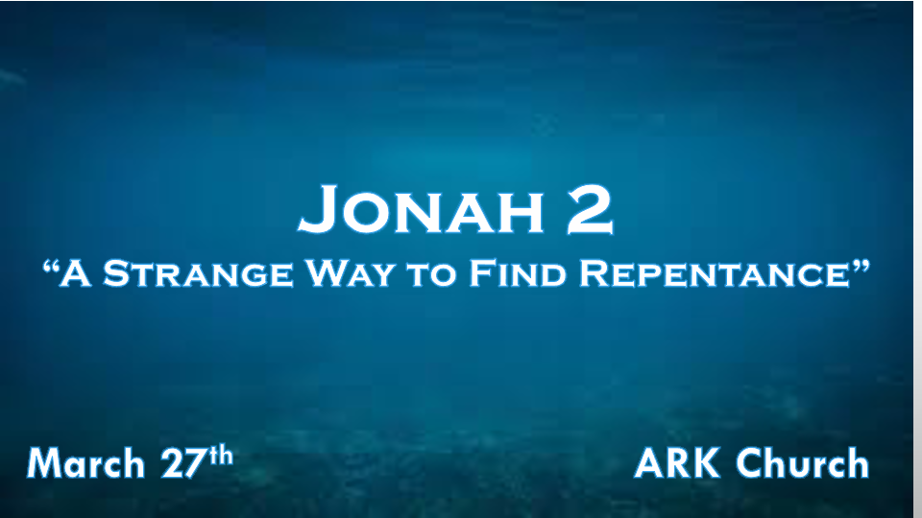

*The Biblical Path to Repentance.

1. Confess and Forsake our sins
*Proverbs 28:13 He who covers his sins will not prosper, but whoever confesses and forsakes them will have mercy.

No person or institution can succeed when sin is in control.

2. Turn from your transgressions. Get a new heart and a new spirit.
*Ezekiel 18:30 “Therefore I will judge you, O house of Israel, every one according to his ways,” says the Lord GOD. “Repent, and turn from all your transgressions, so that iniquity will not be your ruin. 31 Cast away from you all the transgressions which you have committed, and get yourselves a new heart and a new spirit. For why should you die, O house of Israel? 32 For I have no pleasure in the death of one who dies,” says the Lord GOD. “Therefore turn and live!”

3. Receive righteousness.
*Psalm 34:11 Come, you children, listen to me; I will teach you the fear of the LORD.
12 Who is the man who desires life, and loves many days, that he may see good?
13 Keep your tongue from evil, and your lips from speaking deceit.
14 Depart from evil and do good; Seek peace and pursue it.
15 The eyes of the LORD are on the righteous, and His ears are open to their cry.

*Going overboard
*Jonah 1:17 Now the LORD had prepared a great fish to swallow Jonah. And Jonah was in the belly of the fish three days and three nights.
1. God prepared a great fish.
All of God’s steps are prepared.
Rev. 3:18 The Lamb was slain before the foundation of the world
*Eph. 1:4 just as He chose us in Him before the foundation of the world, that we should be holy and without blame before Him in love,

2. Jonah was in the belly of a fish three days and three nights.
God could have rescued Jonah in any number of days, so why three days?
The prayer while in the belly of the whale will reveal that Jonah knew that God heard him.

*The Prophet’s story is about the disobedient coming to repentance and restoration. (The Church)

*Jonah 2:1 Then Jonah prayed to the LORD his God from the fish’s belly. 2 And he said: “I cried out to the LORD because of my affliction, and He answered me. “Out of the belly of Sheol I cried, and You heard my voice.
3 For You cast me into the deep, into the heart of the seas, and the floods surrounded me; All Your billows and Your waves passed over me.
4 Then I said, ‘I have been cast out of Your sight; Yet I will look again toward Your holy temple.’
5 The waters surrounded me, even to my soul; The deep closed around me; Weeds were wrapped around my head.
6 I went down to the moorings of the mountains; The earth with its bars closed behind me forever; Yet You have brought up my life from the pit, O LORD, my God.
7 “When my soul fainted within me, I remembered the LORD; and my prayer went up to You, into Your holy temple.
8 “Those who regard worthless idols forsake their own Mercy.
9 But I will sacrifice to You with the voice of thanksgiving; I will pay what I have vowed. Salvation is of the LORD.”
10 So the LORD spoke to the fish, and it vomited Jonah onto dry land.

- When did repentance start for Jonah?
Jonah 1:16-17 Repentance started on the boat. Jonah remembered who he was in God and understood what happened to him and his world when he didn’t honor God.

- Jonah had great confidence in the belly of the whale, but why? (V:1-2)
Jonah 2:1-2 Jonah connected the dots that the fish was his salvation.
Only God can turn a death situation into a new life. He does this every time someone is born again.

- Is Jonah’s reality and spiritual awareness at a new time high or low? (V:3-7)
V:3 God cast me into the deep of the sea; his situation is extreme, and he is in danger of losing his life.

V:4 A second reality that God cast him out of His sight. Jonah is confident he will see God’s holy temple.

V:5 When his disobedience reached even to the awareness of his soul.

V:6-7 Jonah is having a spiritual revival with God and coming up from the pit of death to new life.

- Who forsakes their own Mercy (God)? (V:8)
A message from the Prophet examines the question. What is your substitute in place of God and His mercy?

- God commands the fish after Jonah takes the vow of salvation.
God waited to fulfill the prophecy connecting to Jesus’ death and resurrection.
God delivers the Prophet to the capital with a new understanding of who God is.

