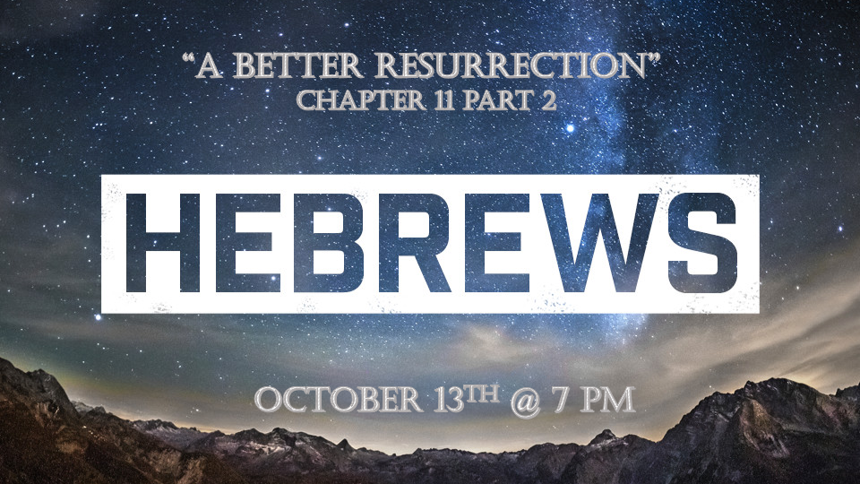

*By faith those with a bad past didn’t let that determine their future.”

*Hebrews 11:21 By faith Jacob, when he was dying, blessed each of Joseph's sons, and worshiped as he leaned on the top of his staff.
22 By faith Joseph, when his end was near, spoke about the exodus of the Israelites from Egypt and gave instructions concerning the burial of his bones.
23 By faith Moses' parents hid him for three months after he was born, because they saw he was no ordinary child, and they were not afraid of the king's edict.
24 By faith Moses, when he had grown up, refused to be known as the son of Pharaoh's daughter. 25 He chose to be mistreated along with the people of God rather than to enjoy the fleeting pleasures of sin. 26 He regarded disgrace for the sake of Christ as of greater value than the treasures of Egypt, because he was looking ahead to his reward. 27 By faith he left Egypt, not fearing the king's anger; he persevered because he saw him who is invisible. 28 By faith he kept the Passover and the application of blood, so that the destroyer of the firstborn would not touch the firstborn of Israel.
29 By faith the people passed through the Red Sea as on dry land; but when the Egyptians tried to do so, they were drowned.

*The strange things that God records as faith.

- V:22 Faith in the future promises Joseph gave instructions about his bones.

- V:23-24 Faith in a tiny ark by Moses’s parents protected him from certain death.

- V:25 By faith Moses reject a life that didn’t honor God. This is why he left Pharaoh’s household.
- V:26 Moses is a type or a shadow of our Messiah (Jesus)
- V:27-29 By faith death passed over and Israel passed through a red sea on dry ground.

*Hebrews11:30 By faith the walls of Jericho fell, after the army had marched around them for seven days.
31 By faith the prostitute Rahab, because she welcomed the spies, was not killed with those who were disobedient.
32 And what more shall I say? I do not have time to tell about Gideon, Barak, Samson, and Jephthah, about David and Samuel and the prophets, 33 who through faith conquered kingdoms, administered justice, and gained what was promised; who shut the mouths of lions, 34 quenched the fury of the flames, and escaped the edge of the sword; whose weakness was turned to strength; and who became powerful in battle and routed foreign armies.

*By faith their weakness was turned to strength.

- *V:30-31Two events are connected by faith. First the supernatural fall of Jericho and then the grace given to Rahab. (The future mother of Boaz the future kinsman-redeemer of Ruth.)

- *V:32-34 Faith is always tested. Don’t let the test nullify your faith. There is a tug of war going on. (The devil wants to sift you and God wants to strengthen you. Which one do you have more faith in?) In the book of James, the whole first chapter is devoted to faith.

- The faith list is complete. The judges by faith, (Gideon, Barak, Samson, and Jephthah.) David the King by faith who serves God, and Samuel represents the prophets who by faith were obedient.

*Hebrews 11:35 Women received back their dead, raised to life again. There were others who were tortured, refusing to be released so that they might gain an even better resurrection. 36 Some faced jeers and flogging, and even chains and imprisonment. 37 They were put to death by stoning; they were sawed in two; they were killed by the sword. They went about in sheepskins and goatskins, destitute, persecuted, and mistreated— 38 the world was not worthy of them. They wandered in deserts and mountains, living in caves and in holes in the ground.

39 These were all commended for their faith, yet none of them received what had been promised, 40 since God had planned something better for us so that only together with us would they be made perfect.

*I WANT a better resurrection! What will it cost?

- V:35 A resurrection that didn’t last was done as a blessing for several women.
- *I Kings 17:17-24 The widow who made a small cake (bread) for Elijah her son was raised from the dead. (The miracle of the flour and oil not running out.)

- *2 Kings 4:32-35 The Shunammite woman's son is raised by Elisha. (The son was a miracle birth too.)

- *Luke 7:15 The widow at Nain her son was raised.
- *John 11:43-44 Martha’s and Mary’s brother Lazarus was raised.

- V:35-38 Suffering for the kingdom is a guarantee for a better resurrection. (It’s the resurrection from the death to eternal life.)

- V:39-40 All of them died without seeing their promise fulfilled. By faith, they held on to the truth that something better was waiting for them. (What are you holding on to?)

