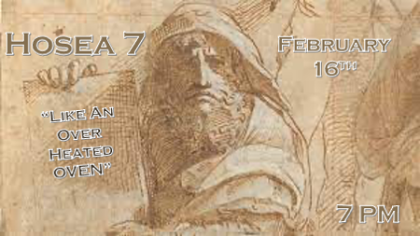

*Hosea chapter 7 reveals the foolishness of wayward believers and nations.

*Hosea 7:1 Whenever I would heal Israel, the sins of Ephraim are exposed and the crimes of Samaria revealed. They practice deceit, thieves break into houses, bandits rob in the streets;
2 but they do not realize that I remember all their evil deeds. Their sins engulf them; they are always before me.
3 "They delight the king with their wickedness, the princes with their lies.
4 They are all adulterers, burning like an oven whose fire the baker need not stir from the kneading of the dough till it rises.
5 On the day of the festival of our king the princes become inflamed with wine, and he joins hands with the mockers.
6 Their hearts are like an oven; they approach him with intrigue. Their passion smolders all night; in the morning it blazes like a flaming fire.
7 All of them are hot as an oven; they devour their rulers. All their kings fall, and none of them calls on me.

*Living in falsehood is like an overheated oven.

- V:1-2 God desires to bring healing to His people and our capitals. The practice of deception by followers of God keeps us from our full healing as a nation. (Isaiah 5:18) Woe, unto them who draw iniquity to themselves and boast about it.

- *V:3-5 Leadership qualification for kings and leaders is righteousness. Proverbs 16:12 KJV 12 It is an abomination to kings to commit wickedness: for the throne is established by righteousness.

- V:6-7 Hot ovens are a symbol of their misplaced passions and lust of a nation. No king survives nor will any leader make it, because they didn’t call on God.

*Hosea 7:8 "Ephraim mixes with the nations; Ephraim is a flat loaf not turned over.
9 Foreigners sap his strength, but he does not realize it. His hair is sprinkled with gray, but he does not notice.
10 Israel's arrogance testifies against him, but despite all this, he does not return to the LORD his God or search for him.

*Half-baked people allow others to sap their strength.

- V:8 Mixing with the wrong people. Israel like the USA was called by God to be the influencers.
  - An unturned person gets burned on one side like a pancake that is not flipped.
  - The uncooked side is not worth anything.
  - The nation that lives this way is marked by a half-baked foreign policy.

- V:9-10 When you focus on foreigners you may not realize it but the foreigners will become the influencer.
  - Sap strength is a symbol of their loss of resources and energy. (Economic and Spiritual)

  - Arrogance proves to be the people’s greatest downfall this keeps them from turning to God.

  - *Judges 16:20 He did not know the Lord had left him. Us like Samson may not have realized that God has abandoned our nation and Churches.

*Hosea 6:11 "Ephraim is like a dove, easily deceived and senseless—now calling to Egypt, now turning to Assyria.
12 When they go, I will throw my net over them; I will pull them down like the birds in the sky. When I hear them flocking together, I will catch them.
13 Woe to them, because they have strayed from me! Destruction to them, because they have rebelled against me! I long to redeem them but they speak about me falsely.
14 They do not cry out to me from their hearts but wail on their beds. They slash themselves, appealing to their gods for grain and new wine, but they turn away from me.
15 I trained them and strengthened their arms, but they plot evil against me.
16 They do not turn to the Most High; they are like a faulty bow. Their leaders will fall by the sword because of their insolent words. For this they will be ridiculed in the land of Egypt.

*Who do you turn to when you don’t turn to God?

- V:11-12 God’s hand is removed from His disobedient people. His second phase is to allow them to be easily deceived and become senseless in who they turn to.

- V:13 Woe, to the person who believes They are a Christian and they speak against God.

- V:14-15 Turning away from the God who gave you the strength is the downfall of a nation. Rejecting the God who trained you in the ways of righteousness to do your evil deeds is bringing a death sentence upon your nation.

- V:16 The countries we look to help us because we’ve turned from God’s help, will in the end ridicule us.

