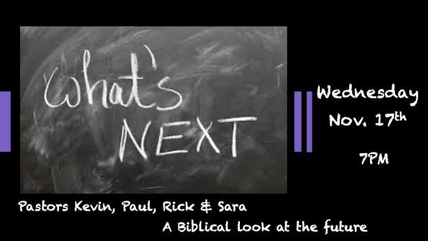

*The Church family is one of the most vital units of the Kingdom of God.

*2 Thessalonians 2:1 Concerning the coming of our Lord Jesus Christ and our being gathered to him, we ask you, brothers, and sisters, 2 not to become easily unsettled or alarmed by the teaching allegedly from us—whether by a prophecy or by word of mouth or by letter—asserting that the day of the Lord has already come. 3 Don't let anyone deceive you in any way, for that day will not come until the rebellion occurs and the man of lawlessness is revealed, the man doomed to destruction. V:3 NKJV Let no one deceive you by any means; for that Day will not come unless the falling away comes first, and the man of [b]sin is revealed, the son of perdition,

*The Church has a mandate, and the future is depending on it.
- Matthew 28:19 Making disciples is the teaching and obeying the Word of God and the His Spirit. This is to take nation-building into all areas.
  - Discipleship is caught and taught.
  - Discipleship is a development of the total being spiritually, emotionally, mentally, and physically.

- 2 Thess. 2:3 To protect against apostasy is the watchmen’s job within God’s Kingdom.
  - A rebellion has come to the Church greater than ever before.
  - The fallen away is only part of the issue.

- We are to build a healthy family. The Church is the family God made up of many families from our community, some are believers and others are seeking.
  - We will be intentional with our family times. Starting with what happens around our service times. No Church next week so that you can be home with your family for thanksgiving
  - We will include more activities around our service times that are natural built-in times of fellowship and family gatherings. This Sunday our adoption papers will be ready as we will have our family communion.

Home Groups by Pastor’s Paul Millan
The New Testament speaks of groups of believers meeting regularly in the intimacy of a home rather than a church building. This house church was a Christian fellowship group formed in and/or around a house (Gr. Oikos). Paul speaks of such a church in the house of Aquila and Priscilla (I Cor. 16:9; Romans 16:3, 5), of Philemon (Philemon 1 & 2), and Nympha in Laodicea (Colossians 4:15).

Examples of 4 specific “house churches” mentioned in the NT
- Priscilla & Aquila (I Cor. 16:9; Romans 16:3,5)
- Philemon (Philemon 1 & 2)
- Stephanas (I Corinthians 16:15)
- Nympha of Laodicea; (Colossians 4:15)
The early church “HOUSE” churches were characterized by the following…
(Acts 2:41-47)
- They gladly received the Word (that taught by the Apostles). The only scriptures available at this time were the OT (Law, Prophets, & Writings).
- They baptized the new believers – the public profession of faith was necessary to those early Jewish Christians. Those who accept Christ through our home groups will be encouraged to be baptized at our ‘parent church’!!
- They continued in the Apostles doctrine – the application of the OT scriptures now in light
of the events of Christ’s ministry, death, and resurrection.
- They continued in fellowship – having a church family is CRUCIAL to keeping your Christian life in harmony!!! This is what fellowship is all about. It provides encouragement, motivation, and accountability!! (Hebrews 10:24-25)
- They continued in the breaking of bread – COMMUNION!!!
One of the great benefits of the home group's ministry is encouragement, by “love and good works” we supplement the regular teaching we hear from this pulpit. Plus, it adds accountability to our sharing and/or demonstrating truth through corporate prayer, and through ministry to one another.
Here’s a three-fold approach to this ministry going forward…
- To continue to model our home groups after the New Testament church model as described.
- To continue to promote participation in our home groups by new attendees and/or new converts.
- To recruit new leaders/facilitators. Everything rises and falls on leadership (Influence). We’re
looking for folks to be a host and/or a facilitator.

Pastors Rick Brummett note section

