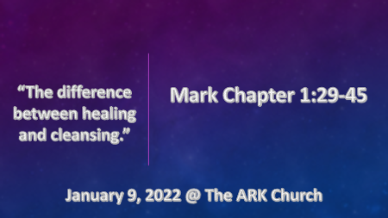

*Spiritually we are moving to embrace the words, immediately, and right now as our theme for 2022. (They are used over 40 times in Mark)

*Understanding the Gospels through the Holy Spirit’s agenda.

- Mark reveals Jesus as the Messiah and suffering servant, and it is written in snapshots.
- Paul and Barnabas took with them John Mark as they went to Cypress. Acts 12:25
- Mark is given the title servant which in Greek was the lowest level of a servant (slave).
- Mark is from a very rich family; some speculate that he could be the rich young ruler.

*Mark 1:29 As soon as they left the synagogue, they went with James and John to the home of Simon and Andrew. 30 Simon's mother-in-law was in bed with a fever, and they immediately told Jesus about her. 31 So he went to her, took her hand, and helped her up. The fever left her and she began to wait on them.

32 That evening after sunset the people brought to Jesus all the sick and demon-possessed. 33 The whole town gathered at the door, 34, and Jesus healed many who had various diseases. He also drove out many demons, but he would not let the demons speak because they knew who he was.

*Jesus brings healing with a personal touch.

- V:29-31 & 41 Mark note the touch of Jesus but why? Jesus was a servant to humanity. His service came with physical touch.
- Mark 5:41 Jairus’ daughter he healed her by taking her by the hand
- Mark 8:23 The blind man is taken by the hand.
- Mark 9:27 The demon-possessed child was taken by the hand.
- Mark 9:36 He took the little child in his arms

- V:32-34 Two distinct groups one has a physical need the other has a cleansing need.
- Jesus heals those with many various diseases.
- Jesus cleansed others by driving out many demons.
- The people didn’t know who Jesus was but they knew he was helping people.
- The demons were not allowed to be a witness to who Jesus was.

*Mark 1:35 Very early in the morning, while it was still dark, Jesus got up, left the house, and went off to a solitary place, where he prayed. 36 Simon and his companions went to look for him, 37, and when they found him, they exclaimed: "Everyone is looking for you!"
38 Jesus replied, "Let us go somewhere else—to the nearby villages—so I can preach there also. That is why I have come." 39 So he traveled throughout Galilee, preaching in their synagogues and driving out demons.

*The Spirit of Jesus is revealed through his healing power.

- V:35 The incarnated Son of God shows how important prayer is in our relationship with the Father.

- V:36-37 Jesus doesn’t alter his agenda because of popularity.

- V:38-39 The combination is the Word of God (Preaching/Proclaiming) Healing and deliverance.

*Mark1:40 A man with leprosy came to him and begged him on his knees, "If you are willing, you can make me clean."

41 Jesus was indignant. He reached out his hand and touched the man. "I am willing," he said. "Be clean!" (KJV) 41 And Jesus, moved with compassion, put forth his hand, and touched him, and saith unto him, I will; be thou clean. 42 Immediately leprosy left him and he was cleansed.

43 Jesus sent him away at once with a strong warning: 44 "See that you don't tell this to anyone. But go, show yourself to the priest and offer the sacrifices that Moses commanded for your cleansing, as a testimony to them." 45 Instead he went out and began to talk freely, spreading the news. As a result, Jesus could no longer enter a town openly but stayed outside in lonely places. Yet the people still came to him from everywhere.

*Jesus is willing, able, and does heal and cleanse today.

- Leprosy as was leaven is a symbol of sin in the New Testament. Yes, one is a disease and the other is the yeast used for making bread.
- Leprosy was considered to go deeper than the skin. Leviticus 13:3 (Pronounced unclean)
- It spreads and so does sin. Leviticus 13:6-8 (Pronounced unclean)
- Leprosy defiles you and isolates you and so does sin. Leviticus 13:44-46 (The person with leprosy must declare to others unclean, unclean.)

- V:43-45 Give a witness to what Jesus has done in your life. Be wise in who and how you share.

