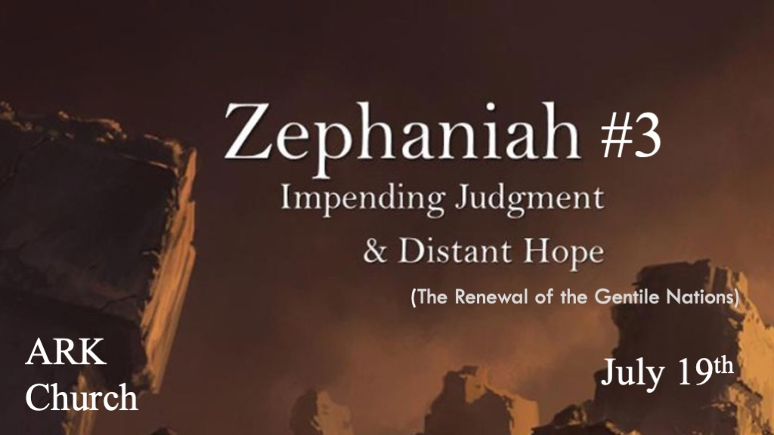
*Zephaniah means Yahweh has hidden or to hide or conceal carefully.

*The Contrast of a Wicked City and Our Righteous God.
*Zephaniah 3:1 Woe to her who is rebellious and polluted, To the oppressing city! 2 She has not obeyed His voice,
She has not received correction; She has not trusted in the LORD, she has not drawn near to her God. 3 Her princes in her midst are roaring lions; Her judges are evening wolves that leave not a bone till morning. 4 Her prophets are insolent, treacherous people; Her priests have polluted the sanctuary, they have done violence to the law. 5 The LORD is righteous in her midst, He will do no unrighteousness. Every morning He brings His justice to light; He never fails,
But the unjust knows no shame.

V:1-2 The disobedience of Jerusalem. See if this rebellious spirit of people parallels today.

- Her polluted heart is rebellious.
A contaminated heart, mind, spirit, or soul cannot produce something healthy for society. Pollution is on the inside and then acted out in civilization.

- She has not received the correction.
It’s implied that the steps to correct were given. Now the consequences are coming.

- She has not trusted in the Lord.
What are you trusting in when it’s not God?

- She has not drawn near to God.
What has a higher place than God in your life?

V:3-4 Every level of leadership is infected by pollution.
Princes, Judges, Prophets, and Priests.

V:5 God’s righteousness is for those who have eyes to see and heart to receive.
The God who is Just brings light and never fails.

*The Sequence of God’s Judgment.
*Zephaniah 3:6 “I have cut off nations, their fortresses are devastated; I have made their streets desolate, with none passing by.
Their cities are destroyed; There is no one, no inhabitant. 7 I said, ‘Surely you will fear Me, you will receive instruction’—So that her dwelling would not be cut off, despite everything for which I punished her. But they rose early and corrupted all their deeds.
8 “Therefore wait for Me,” says the LORD, “Until the day I rise up for plunder; My determination is to gather the nations to My assembly of kingdoms, to pour on them My indignation, all My fierce anger; all the earth shall be devoured with the fire of My jealousy. 9 “For then I will restore to the peoples a pure language, that they all may call on the name of the LORD, to serve Him with one accord. 10 From beyond the rivers of Ethiopia My worshipers, the daughter of My dispersed ones, shall bring My offering. 11 In that day you shall not be shamed for any of your deeds in which you transgress against Me; For then I will take away from your midst those who rejoice in your pride, and you shall no longer be haughty in My holy mountain. 12 I will leave in your midst a meek and humble people, and they shall trust in the name of the LORD. 13 The remnant of Israel shall do no unrighteousness and speak no lies, nor shall a deceitful tongue be found in their mouth; For they shall feed their flocks and lie down, and no one shall make them afraid.”

V:6-7 Failure of God’s people to learn from the judgment of other nations.
Egypt

The Northern Kingdom of Israel

Assyria

V:8 The Start of the Great Tribulation
Indignation is a connector to Isaiah 26:20

V:9-10 The Renewal of Nations after judgment.
Christ is ruling, and this is the millennial age period.

V:11-13 Israel’s righteousness is evident by trust, truth, and boldness.
This, too, is the millennial age.

*Restoration is Only in The Lord your God being in our Midst.
*Zephaniah 3:14 Sing, O daughter of Zion! Shout, O Israel! Be glad and rejoice with all your heart, O daughter of Jerusalem!
15 The LORD has taken away your judgments, He has cast out your enemy. The King of Israel, the LORD, is in your midst;
you shall see disaster no more. 16 In that day it shall be said to Jerusalem: “Do not fear; Zion, let not your hands be weak.
17 The LORD your God in your midst, The Mighty One, will save; He will rejoice over you with gladness, He will quiet you with His love, He will rejoice over you with singing.” 18 “I will gather those who sorrow over the appointed assembly, Who are among you, to whom its reproach is a burden. 19 Behold, at that time I will deal with all who afflict you; I will save the lame,
and gather those who were driven out; I will appoint them for praise and fame in every land where they were put to shame.
20 At that time I will bring you back, even at the time I gather you; For I will give you fame and praise among all the peoples of the earth, when I return your captives before your eyes,” Says the LORD.

V:14-15 The King is Here, the end of the tribulation, and the Second Coming has happened.
We cannot find the words. To describe what this means to the world that’s been seven years of Wrath.

*Those who don’t believe in the great tribulation and millennial reign do not understand what they are saying.
- *They are saying God doesn’t keep His Word. The covenant to Abraham and to David are the issue.
- *They self-righteously say; “No one else got to escape a bad time period.”
- *Ignorance about how devasting; The great tribulation is beyond anything humanity has experienced. Jerusalem will only know peace after the second coming and during the millennial reign of Christ.

V:16-19 In That Day.
This is more than likely a comfort message to Israel and those who are in the great tribulation.

V:20 At that time, a Holy New order is established.
A new order comes to the Nations, a new order in the length of biological life, and a new order in the animal world.

