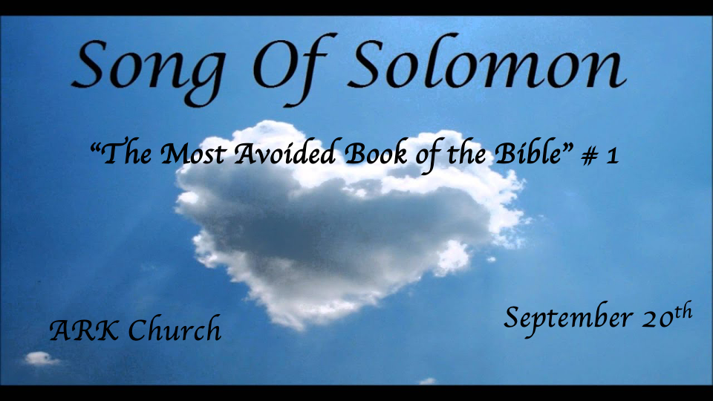
John the Baptist: John 3:29 I have been sent before Him.’ 29 He who has the bride is the bridegroom; but the friend of the bridegroom, who stands and hears him, rejoices greatly because of the bridegroom’s voice. Therefore this joy of mine is fulfilled.

Jesus: Matthew 9:15 And Jesus said to them, “Can the friends of the bridegroom mourn as long as the bridegroom is with them? But the days will come when the bridegroom will be taken away from them, and then they will fast.

*Two of the three reflections: Preparing for the wedding feast and being there.
*Song of Solomon 1:1-8

1 The song of songs, which is Solomon’s.
The Banquet
The Shulamite
2 Let him kiss me with the kisses of his mouth—
For your love is better than wine.
3 Because of the fragrance of your good ointments,
Your name is ointment poured forth;
Therefore the virgins love you.
4 Draw me away!
The Daughters of Jerusalem
We will run after you.
The Shulamite
The king has brought me into his chambers.
The Daughters of Jerusalem
We will be glad and rejoice in you.
We will remember your love more than wine.
The Shulamite
Rightly do they love you.
5 I am dark, but lovely,
O daughters of Jerusalem,
Like the tents of Kedar,
Like the curtains of Solomon.
6 Do not look upon me, because I am dark,
Because the sun has tanned me.
My mother’s sons were angry with me;
They made me the keeper of the vineyards,
But my own vineyard I have not kept.
(To Her Beloved)
7 Tell me, O you whom I love,
Where you feed your flock,
Where you make it rest at noon.
For why should I be as one who veils herself
By the flocks of your companions?
The Beloved
8 If you do not know, O fairest among women,
Follow in the footsteps of the flock,
And feed your little goats
Beside the shepherds’ tents.

Insights V:1-4: I Kings 10:23 So King Solomon surpassed all the kings of the earth in riches and wisdom.

V:1 Song of songs, the repetition of the noun in the possessive form, makes it unparalleled.
Examples: Holy of Holies, Lord of Lords, or King of Kings. Declares our God is above all other gods.

V:2 When we meet our unparalleled person, it is described as the intoxication of true love.
The virgins who love Jesus will be ready and waiting for their bridegroom as the 5 wise virgins. Matt. 25 1-10

V:3 There is a fragrance of the bridegroom. There is a sweet aroma of Christ and His love.
His name is a sweet fragrance. Jesus is the sweetest name I know.

Insights V4b-8: Marriage connects more than just two people.

A great allegory asking will we run after Jesus? If so, you may be taken in the rapture.

Self-evaluation seems to always be on the lower side. Shulamite understands he (Jesus) gives her actual value or worth.

(Possibly literal/allegory) The mother is Bathsheba (Israel,) and the sons are her stepbrothers. Israel didn’t keep up the vineyard, and The Church received that duty. The church hasn’t developed the connection with the true vine. (Caring for the church is not the same as an intimate relationship with Jesus.)

Literal Insights: Does this generation know where or how to find a spouse?

What should a woman see as desirable in a man? Genesis 2:15-18
Four needs of a woman in marriage: A work ethic, a man who draws the good out of life. A man who will hear the Spirit of God. A man learning the different levels of oneness.

What should a man desire in a woman? I Peter 3:7 Husbands, likewise, dwell with them with understanding, giving honor to the wife, as to the weaker vessel, and as being heirs together of the grace of life, that your prayers may not be hindered.
Four needs of men in marriage: Honor, respect, sex, and friendship.

Allegory insights:
V:8 The bridegroom (Jesus the Shepherd) is saying follow the footsteps of the flock?
- The above statement places great responsibility on the church.
- We come to church to reveal to others our great love in following our Savior.
- The Shepherd/King is the connection to Jesus, our Great Shepherd/King.

*Reflections continue: At the wedding feast and in the bridal chambers.
*Song of Solomon 1:9-14
(The Beloved at the wedding feast)

9 I have compared you, my love,
To my filly among Pharaoh’s chariots.
10 Your cheeks are lovely with ornaments,
Your neck with chains of gold.
11 We will make you ornaments of gold
With studs of silver.
The Shulamite
12 While the king is at his table,
My spikenard sends forth its fragrance.
13 A bundle of myrrh is my beloved to me,
That lies all night between my breasts.
14 My beloved is to me a cluster of henna blooms
In the vineyards of En Gedi.
*Song of Solomon 1:15-17 & 2:1-7
The Beloved (In the bridal chambers)
15 Behold, you are fair, my love!
Behold, you are fair!
You have dove’s eyes.
The Shulamite
16 Behold, you are handsome, my beloved!
Yes, pleasant!
Also our bed is green.
17 The beams of our houses are cedar,
And our rafters of fir.

Insights literal V:9-11: Have you compared your wife to a horse lately?

V:9-11 The idiom was saying how much he valued her. (today’s you are better than my newest car and are more valuable.) It is a comment on her beauty also.

Insights literal V:12-14 Have you given your wife expensive dark chocolate lately?

V:12 Spikenard came from the stem of plant leaves from the Himalayas. Its fragrance is fantastic, and it's expensive. It was also a spice that increased sexual passion.

V:13-14 Never lose your seductive power that you capture your man with. Keep that power over him all the days of your life.

Insights V:15-17: Verbalize Compliments, intimacy, and what they mean to you. Marriage is an investment. The dove is a bird that mates for life. She asked for two things in V:7: to be fed and rest.
She’s fed in V:12 and rests in V:16. Notice the switch to our bed, our house, and our rafters.

