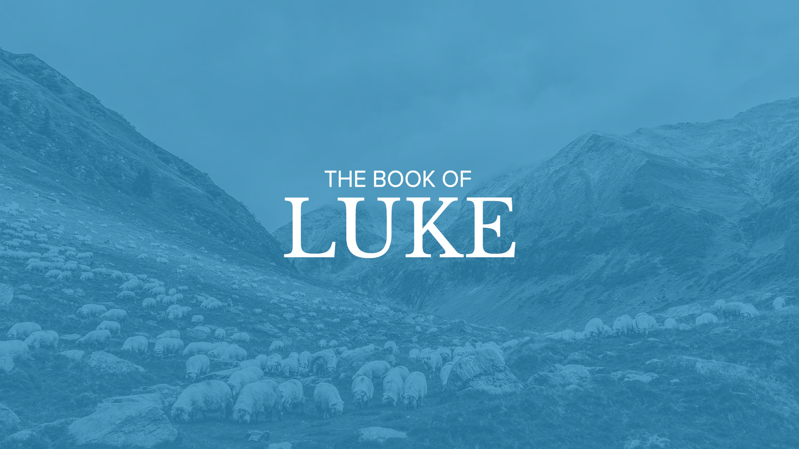

“The Messiah’s Authority”

January 31st

8:45 am & 10:45 am

Chapter 8

The different focus of the Gospels

- Matthew: Jesus as Messiah, the King (His earthly royalty). So the genealogy goes back through Solomon, David all the way to Abraham. Matthew’s primary audience is the Jewish people.

- Mark: Jesus is the Suffering Servant. There’s no genealogy, the gospel starts with Jesus obediently being baptized by his cousin John. Mark’s primary audience is the Romans.

- Luke: Jesus is the son of man (His humanity). As a matter of fact, Jesus’s favorite title for himself was “The Son of Man”. The genealogy traces all the back to Adam through Mary’s bloodline. Luke’s primary audience is the Gentiles.

- John: Jesus is the son of God (His Divinity & His heavenly royalty). This genealogy is found in the creation. In the beginning was the Word and the Word was with God and the Word is God (John Chapter 1). John’s primary audience was the church.

Summary of Luke, chapter 8…

(John 4:34; John 5:30; John 6:38; NKJV)

Jesus performed all the tasks that His Father gave Him to do in the precise timing that His Father had Him perform them. He especially made certain that the most important of those tasks, His sacrificial death, did not take place until the precise time determined by the Father.

- Vss. 19-21: Jesus’ Messianic Authority supersedes human relationships - “Who is my mother and my father”

- Vss. 22-25: Jesus’ Messianic Authority supersedes natural elements – “even the wind and the sea obey Him.”

- Vss. 26-39: Jesus’ Messianic Authority supersedes supernatural activity – “I beg you, do not torment me”

- Vss. 41-56: Messianic Authority supersedes the power of death - “Little girl, arise”

The Parable of the 4 Soils (vss. 4-15)

- Vss. 5 & 12: NO Penetration (vss. 5 & 12) “Hard-packed Ground”
- Vss. 6 & 13: NO Internalization (vss. 6 & 13) “Stony Ground”
- Vss. 7 & 14: NO Germination (vss. 7 & 14) “Thorny Ground”
- Vss. 8 & 15: NET Culmination (vss. 8 & 15) “Fertile Ground”

The truth contained in this parable was for Christ’s disciples only. Jesus identified its key elements. Significantly, He did not name the sower (as he so identified Himself in His explanation for the parable of the wheat and the tares), since the sower is not the issue. Anyone who proclaims the gospel is a sower. Jesus identified the issue. Jesus identified the seed as the word of God, specifically in this context the gospel message of salvation. Peter used that same analogy when he wrote, “you have been born again not of seed which is perishable but imperishable, that is through the living and enduring word of God”. (I Peter 1:23)

You did not choose Me, but I chose you and appointed you that you should go and bear fruit, and that your fruit should remain, that whatever you ask the Father in My name He may give you. (John 15: 16 – NKJV)

Eighteenth Century British Methodist Theologian, Biblical Scholar, and author of the Adam Clarke Biblical Commentary once said…

Let it ever be remember that genuine faith in Christ will ever be productive of good works; for this faith works by love, as the apostle says, and love to God always produces obedience to His holy laws.

~Adam Clarke

