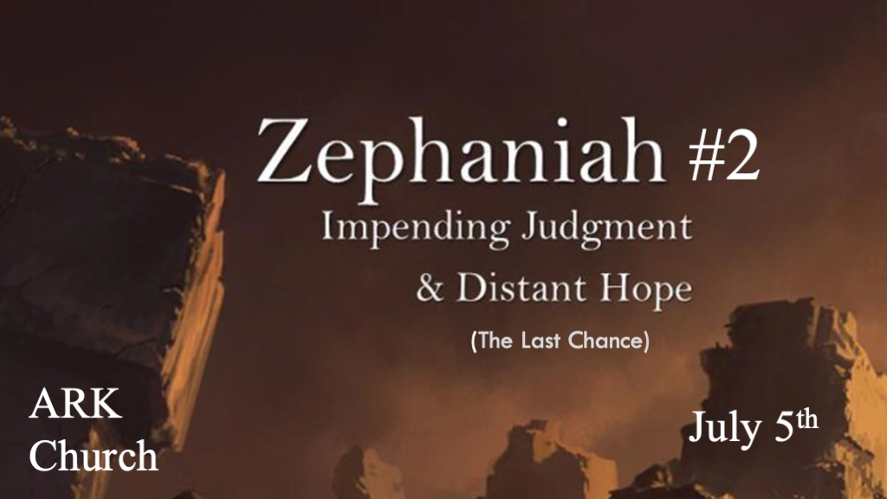
*Zephaniah means Yahweh has hidden or to hide or conceal carefully.

Jehovah has hidden His treasure.

*Prophecy To The Nations, What They Must Do “Before” the Wrath.
*Zephaniah 2:1 Gather yourselves together, yes, gather together, O undesirable nation, 2 Before the decree is issued,
or the day passes like chaff, before the LORD’s fierce anger comes upon you, before the day of the LORD’s anger comes upon you! 3 Seek the LORD, all you meek of the earth, who have upheld His justice. Seek righteousness, seek humility.
It may be that you will be hidden in the day of the LORD’s anger.

V:1-2 What must happen in order to be hidden from the Lord’s wrath?

- V:1 Instead of indifference to the cultural evils, there must be?
Gather under repentance and seek God.

The spirit of complacency in the world regarding the gathering to seek God is at an all-time high.

O undesirable nation, you are undesirable because of your shameless sin. (It’s not that God doesn’t love them.)

- V:2 Before the decree is issued. Before the day passes and the wrath of God is upon you.
Notice the urgency in this message, for God does have a point of no return. Before the judgment is repeated for a second time in one verse.

Who will face the consequence of God’s wrath? This does not mean you cannot find salvation—only those who continue to reject His Grace.

- V:3 Will, you belong to the group who are hidden from the Wrath?
A hint of something more profound.

*Revelation 3:10 Because you have kept My command to persevere, I also will keep you from the hour of trial which shall come upon the whole World, to test those who dwell on the earth.

Isaiah 26:19-21 Come my people, enter into thy chambers, while my indignation passes over.

Psalm 27:5 For in the time of trouble He shall hide me in His pavilion; In the secret place of His tabernacle
He shall hide me; He shall set me high upon a rock. (The Rock is always the symbol of Jesus)

*The doom of Israel's neighbors and those who curse Israel.
*Zephaniah 2:4 For Gaza shall be forsaken, and Ashkelon desolate; They shall drive out Ashdod at noonday, and Ekron shall be uprooted. 5 Woe to the inhabitants of the seacoast, The nation of the Cherethites! The word of the LORD is against you,
O Canaan, land of the Philistines: “I will destroy you; So there shall be no inhabitant.” 6 The seacoast shall be pastures, with shelters for shepherds and folds for flocks. 7 The coast shall be for the remnant of the house of Judah; They shall feed their flocks there; In the houses of Ashkelon they shall lie down at evening. For the LORD their God will intervene for them, and return their captives. 8 “I have heard the reproach of Moab, and the insults of the people of Ammon, with which they have reproached My people, and made arrogant threats against their borders. 9 Therefore, as I live,” Says the LORD of hosts, the God of Israel,
“Surely Moab shall be like Sodom, and the people of Ammon like Gomorrah—Overrun with weeds and saltpits, and a perpetual desolation. The residue of My people shall plunder them, and the remnant of My people shall possess them.”

- V:4-8 God is God over the whole world. Even if you don’t believe in Him, He will show judgment to all.
Philistines are to the west of Israel.
Moabites and Ammonites are to the east of Israel.
Ethiopians are to the south of Israel.
Assyrians are to the North of Israel.

Cherethites came from the island of Crete. They are Philistines, and their name means immigrants.
(Is this a shadow of a single nation of immigrants?)

- V:9 The Ammonites are prideful about their stance against Israel. (God)
When you take a stance against Israel, Biblically, you are also taking a position against God.

Is it just a coincidence that the nations representing “The Last Days” are called Sodom and Gomorrah, which is a big part of the coming wrath?

- The picture becomes clear on why the world is judged. My insights are from Chuck Missler.
Pride and arrogance Isaiah 16:6 We have heard of the pride of Moab—He is very proud—Of his haughtiness and his pride and his wrath; But his lies shall not be so.

Gross immorality and Idolatry I Kings 11:7 Then Solomon built a high place for Chemosh, the abomination of Moab, on the hill that is east of Jerusalem, and for Molech the abomination of the people of Ammon.

Psychopathic inhumanity 2 Kings 3:26-27 And when the king of Moab saw that the battle was too fierce for him, he took with him seven hundred men who drew swords, to break through to the king of Edom, but they could not. 27 Then he took his eldest son who would have reigned in his place, and offered him as a burnt offering upon the wall, and there was great indignation against Israel. So they departed from him and returned to their own land.

~Their greatest sins were a pride of origin and a pride of grace – Chuck Missler

*The Lord reduces all the gods of the earth.
*Zephaniah 2:10 This they shall have for their pride, because they have reproached and made arrogant threats against the people of the LORD of hosts. 11 The LORD will be awesome to them, for He will reduce to nothing all the gods of the earth;
People shall worship Him, each one from his place, indeed all the shores of the nations. 12 “You Ethiopians also, you shall be slain by My sword.” 13 And He will stretch out His hand against the north, destroy Assyria, and make Nineveh a desolation,
as dry as the wilderness. 14 The herds shall lie down in her midst, every beast of the nation. Both the pelican and the bittern
shall lodge on the capitals of her pillars; Their voice shall sing in the windows; Desolation shall be at the threshold; For He will lay bare the cedar work. 15 This is the rejoicing city that dwelt securely, that said in her heart, “I am it, and there is none besides me.” How has she become a desolation, a place for beasts to lie down! Everyone who passes by her shall hiss and shake his fist.

- V:10-12 Those that follow the gods of pride have made overconfident threats against the people of The Lord of Host.
God’s power against evil could have its literal fulfillment right before our eyes.

The Lord of Host will be awesome, reducing their gods to nothing.

A specific instrument of wrath will be used on those living south of Israel. God’s Sword will slay them. It is probably because of the atrocities against their own people.

- V:13-14 Man’s lack of understanding about Biblical truth. (The destruction of Nineveh)
For Centuries archaeologists said the Bible isn’t true. Why? Because the great city of Nineveh could not be located. A city sixty miles in diameter with twelve towers and walls a hundred feet high and so thick that three chariots could race across the top of its city's outer walls. They discovered the ruins 1850s.

- V:15 Beware of speaking sinful pride over a city or nation.
Nineveh should be a lesson to countries north of Israel in the 21st century.

