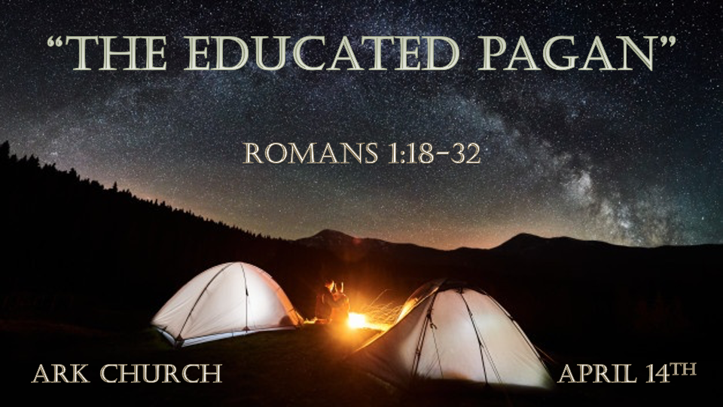

*Romans is a Book about Two Camps, The Pagan and The Christian.

- 590 A.D. – 1517 A.D. The Dark Ages. It was a season when it was hard to distinguish the Christian from the Pagan.
When Christianity acts out of step with the Bible and the heart of God, darkness is always the result.

- The Age of Grace. It was a simpler time when forgiveness and love ruled the Christian community.

The Bible teaches that the end of the Age of Grace will be marked by lawlessness.
Laws are changing, enabling the spirit of lawlessness. This time, the darkness makes it hard to distinguish truth from falsehood in life.

*The Suppression of Truth and Its Consequences

*Romans 1:18 For the wrath of God is revealed from heaven against all ungodliness and unrighteousness of men, who suppress the truth in unrighteousness, 19 because what may be known of God is manifest in them, for God has shown it to them. 20 For since the creation of the world His invisible attributes are clearly seen, being understood by the things that are made, even His eternal power and Godhead, so that they are without excuse, 21 because, although they knew God, they did not glorify Him as God, nor were thankful, but became futile in their thoughts, and their foolish hearts were darkened. 22 Professing to be wise, they became fools, 23 and changed the glory of the incorruptible God into an image made like corruptible man—and birds and four-footed animals and creeping things.
24 Therefore God also gave them up to uncleanness, in the lusts of their hearts, to dishonor their bodies among themselves, 25 who exchanged the truth of God for the lie, and worshiped and served the creature rather than the Creator, who is blessed forever. Amen.

- V:18 The wrath of God and the Holy Spirit is the cleansing agent.
Ungodliness and unrighteousness of humanity are the foundation of lies. Sinful people's moral compass includes lying.
God sent His Spirit to cleanse hearts and change lives. In time, God will cleanse humanity of sin and evil.

- V:19-21 Understanding the process of a heart that became dark.
When the light of the gospel is given and accepted freely, non-Christians live a more moral life.
- In the mid-1900s, the average non-Churchgoer had many things in common with Christians.
- Common community goals. Pregnancy outside of marriage was not considered wise or celebrated.
- Common national outlook. Being an American was declared by both left and right. They could even have statesmen who would work across the political aisle for what was best for the majority.
- In today's cultural views, the minority are protected even if their lifestyle would offend God. The majority are taught that your voice only counts when supporting the minority.

- V:22-25 Professing your wisdom doesn't make it so.

The fear of the Lord is the beginning of Wisdom.

*When We Deserve Death but Receive Grace.
*Romans 1:26 For this reason God gave them up to vile passions. For even their women exchanged the natural use for what is against nature. 27 Likewise also the men, leaving the natural use of the woman, burned in their lust for one another, men with men committing what is shameful, and receiving in themselves the penalty of their error which was due.
28 And even as they did not like to retain God in their knowledge, God gave them over to a debased mind, to do those things which are not fitting; 29 being filled with all unrighteousness, sexual immorality, wickedness, covetousness, maliciousness; full of envy, murder, strife, deceit, evil-mindedness; they are whisperers, 30 backbiters, haters of God, violent, proud, boasters, inventors of evil things, disobedient to parents, 31 undiscerning, untrustworthy, unloving, unforgiving, unmerciful; 32 who, knowing the righteous judgment of God, that those who practice such things are deserving of death, not only do the same but also approve of those who practice them.

- V:26-27 Vile passions! The absence of a relationship with God is an awful world.
Society is sowing seeds of shame, and the harvest is being fed to our children.

The death of innocence is the most significant death this generation is experiencing.

- V:28 Rejection of the Creator will make you a slave to creation.
Environmentalists believe their god is creation. Creation enslaves one another. The Creator set us to be free.

- V:29-32 Does your approval of sin say what you are willing to practice?
Aren't all adults responsible for protecting children?
YES, we are mandated by God's Word to protect, and if we harm a child, it is better to tie a large rock around your neck and be cast into the sea.

Debased mind or Depraved thinking is when we disapprove of God in our thoughts, so He gives us over to the experience of a limited, unapproved, or non-wholesome thinking world without Him.

Interesting list of words describing the world without God's views in verses 29-32
*Disobedient to Parents
*Inventors of evil
*Whisperers
*Untrustworthy
*Unloving
*Unforgiving
*Unmerciful

