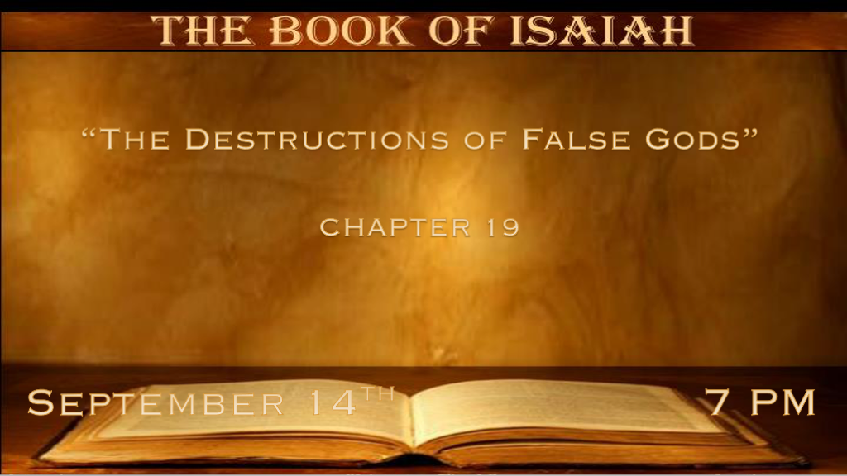

*Could some scientists be modern-day false prophets?

*The Second Coming and the world conditions prior to it.

*Isaiah 19:1 The burden against Egypt. Behold, the LORD rides on a swift cloud, and will come into Egypt; The idols of Egypt will totter at His presence, and the heart of Egypt will melt in its midst.
2 “I will set Egyptians against Egyptians; Everyone will fight against his brother, and everyone against his neighbor, city against city, kingdom against kingdom. 3 The spirit of Egypt will fail in its midst; I will destroy their counsel, and they will consult the idols and the charmers, the mediums and the sorcerers. 4 And the Egyptians I will give Into the hand of a cruel master, and a fierce king will rule over them,” says the Lord, the LORD of hosts. 5 The waters will fail from the sea, and the river will be wasted and dried up. 6 The rivers will turn foul; The brooks of defense will be emptied and dried up; The reeds and rushes will wither. 7 The papyrus reeds by the River, by the mouth of the River, and everything sown by the River, will wither, be driven away, and be no more. 8 The fishermen also will mourn; All those will lament who cast hooks into the River, and they will languish who spread nets on the waters. 9 Moreover those who work in fine flax and those who weave fine fabric will be ashamed; 10 And its foundations will be broken. All who make wages will be troubled of soul.

- V:1-4 The prophecy of Egypt. Like many nations, Egypt will experience a great division among its people.
*Mark 13:12 "Brother will betray brother to death, and a father his child. Children will rebel against their parents and have them put to death. 13 Everyone will hate you because of me, but the one who stands firm to the end will be saved.
Psalm 115:8 We become like the gods we worship. Their deception becomes ours and so on.

- V:5-7 Dried-up rivers will mark this time. Joel 1:20, Hosea 13:15, Ezekiel 30:12, Jeremiah 50:38, Zechariah 10:11, and Revelation 16:12
*The Aswan dam system has changed the Nile from the 1950s thru 1976.

Some say the dam system brought good while others say it has brought ecological/environmental damage beyond repair.
Amir Tsarfati shared on September 14th that the drought in China is the worst since 1865. Dried-up rivers are affecting transportation and electricity.

- V:8-10 The loss of employment and broken foundations.
Implied within the text is again economic upheaval and long-term trade relations are broken.

*Foolish Leadership and Counsel Because of Deception.

*Isaiah 19:11 Surely the princes of Zoan are fools; Pharaoh’s wise counselors give foolish counsel.
How do you say to Pharaoh, “I am the son of the wise, The son of ancient kings?” 12 Where are they? Where are your wise men? Let them tell you now, and let them know what the LORD of hosts has purposed against Egypt.
13 The princes of Zoan have become fools; The princes of Noph are deceived; They have also deluded Egypt, those who are the mainstay of its tribes. 14 The LORD has mingled a perverse spirit in her midst; and they have cause Egypt to err in all her work, as a drunken man staggers in his vomit. 15 Neither will there be any work for Egypt, which the head or tail, Palm branch or bulrush, may do.

- V:11 Cruel Rulers bring what to their people?
The foolish rulers bring all that we saw in the 1st ten verses economic, spiritual, and agricultural disasters all because they turn to false gods.
- V:12 Cruel Counsel puts the people under a curse of foolish living.
When the wise men of a country are fools the country will never be prepared for the future.

- V:13-15 Recognizing the false god of Perversion. A mindset that refuses even the basic elements of life for they serve the false gods of deception.
*Romans 1:22 Although they claimed to be wise, they became fools.
*Romans 1:23 and exchanged the glory of the immortal God for images made to look like a mortal human being and birds and animals and reptiles.
*Romans 1:24 Therefore God gave them over in the sinful desires of their hearts to sexual impurity for the degrading of their bodies with one another.
*Romans 1:25 They exchanged the truth about God for a lie and worshiped and served created things rather than the Creator—who is forever praised. Amen.

*In That Day a New Language and Relationship.

*16 In that day Egypt will be like women, and will be afraid and fear because of the waving of the hand of the LORD of hosts, which He waves over it. 17 And the land of Judah will be a terror to Egypt; everyone who makes mention of it will be afraid in himself, because of the counsel of the LORD of hosts which He has determined against it.
18 In that day five cities in the land of Egypt will speak the language of Canaan and swear by the LORD of hosts; one will be called the City of Destruction.
19 In that day there will be an altar to the LORD in the midst of the land of Egypt, and a pillar to the LORD at its border. 20 And it will be for a sign and for a witness to the LORD of hosts in the land of Egypt; for they will cry to the LORD because of the oppressors, and He will send them a Savior and a Mighty One, and He will deliver them. 21 Then the LORD will be known to Egypt, and the Egyptians will know the LORD in that day and will make sacrifice and offering; yes, they will make a vow to the LORD and perform it. 22 And the LORD will strike Egypt, He will strike and heal it; they will return to the LORD, and He will be entreated by them and heal them.
23 In that day there will be a highway from Egypt to Assyria, and the Assyrian will come into Egypt and the Egyptian into Assyria, and the Egyptians will serve with the Assyrians.
24 In that day Israel will be one of three with Egypt and Assyria—a blessing in the midst of the land, 25 whom the LORD of hosts shall bless, saying, “Blessed is Egypt My people, and Assyria the work of My hands, and Israel My inheritance.”

- V:16-17 Five insights to the future.
In that day, a simple wave of Jesus' hand will set certain things in place or in motion.
A Historical change is that Israel has feared Egypt for most of its existence.

- V:18 A progression in a relationship with Jesus.
In that day, Egypt will fear Judah, I like identifying with the fear of Judah. Jesus is the Lion of Judah.
5 Cities then will start a relationship with the Lord of Host. One is known as the city of Destruction.
Isn’t that just like Jesus as Egypt will turn in the future to Him it starts with that which was known as the city of destruction?

- V:19-22 In that day, in regions of Pyramids and false gods, were worshipped, now true worship.
*The Altar is a symbol of sacrifice in the heart of Egypt.
*The Pillar is a symbol throughout the Bible of protection, guidance, and stability.
Double edge blessing Jesus striking and healing. The Word of God does this it cuts the sin away and brings healing to our life, soul, mind, and body.

- V:23 In that day, a connection to three countries that during the time of Isaiah’s writings are at war.
The millennial reign of Christ brings peace no other period in history can say this.

- V:24-25 In that day, we will see the truth of John 3:16 lived out.
*It is powerful to say oneness between Israel and Egypt.
*Until that day, it seems unbelievable that Assyria, Egypt, and Israel will be blessed by God and the work of His hand.

