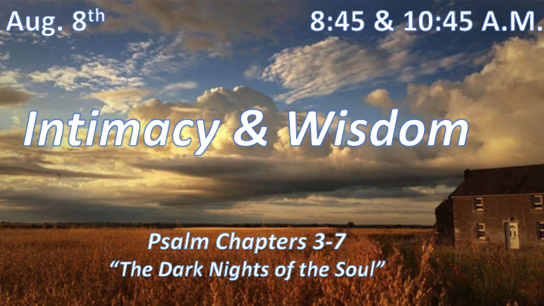

*How do you handle the dark times of life?

Psalm Chapters 3-7 Overview

- King Saul was trying to kill David and he has to hide in caves.
- Had to leave his hometown Jerusalem because of the attacks.
- His son Absalom later tries to kill him and take over his throne.

*Psalm 3:1 LORD, how many are my foes! How many rise up against me!
2 Many are saying of me, "God will not deliver him."
3 But you, LORD, are a shield around me, my glory, the One who lifts my head high.
4 I call out to the LORD, and he answers me from his holy mountain.
5 I lie down and sleep; I wake again, because the LORD sustains me.
6 I will not fear though tens of thousands assail me on every side.
7 Arise, LORD! Deliver me, my God! Strike all my enemies on the jaw; break the teeth of the wicked.
8 From the LORD comes deliverance. May your blessing be on your people.

*Christians do have dark times.

- V:1-2 Be careful who you are listening to. Many in our world are saying the wrong things about God.

- V:3-6 God is working even while we are sleeping.
- Mornings and rest give us a better perspective on all things. Things appear unspoiled in the morning.

- V:6 In the morning or after meeting with God our courage is renewed.

- V:7-8 The Lord of Deliverance. Shutting the mouths of lions and breaking the teeth of the wicked is God’s deliverance. Jonah 2:9

Songs of Psalm 4, 5, 6, 7 Lessons we can learn during times of darkness.

*Psalm 4:1(KJV) Hear me when I call, O God of my righteousness: thou hast enlarged me when I was in distress; have mercy upon me, and hear my prayer.

*Psalm 5:7 (KJV) But as for me, I will come into thy house in the multitude of thy mercy: and in thy fear will I worship toward thy holy temple.

*Psalm 6:6 I am worn out from my groaning. All night long I flood my bed with weeping and drench my couch with tears.
*Psalm 7:15 Whoever digs a hole and scoops it out falls into the pit they have made.

*We learn and grow more in my times of despair than in prosperity.

- Psalm Chapter 4:1 The righteous are enlarged or grow through troubling times. You cannot eat your dilemmas away.

- Psalm Chapter 5:7 Worship is a key ingredient in our trials.
- James 1:2 Count it all a joy.
- *Jeremiah 17:14 Heal me, O Lord, and I shall be healed; save me, and I shall be saved, for you are my praise.
- Psalm 119:164 Seven times a day I praise you for your righteous rules.

- Psalm Chapter 6:6 The collection bottle is for now and our future.
- *Psalm 56:8 Record my misery; list my tears on your scroll—are they not in your record?
- *Psalm 126:5 Those who sow with tears will reap with songs of joy. (Solomon words)

- Psalm Chapter 7:15 The boomerang outcome is a Biblical principle.
- Pharaoh order babies to be drowned in the river during the time of Moses.

- Haman built gallows to hang the Jews and Mordecai.

- Saul wanted David killed by the sword.

*Will you allow God to use your dark nights to draw you to intimacy?

