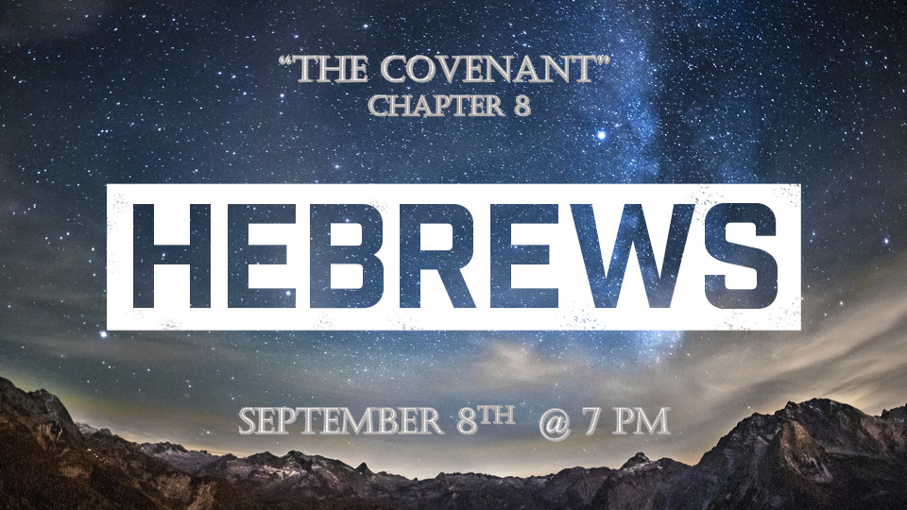

*The great exchange is the meat of the Gospel.

*Jesus is the answer, not the angels (Chapters 1-2)
*Jesus is the way, not Moses or the law. (Chapters 3 -5)
*Jesus is the gift, sacrifice, and kinsman, not the Levitical priesthood. (Chapters 5 -7)

*Hebrews8:1 Now the main point of what we are saying is this: We do have such a high priest, who sat down at the right hand of the throne of the Majesty in heaven, 2 and who serves in the sanctuary, the true tabernacle set up by the Lord, not by a mere human being.

3 Every high priest is appointed to offer both gifts and sacrifices, and so it was necessary for this one also to have something to offer. 4 If he were on earth, he would not be a priest, for there are already priests who offer the gifts prescribed by the law. 5 They serve at a sanctuary that is a copy and shadow of what is in heaven. This is why Moses was warned when he was about to build the tabernacle: "See to it that you make everything according to the pattern shown you on the mountain."

*The gift of God reveals a pattern.

- V:1-2 The Tabernacle it’s Outer Court symbolizes the body; the Holy Place represents the soul and the Holy of Holies symbolizes the spirit of man.

- V:3-5 The Pattern for the Tabernacle was from heaven. (Exodus 25:9) You can see there are multi-levels of insights to this teaching. This is the meat of the Word.

*Hebrews8:6 But in fact the ministry Jesus has received is as superior to theirs as the covenant of which he is mediator is superior to the old one, since the new covenant is established on better promises.

7 For if there had been nothing wrong with that first covenant, no place would have been sought for another. 8 But God found fault with the people and said: "The days are coming, declares the Lord, when I will make a new covenant with the people of Israel and with the people of Judah.

*The Superiority of Jesus Covenant.

- Covenant is a promise a testimony (Testament) between two parties in agreement.
- Genesis 15:9-19 To bind an agreement or promise sealed through blood.
- The sacrifice of the covenant is to cut an oath. This was done through animal sacrifice.
- The Seal, the blessing, and the meal of the covenant. (Exodus 24:11)
- The Exchange. The exchange of enemies, and identity.
- 5 Covenants. The Noahic covenant (Gen.9:16-17), Abrahamic (Gen. 12:2-3), Mosaic (Exodus 19:5), Davidic (2Samuel 7:8-17), and Jesus (Jeremiah 31:31-34)

- V:6 Jesus ministry was superior it was based on what He would do out of obedience to the Father.

- V:7-8 The 1st four covenants survived because of God’s honor. Humanity had no ability to keep the covenant in their own strength.

- *Jeremiah 31:31-34 the prophecy of the Messianic covenant. The Old Testament covenants made nothing perfect.

*Hebrews 8:9 It will not be like the covenant I made with their ancestors when I took them by the hand to lead them out of Egypt, because they did not remain faithful to my covenant, and I turned away from them, declares the Lord. 10 This is the covenant I will establish with the people of Israel after that time, declares the Lord. I will put my laws in their minds and write them on their hearts. I will be their God, and they will be my people.
11 No longer will they teach their neighbor, or say to one another, 'Know the Lord,' because they will all know me, from the least of them to the greatest.
12 For I will forgive their wickedness and will remember their sins no more."
13 By calling this covenant "new," he has made the first one obsolete; and what is obsolete and outdated will soon disappear.

*The fulfillment of God’s promises are soon to be realized.

- V:9-11 This new covenant points to salvation and the millennial reign of Christ.

- V:12 The prophecy is I will forgive their wickedness and will remember their sins no more.

- V:13 The Old Covenants will disappear, becoming obsolete is the key. When will this be complete? *Zechariah 12:10 "And I will pour out on the house of David and the inhabitants of Jerusalem a spirit of grace and supplication. They will look on me, the one they have pierced, and they will mourn for Him as one mourns for an only child, and grieve bitterly for him as one grieves for a firstborn son.

