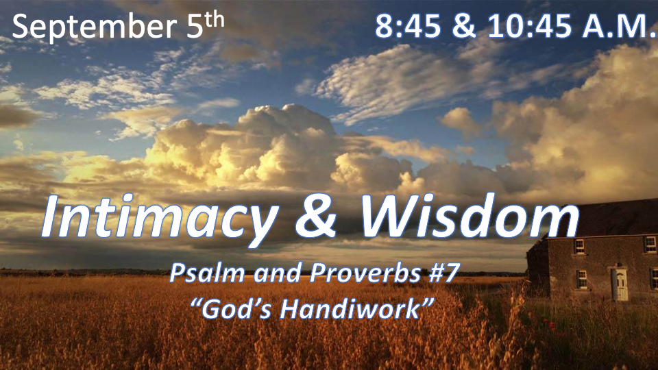

*What you think about God determines how you think about everything else.

*Psalm 19:1 The heavens declare the glory of God; the skies proclaim the work of his hands.
2 Day after day they pour forth speech; night after night they reveal knowledge.
3 They have no speech; they use no words; no sound is heard from them.
4 Yet their voice goes out into all the earth, their words to the ends of the world. In the heavens God has pitched a tent for the sun.
5 It is like a bridegroom coming out of his chamber, like a champion rejoicing to run his course.
6 It rises at one end of the heavens and makes its circuit to the other; nothing is deprived of its warmth.
7 The law of the LORD is perfect, refreshing the soul. The statutes of the LORD are trustworthy, making wise the simple.

*What part of creation declares God’s glory?

*1.6 million species of fungi
*10 thousand species of ants
*300,000 thousand species of flowering plants
*4 – 5 thousand species of mammals
*10 thousand species of birds
~Edward Wilson Biologist

- V:1-3 The heavens declare the glory of God. There are more than 200 billion galaxies in our Universe. (NASA) This 2021 estimate and it’s down from the 2016 est. of 2 Trillion.
- Each galaxy can have 10 million to 1 trillion stars orbiting around a center of gravity.
- Most galaxies are several thousand to several hundred thousand light-years in diameter.
- He knows the stars and calls them by name. *Psalm 147:4 He determines the number of the stars and calls them each by name.

- V:4 What’s the message of the stars?
- *Isaiah 40:25 "To whom will you compare me? Or who is my equal?" says the Holy One.
- *Isaiah 40:26 Lift up your eyes and look to the heavens: Who created all these? He who brings out the starry host one by one and calls forth each of them by name. Because of his great power and mighty strength, not one of them is missing.

- V:1-4 (KJV) *2 Day unto day uttereth speech, and night unto night sheweth knowledge.
3 There is no speech nor language, where their voice is not heard. V:1-4 _________________

*Psalm 19:8 The precepts of the LORD are right, giving joy to the heart. The commands of the LORD are radiant, giving light to the eyes.
9 The fear of the LORD is pure, enduring forever. The decrees of the LORD are firm, and all of them are righteous.
10 They are more precious than gold, than much pure gold; they are sweeter than honey, than honey from the honeycomb.
11 By them your servant is warned; in keeping them there is great reward.

*God’s Glory is connected to what He values.

- How is what God values determined?
- By the amount of scripture devoted to it. (_______________________)
- Value is determined by its cost. (______________________________)
- His Word is pure. Psalm 119:140 (Thoroughly tested) & Proverbs 30:5 (Flawless)
- His Word is above His name. Psalm 138:2

- V:8-9 God’s precepts, commands are radiant and His decrees are firm (stable).

- V:10 The Value of the Word is MORE precious than pure gold and sweeter than honey than from the honeycomb.

*Psalm 19:12 But who can discern their own errors? Forgive my hidden faults.
13 Keep your servant also from willful sins; may they not rule over me. Then I will be blameless, innocent of great transgression.
14 May these words of my mouth and this meditation of my heart be pleasing in your sight, LORD, my Rock and my Redeemer.

*Intimacy of God’s Word and the Last Days.

- V:12 The error of this generation is not giving God glory for His creation and His Word.

- V:13 Our real hope is in the same God who created the Universe, who brought this amazing Word of God to life. Our prayer is, Lord, to keep us from willful sins.

- V:14 The words of my mouth reveal what I’ve been meditating on.

