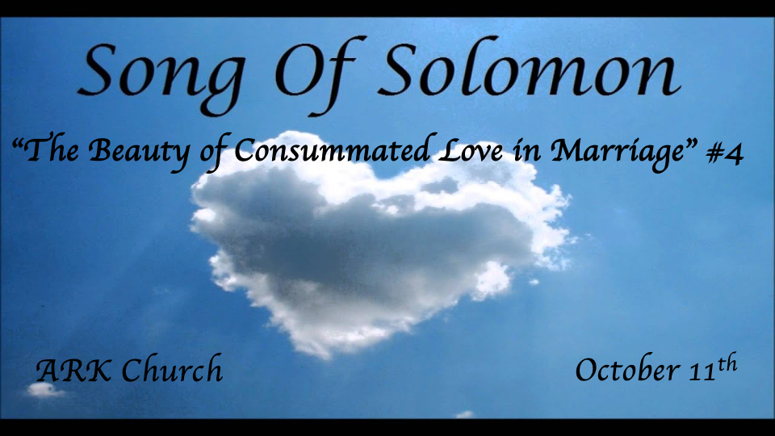
Reflections:
- Preparing for the Wedding feast
- At the Wedding banquet
- In the Bridal chambers (Shulamite)
- Courtship & the pain of separation
- The Wedding Procession (Shulamite)
- The Wedding Night (The Beloved) except for Chapter 4:16

The Shulamite’s Words are 50% of the Song of Songs.

*The Seven-fold Praise of Her Beauty.
*Song of Solomon 4:1-8

1 Behold, you are fair, my love!
Behold, you are fair!
You have dove’s eyes behind your veil.
Your hair is like a flock of goats,
Going down from Mount Gilead.
2 Your teeth are like a flock of shorn sheep
Which have come up from the washing,
Every one of which bears twins,
And none is barren among them.
3 Your lips are like a strand of scarlet,
And your mouth is lovely.
Your temples behind your veil
Are like a piece of pomegranate.
4 Your neck is like the tower of David,
Built for an armory,
On which hang a thousand bucklers,
All shields of mighty men.
5 Your two breasts are like two fawns,
Twins of a gazelle,
Which feed among the lilies.
6 Until the day breaks
And the shadows flee away,
I will go my way to the mountain of myrrh
And to the hill of frankincense.
7 You are all fair, my love,
And there is no spot in you.
8 Come with me from Lebanon, my spouse,
With me from Lebanon.
Look from the top of Amana,
From the top of Senir and Hermon,
From the lions’ dens,
From the mountains of the leopards.

Insights V:1 Hair in the Bible speaks of two things. He is speaking in Allegory, but there is a literal application.
Consecration for the Nazarites they were not to cut their hair as a sign of commitment. (Samson) Judges 13:5
Submission for the woman and the hair was considered her glory. I Corinthians 11:15

Insights V:2-3 Idioms about a woman’s looks that were flattery in Solomon’s day. But more!
(Allegory) Teeth and none are missing. Hebrews 5: the mature can digest the strong meat of the Word. She will not leave any part of the Word of God.
Lips as scarlet. The Scarlet Thread was Salvation for Rehab. Thin lips were more desirable in this age.
Temples like pomegranate. In the Lord’s temple, the redness of pomegranate is an important color. Jer. 52:22. Was there a play on words too? Pomegranates were a part of the rank on the hem of the garment for men.

Insights V:4-5 Her sexuality is much more than her ability to have sex.
Her neck idiom is one of royalty and power. The husband may be the head, but the wife is the neck that turns the head. The term here was of nobility and character.
Her breast idioms are described as two fawns. There is pleasure in petting and playing with them.
The Allegory actually has a very unique connection to the Bible.
The Two Testaments of the Bible. Love them, and don’t let go of them.
At this time, the Rabbis wrongly put the reading of Song of Songs to those only over 30 years of age.

Insights V:6-8 A whole night of the sanctity of Love and oneness. V:7 No spot in you is a reference to lamb or heifer without blemish.
The idiom is the adventure of traveling to ecstatic heights and pleasure, describing the transformation of the fear of the lion’s den to the joy of marital love.

*The Sixth Reflection: The Wedding Night
*Song of Solomon 4:9—5:1

9 You have ravished my heart,
My sister, my spouse;
You have ravished my heart
With one look of your eyes,
With one link of your necklace.
10 How fair is your love,
My sister, my spouse!
How much better than wine is your love,
And the scent of your perfumes
Than all spices!
11 Your lips, O my spouse,
Drip as the honeycomb;
Honey and milk are under your tongue;
And the fragrance of your garments
Is like the fragrance of Lebanon.
12 A garden enclosed
Is my sister, my spouse,
A spring shut up,
A fountain sealed.
13 Your plants are an orchard of pomegranates
With pleasant fruits,
Fragrant henna with spikenard,
14 Spikenard and saffron,
Calamus and cinnamon,
With all trees of frankincense,
Myrrh and aloes,
With all the chief spices—
15 A fountain of gardens,
A well of living waters,
And streams from Lebanon.
The Shulamite
16 Awake, O north wind,
And come, O south!
Blow upon my garden,
That its spices may flow out.
Let my beloved come to his garden
And eat its pleasant fruits.
The Beloved
5:1 I have come to my garden, my sister, my spouse;
I have gathered my myrrh with my spice;
I have eaten my honeycomb with my honey;
I have drunk my wine with my milk.
Eat, O friends!
Drink, yes, drink deeply,
O beloved ones!

Insight V:9-10: A love engraved into the married couple's hearts.
Notice it is a heart connection then a physical one. The sister and spouse is saying they are now family.

Insights V:11-15 The details of creating an environment for romance, not just sex. It’s for the joy of the celebration of what God made sacred.
V:12 Her sexuality was sealed only to be accessed by the rightful owner.
God allows such beautiful graphic descriptions here because it takes us back to the garden of Eden, where God declares it’s not good for man to be alone.
We are literally celebrating the creation of sex that God gave humanity in this situation. All other sexual situations do not have this splendor.

V:16 A married woman is free in her sexuality because of the safety of the marital bed.
The garden, she now declares it’s his garden. Nowhere in the Bible do we ever see a public garden? For the young ladies, it is a private garden until marriage, when they freely give themselves to the groom.

Insights 5:1 The night is celebrated as the anniversary that brought us to a new beginning.
The closing statement to eat and drink deeply is a call from God to celebrate His gift to humanity, marriage, and martial bed.

