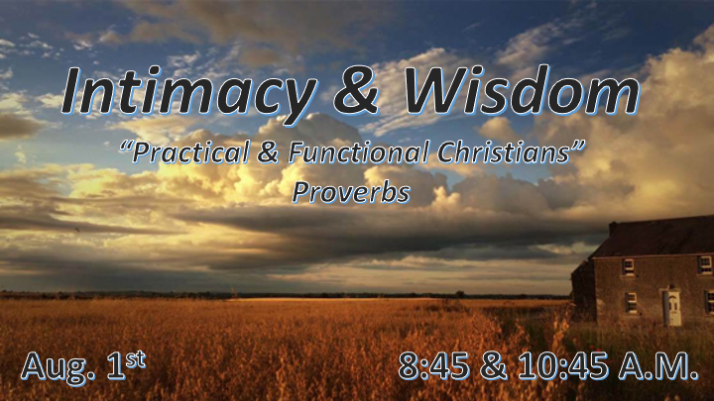

*Are you a functional Christian?

Overview of Proverbs

- The goal of this book is to bring wisdom to our world.
- Three people are continually warned. The simple, the fool, and the scorner/mocker. Their destinies are revealed.
- The prophetic voice speaks to all who love knowledge and seeks wisdom. It will bring judgement to all others.

Proverbs 1:1 The proverbs of Solomon son of David, king of Israel:
2 for gaining wisdom and instruction; for understanding words of insight;
3 for receiving instruction in prudent behavior, doing what is right and just and fair;
4 for giving prudence to those who are simple, knowledge and discretion to the young—
5 let the wise listen and add to their learning, and let the discerning get guidance—
6 for understanding proverbs and parables, the sayings and riddles of the wise.
7 The fear of the LORD is the beginning of knowledge, but fools despise wisdom and instruction.

*Why do we need wise Christians?

- V:2 Without insight Christians will fall away from God. What is the path to wisdom?
*Knowledge + Understanding = Wisdom, but only when it is applied.

- V:3-5 Christians who hear the Word of God and add it to their behavior, are revealing their wisdom to others. Those who don’t will...

- V:6-7 Embracing all of God’s Word enables us to know the deeper things of God. What is the true basis for wisdom? *Jeremiah 9:23-24 This is what the LORD says: "Let not the wise boast of their wisdom or the strong boast of their strength or the rich boast of their riches,
24 but let the one who boasts boast about this: that they have the understanding to know me, that I am the LORD, who exercises kindness, justice and righteousness on earth, for in these I delight," declares the LORD.

*Proverbs 1:8 Listen, my son, to your father's instruction and do not forsake your mother's teaching.
9 They are a garland to grace your head and a chain to adorn your neck.
10 My son, if sinful men entice you, do not give in to them.

*Learning what to embrace and what to shun is the secret of family wisdom.

- Fathers and Mothers are a tag team. Exodus 20:12 & Leviticus 19:3

- Where does wisdom begin? Romans 1:19-20

- The enticement will come to all. 1st Corinthians 10:13

*Proverb 1:20 Out in the open wisdom calls aloud, she raises her voice in the public square;
21 on top of the wall she cries out, at the city gate she makes her speech:
22 "How long will you who are simple love your simple ways? How long will mockers delight in mockery and fools hate knowledge?
23 Repent at my rebuke! Then I will pour out my thoughts to you, I will make known to you my teachings.
24 But since you refuse to listen when I call and no one pays attention when I stretch out my hand,
25 since you disregard all my advice and do not accept my rebuke,
26 I in turn will laugh when disaster strikes you; I will mock when calamity overtakes you—
27 when calamity overtakes you like a storm, when disaster sweeps over you like a whirlwind, when distress and trouble overwhelm you.
28 "Then they will call to me but I will not answer; they will look for me but will not find me,
29 since they hated knowledge and did not choose to fear the LORD.

*A Generation that doesn’t have wisdom won’t understand rebukes.

- Proverbs 1:20-21 Out in the open in the public square. At the city gate, she makes her speech.

- V:22-28 Repent is not a rebuke. To the simple your need is discernment, to the fool, your need is to accept instruction, to the mockers you must stop your rejection of truth and of God.

- V:29 Hating knowledge that points to our Creator is the mark of a mocker. Choosing not to fear the Lord is a warning to all of us.

- Jeremiah the Prophet spoke these truths!
*Jeremiah 5:21 Hear this, you foolish and senseless people, who have eyes but do not see, who have ears but do not hear:
22 Should you not fear me?" declares the LORD. “Should you not tremble in my presence? I made the sand a boundary for the sea, an everlasting barrier it cannot cross. The waves may roll, but they cannot prevail; they may roar, but they cannot cross it.
23 But these people have stubborn and rebellious hearts; they have turned aside and gone away.
24 They do not say to themselves, 'Let us fear the LORD our God, who gives autumn and spring rains in season, who assures us of the regular weeks of harvest.'
25 Your wrongdoings have kept these away; your sins have deprived you of good.

*God connects fearing Him and understanding the power of boundaries as wisdom.

