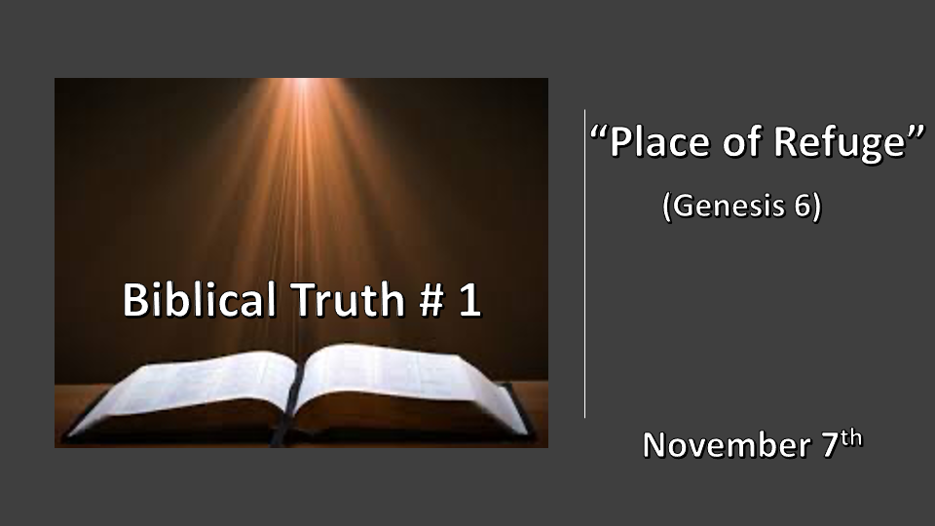

*“Sanctify them by the truth; your word is truth." John 17:17

1. Creation foundation #1 Chaos to Order
2. Creation foundation #2 Made in God’s image
3. Creation foundation #3 The 1st institution Marriage
4. Creation foundation #4 Understanding Sin
5. Creation foundation #5 The Path to Life (5 Biblical building blocks for humanity)

*Proverbs 18:13 (NJKV) He who answers a matter before he hears it, it is folly and shame unto him.

*Genesis 6:1 When human beings began to increase in number on the earth and daughters were born to them, 2 the sons of God saw that the daughters of humans were beautiful, and they married any of them they chose. 3 Then the LORD said, "My Spirit will not contend with humans forever, for they are mortal; their days will be a hundred and twenty years."

4 The Nephilim were on the earth in those days—and also afterward—when the sons of God went to the daughters of humans and had children by them. They were the heroes of old, men of renown.

5 The LORD saw how great the wickedness of the human race had become on the earth, and that every inclination of the thoughts of the human heart was only evil all the time. 6 The LORD regretted that he had made human beings on the earth, and his heart was deeply troubled. 7 So the LORD said, "I will wipe from the face of the earth the human race I have created—and with them the animals, the birds and the creatures that move along the ground—for I regret that I have made them." 8 But Noah found favor in the eyes of the LORD.
9 This is the account of Noah and his family. Noah was a righteous man, blameless among the people of his time, and he walked faithfully with God. 10 Noah had three sons: Shem, Ham, and Japheth.

*Understanding Genesis 6 is foundational to understanding most of the O. T.

- V:1-4 The Creation of Hybrid humans. This is a violation against our Biblical foundation #2 made in God’s image. The sons of Gods is the term of direct creation from God. Only Adam is a direct creation. Seth was created in Adam’s image which now has a fallen nature. Genesis 5:3
- Sons of God are fallen angels. (Jude 1:6-7) & (2 Peter 2:4-5)
- Daughters of humans are fully human.
- Nephilim is the hybrid of a half-angel and half-human. (Numbers 13:33 NIV)

- V:5-7 Wickedness and the thoughts of the heart are evil are the descriptions of the day of Noah.
- Wrath is sent as the remedy when the cup of sin becomes full.
- *Wrath was sent to protect the bloodline of the Messiah. *Genesis 3:15 (NKJV) And I will put enmity between you and the woman, and between your seed and her Seed; He shall bruise your head, And you shall bruise His heel.”

- *V:8-10 Noah was blameless? (His ancestry had a clean bloodline.)
- Righteousness and holiness were taught to each generation.
- The price of redemption was practiced by his ancestors. (Genesis 8:20)

*Genesis 6:11 Now the earth was corrupt in God's sight and was full of violence. 12 God saw how corrupt the earth had become, for all the people on earth had corrupted their ways. 13 So God said to Noah, "I am going to put an end to all people, for the earth is filled with violence because of them. I am surely going to destroy both them and the earth. 14 So make yourself an ark of cypress wood; make rooms in it and coat it with pitch inside and out. 15 This is how you are to build it: The ark is to be three hundred cubits long, fifty cubits wide, and thirty cubits high. 16 Make a roof for it, leaving below the roof an opening one cubit high all around. Put a door in the side of the ark and make lower, middle, and upper decks. 17 I am going to bring floodwaters on the earth to destroy all life under the heavens, every creature that has the breath of life in it. Everything on earth will perish. 18 But I will establish my covenant with you, and you will enter the ark—you and your sons and your wife and your sons' wives with you. 19 You are to bring into the ark two of all living creatures, male and female, to keep them alive with you. 20 Two of every kind of bird, of every kind of animal and of every kind of creature that moves along the ground will come to you to be kept alive. 21 You are to take every kind of food that is to be eaten and store it away as food for you and for them."

22 Noah did everything just as God commanded him.

*A place of safety before the wrath of God.

- Genesis 6:11-13 Total destruction is an example of eternal judgment.
- Joshua 6:21 The total destruction of the city and people of Jericho. (Was it also to kill off the bloodline again of the Nephilim?)

- Genesis 15:16 After 400 years the sins of the Amorites become full. (There is no refuge from sin, only deliverance. There is a refuge from the wrath of God, it’s the blood of the lamb.)

- Genesis 6:14-17 Build a place of refuge. Cities of refuge so that the blood of murders won’t destroy the land. (Numbers 35:6-34)

- Genesis 6: 18-22 Our God is a covenant maker. Are you living under the blood covenant?
(The Covenant is an ark a place of refuge.)

*Genesis 7:1 The LORD then said to Noah, "Go into the ark, you and your whole family, because I have found you righteous in this generation. 2 Take with you seven pairs of every kind of clean animal, a male and its mate, and one pair of every kind of unclean animal, a male and its mate, 3 and also seven pairs of every kind of bird, male and female, to keep their various kinds alive throughout the earth. 4 Seven days from now I will send rain on the earth for forty days and forty nights, and I will wipe from the face of the earth every living creature I have made."
*Genesis 7:16 The animals going in were male and female of every living thing, as God had commanded Noah. Then the LORD shut him in.

- Genesis 7:1-4 God has a plan for the righteous and an escape route before the wrath. (Matthew 24:37)
- Genesis 7:16 When God shuts you in nothing will harm you. (Revelation 3:7) & (Job 38)

