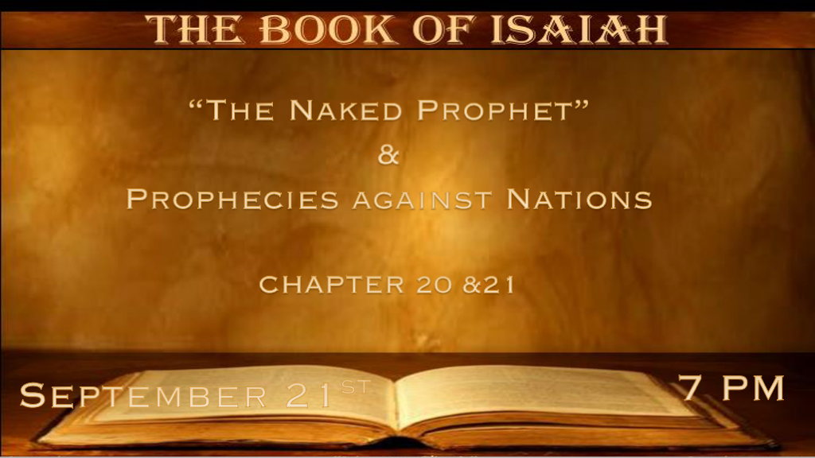

*Visible Signs often have a deeper meaning.

*Isaiah 20:1 In the year that Tartan came to Ashdod, when Sargon the king of Assyria sent him, and he fought against Ashdod and took it, 2 at the same time the LORD spoke by Isaiah the son of Amoz, saying, “Go, and remove the sackcloth from your body, and take your sandals off your feet.” And he did so, walking naked and barefoot.
3 Then the LORD said, “Just as My servant Isaiah has walked naked and barefoot three years for a sign and a wonder against Egypt and Ethiopia, 4 so shall the king of Assyria lead away the Egyptians as prisoners and the Ethiopians as captives, young and old, naked and barefoot, with their buttocks uncovered, to the shame of Egypt. 5 Then they shall be afraid and ashamed of Ethiopia their expectation and Egypt their glory. 6 And the inhabitant of this territory will say in that day, ‘Surely such is our expectation, wherever we flee for help to be delivered from the king of Assyria; and how shall we escape?’ ”

- V:1-2 Remove the sackcloth. This is a sign that God is declaring the time of grieving is over. God has asked other prophets to be the message physically. Ezekiel 4:9
Ezekiel is asked to lay on his side for 390 days.
The message was humility and poverty were coming to the Egyptians and Cush (Ethiopians and Sudan) in 711 B.C.

- V:3-4 Three years of humiliation. The prophet’s three years of obedience brought 3 years of judgment to Egypt. These events are historical but could have future meanings too.
The public shame of a country is a powerful tool used for correction if the correction is done destruction follows.

- V:5-6 There’s no place for security outside of God’s will.
Judah felt the consequences of looking to Egypt for help instead of to God.
How shall we escape is the question of the day.

*The Omniscient God knows Empires and their destinies before they are born.

*Isaiah 21:1 The burden against the Wilderness of the Sea. As whirlwinds in the South pass through, so it comes from the desert, from a terrible land. 2 A distressing vision is declared to me; The treacherous dealer deals treacherously, and the plunderer plunders. Go up, O Elam! Besiege, O Media! All its sighing I have made to cease.
3 Therefore my loins are filled with pain; Pangs have taken hold of me, like the pangs of a woman in labor. I was distressed when I heard it; I was dismayed when I saw it. 4 My heart wavered, fearfulness frightened me; The night for which I longed He turned into fear for me. 5 Prepare the table, set a watchman in the tower, eat and drink. Arise, you princes, anoint the shield! 6 For thus has the Lord said to me: “Go, set a watchman, let him declare what he sees.”
7 And he saw a chariot with a pair of horsemen, a chariot of donkeys, and a chariot of camels, and he listened earnestly with great care. 8 Then he cried, “A lion, my Lord! I stand continually on the watchtower in the daytime;
I have sat at my post every night. 9 And look, here comes a chariot of men with a pair of horsemen!” Then he answered and said, “Babylon is fallen, is fallen! And all the carved images of her gods He has broken to the ground.”
10 Oh, my threshing and the grain of my floor! That which I have heard from the LORD of hosts, The God of Israel,
I have declared to you.

- V:1-3 Isaiah prophesied about the Medes/Persian empire destroying the Babylonian empire.
God’s omniscient power is revealed as Babylon has not risen to power and the Persian empire won’t even come on the scene for over one hundred years.

- V:4-8 The importance of the watchmen. Let them declare what they see.
Who is keeping you ready and helping you understand the times? Birth pains teach us about the end times.
- V:9-10 Parallel events. Horsemen riding and Babylon is fallen, is fallen! Revelation 6 & 14:8
and Revelation 18:2
When Babylon was conquered by Cyrus/Alexander, they did not destroy the idols. Cyrus/Alexander used Babylon as their capital it has never been destroyed only left to ruins.

*The Watchmen Message Return to God, Come Back!

*Isaiah 21:11 The burden against Dumah. He calls to me out of Seir, “Watchman, what of the night?
Watchman, what of the night?” 12 The watchman said, “The morning comes, and also the night. If you will inquire, inquire; Return! Come back!”
13 The burden against Arabia. In the forest in Arabia you will lodge, O you traveling companies of Dedanites.
14 O inhabitants of the land of Tema, bring water to him who is thirsty; With their bread they met him who fled.
15 For they fled from the swords, from the drawn sword, from the bent bow, and from the distress of war.
16 For thus the LORD has said to me: “Within a year, according to the year of a hired man, all the glory of Kedar will fail; 17 and the remainder of the number of archers, the mighty men of the people of Kedar, will be diminished; for the LORD God of Israel has spoken it.”

- V:11-12 If you can return or come back implying at one time there was a relationship.
This being spoken to gentiles has great implications for our day and time.

- V:13-17 Bring water (Jesus is the living water) and bring bread (Jesus is the bread of life).
Isaiah is using tribal names of what are nations today. Nations change names in history the tribal names give us the root of who the people are.

*Feast of Trumpets

- *The Classical rapture theories. The day that no one knows the day or the hour. (Matt. 24:36). Because the moon is invisible to the eye. The Church is the lesser light or the moon. (Isaiah 26:20) The bride is hidden in her chambers while the wrath passes the earth.

- *The theme of the “Trumpets”. The purpose of blowing the shofar is to awaken God’s compassion toward His people. They are required to blow it 30 times but tradition has them blowing it 100 times. The warnings are to bring the people to redemption. (Leviticus 23:24)

- *The heavenly signs point to the feast this year. Jupiter known as the king planet will be the closest to the earth in 70 years. The King is in the field month Elul ends on sundown Sunday the 25th.

- *Wedding reminders some traditional Jews say this points to Adam and Eve. This year seven years from the signs from the moon (The Church is the moon). It starts on Sunday at sundown and ends on Tuesday at sundown the double blessed wedding day. (Genesis 1:9-13 & John 2:3-10)

- *The season of grace can only continue while the righteous are here. (Genesis 7:1) & (Genesis18:24-32)
(Luke 17:26-30)

