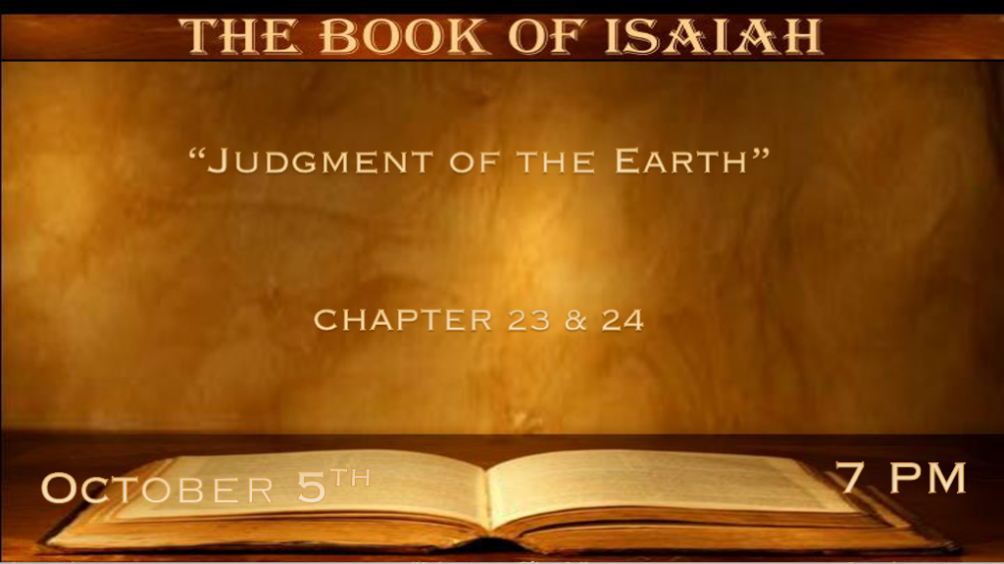

*God Reveals His Omniscient Power. (Read Chapter 23 at home)
*Isaiah 23:1 The burden against Tyre. Wail, you ships of Tarshish! For it is laid waste, so that there is no house, no harbor;
From the land of Cyprus it is revealed to them. 2 Be still, you inhabitants of the coastland, you merchants of Sidon, whom those who cross the sea have filled. 3 And on great waters the grain of Shihor, the harvest of the River, is her revenue;
And she is a marketplace for the nations. 4 Be ashamed, O Sidon; For the sea has spoken, the strength of the sea, saying,
“I do not labor, nor bring forth children; Neither do I rear young men, Nor bring up virgins.” *5 When the report reaches Egypt, they also will be in agony at the report of Tyre. Isaiah 23:6 Cross over to Tarshish; Wail, you inhabitants of the coastland! 7 Is this your joyous city, whose antiquity is from ancient days, whose feet carried her far off to dwell? 8 Who has taken this counsel against Tyre, the crowning city, whose merchants are princes, whose traders are the honorable of the earth? 9 The LORD of hosts has purposed it, to bring to dishonor the pride of all glory, to bring into contempt all the honorable of the earth. 10 Overflow through your land like the River, O daughter of Tarshish; There is no more strength. 11 He stretched out His hand over the sea, he shook the kingdoms; The LORD has given a commandment against Canaan to destroy its strongholds. 12 And He said, “You will rejoice no more, O you oppressed virgin daughter of Sidon. Arise, cross over to Cyprus; There also you will have no rest.” 13 Behold, the land of the Chaldeans, this people which was not; Assyria founded it for wild beasts of the desert. They set up its towers, they raised up its palaces and brought it to ruin. 14 Wail, you ships of Tarshish! For your strength is laid waste. *15 Now it shall come to pass in that day that Tyre will be forgotten seventy years, according to the days of one king. At the end of seventy years it will happen to Tyre as in the song of the harlot: 16 “Take a harp, go about the city, You forgotten harlot; Make sweet melody, sing many songs, that you may be remembered.” 17 And it shall be, at the end of seventy years, that the LORD will deal with Tyre. She will return to her hire, and commit fornication with all the kingdoms of the world on the face of the earth. 18 Her gain and her pay will be set apart for the LORD; it will not be treasured nor laid up, for her gain will be for those who dwell before the LORD, to eat sufficiently, and for fine clothing.

- V:1-15 The background of Chapter 23.
- The Players are God, Tyre, the Phoenicians, Nebuchadnezzar, and Alexander the Great.
- 13 years Nebuchadnezzar tries to destroy Tyre. He finally gives up.
It is essential that Christians believe in the Triune God that is omniscient.

- V:16-17 The Story of the Judgment of Tyre.
- Nebuchadnezzar held a siege around the city of Tyre for thirteen years. The problem was the leaders of Tyre had moved the leadership and all its riches to an island a ½ mile off the coast.
- As prophesied by Isaiah about seventy years later God raised Alexander the Great. Engineers build a causeway to the island. This judgment that Chapter 22 writes about is 332 B.C.
- He cries at the age of 29 because there are no more worlds to conquer. This victory is what made Alexander a legend and the world took notice of the Greek Empire. (Picture in Dropbox)

- V:17-18 Is the return of Tyre a nation in our world today?
Is there a nation today with amazing exports to the world that would go on and commit sins against God by its interactions with the kingdoms of the world? England? The USA?

* “The Great Tribulation” details that the book of Revelation does not give.

*Isaiah 24:1 Behold, the LORD makes the earth empty and makes it waste, distorts its surface and scatters abroad its inhabitants. 2 And it shall be: As with the people, so with the priest; As with the servant, so with his master; As with the maid, so with her mistress; As with the buyer, so with the seller; As with the lender, so with the borrower; As with the creditor, so with the debtor. 3 The land shall be entirely emptied and utterly plundered, for the LORD has spoken this word.
4 The earth mourns and fades away, the world languishes and fades away; the haughty people of the earth languish. 5 The earth is also defiled under its inhabitants, because they have transgressed the laws, changed the ordinance, broken the everlasting covenant. 6 Therefore the curse has devoured the earth, and those who dwell in it are desolate. Therefore the inhabitants of the earth are burned, and few men are left.

- V:1-2 No one is exempt. Complete in scope to all, if you were rich, connected, or just lucky you can’t escape the consequences of your choices in the Great Tribulation.
The time to escape all that is about to happen is now!

- V:3-4 Suffering is the rule, not the exception. This is true for the land as well as all the inhabitants of the earth.

- V:5-6 A broken world and lawlessness.
- *Sins (transgression) willfully changing natural biology and gender is the prophecy.

- *Changing the Ordinances/Decrees/Laws: The Torah is implied and the O.T. verifies that before you were formed in your mother’s womb He knew you. New laws that honor the sin of abortion.

- *Everlasting covenants are broken. This could be implying Marriage.

- *Therefore, the curse is upon the world. Burning is a purifying punishment.

*Delusional thinking believes everything will return to normal.

*Isaiah 24:7 The new wine fails, the vine languishes, all the merry-hearted sigh. 8 The mirth of the tambourine ceases,
the noise of the jubilant ends, the joy of the harp ceases. 9 They shall not drink wine with a song; Strong drink is bitter to those who drink it. 10 The city of confusion is broken down; Every house is shut up, so that none may go in. 11 There is a cry for wine in the streets, all joy is darkened, the mirth of the land is gone. 12 In the city desolation is left, and the gate is stricken with destruction. 13 When it shall be thus in the midst of the land among the people, It shall be like the shaking of an olive tree, like the gleaning of grapes when the vintage is done.

- V:7-9 All the merry-hearted is stopped. As the pandemic hit in 2020 everyone looked for those days to return to normal.
God was looking to see who would return to Him. The Church has not returned to God.

- V:10-11 The cities are broken down. Every house is shut up or covered. (Could be bars on the houses)
The confusion in the cities is already being felt. You can steal from stores as long as it is less than a thousand dollars. Cities have defunded the police in order to teach who a lesson?

- V:12-13 The cities will look like bare trees. Again implying the stripping of protection and life the cities are being emptied.
The Bible has an integrated message system and you don’t have to wait till the book of Revelation to figure out the future.

*Salvation is still available and the remnant will sing.
*Isaiah 24:14 They shall lift up their voice, they shall sing; For the majesty of the LORD they shall cry aloud from the sea. 15 Therefore glorify the LORD in the dawning light, the name of the LORD God of Israel in the coastlands of the sea. 16 From the ends of the earth we have heard songs: “Glory to the righteous!” But I said, “I am ruined, ruined! Woe to me! The treacherous dealers have dealt treacherously, indeed, the treacherous dealers have dealt very treacherously.” 17 Fear and the pit and the snare are upon you, O inhabitant of the earth. 18 And it shall be that he who flees from the noise of the fear shall fall into the pit, and he who comes up from the midst of the pit shall be caught in the snare; For the windows from on high are open, and the foundations of the earth are shaken. 19 The earth is violently broken, the earth is split open, the earth is shaken exceedingly. 20 The earth shall reel to and fro like a drunkard, and shall totter like a hut; Its transgression shall be heavy upon it, and it will fall, and not rise again. 21 It shall come to pass in that day that the LORD will punish on high the host of exalted ones, and on the earth the kings of the earth. 22 They will be gathered together, as prisoners are gathered in the pit, and will be shut up in the prison; after many days they will be punished. 23 Then the moon will be disgraced and the sun ashamed; For the LORD of hosts will reign on Mount Zion and in Jerusalem and before His elders, gloriously.

- V:14-16 The remnant’s holy zeal. They will deal with deceitfulness & ruin but, they will be saved.
Never underestimate the power of the Holy Spirit even in this age.

- V:17-20 The earth is shaken and broken. This is a physical literal description alongside the reality of what happens when you live deceived.
Fear will be the norm for all. This will be the righteousness of God revealing His eternal justice.

- V:21-23 The punishment will go beyond humanity and the earth.
The fallen angels are punished during this period.

