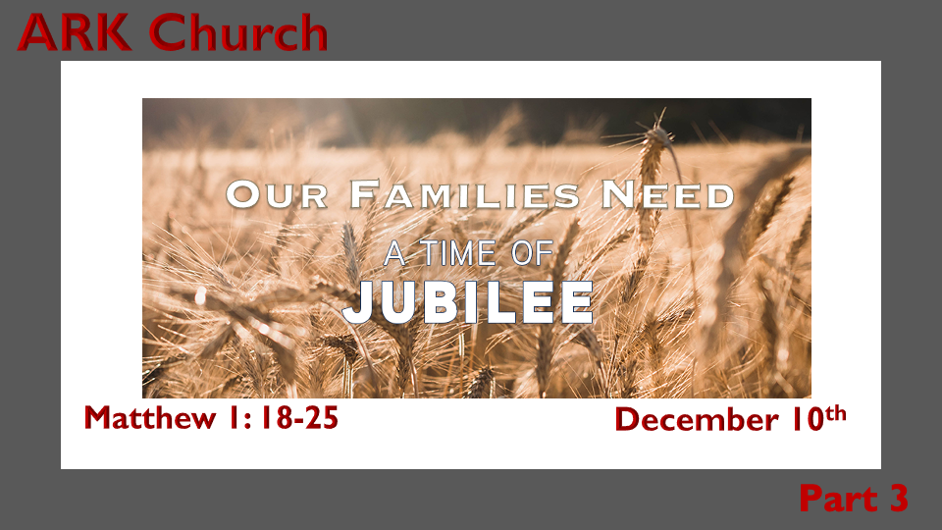

*Advent is the (simple) story of God's son coming from heaven. (The supernatural birth event)
*The Jubilee is the (complex) story about Jesus' life bringing restoration to all humanity.

*Jubilee is a multifaceted overriding of law and biology. (7Pictures)

- Jubilee, the key to Jesus' return?
- Jubilee's possible timeline.
- The Year of the Lord's Favor.
- Freedom from all Debts.
- Jubilee the sound of freedom at the ram's horn
- The Land is freed to its rightful owner. (God is the Creator of the Land)
- 30 bible verses for Jubilee

Why Jubilee is the need of every family.
*Genesis 3:13c The woman said, "The serpent deceived me, and I ate."
14 So the LORD God said to the serpent: "Because you have done this, you are cursed more than all cattle, and more than every beast of the field; On your belly you shall go, and you shall eat dust all the days of your life. 15 And I will put enmity between you and the woman, and between your seed and her Seed; He shall bruise your head, and you shall bruise His heel."

*Isaiah 7:14 Therefore the Lord Himself will give you a sign: Behold, the virgin shall conceive and bear a Son, and shall call His name Immanuel.

A Woman does NOT have a seed, but God declared one woman would be known in the future because of her seed. Jubilee was promised in the Garden.

*Christmas with a Capital "C." (Jubilee & Family)

The Back Story to the Story of God of a Child is born and a Son is given. Isaiah 9:6

*Matthew 1:18 Now the birth of Jesus Christ was as follows: After His mother Mary was betrothed to Joseph, before they came together, she was found with child of the Holy Spirit. 19 Then Joseph her husband, being a just man, and not wanting to make her a public example, was minded to put her away secretly. 20 But while he thought about these things, behold, an angel of the Lord appeared to him in a dream, saying, "Joseph, son of David, do not be afraid to take to you Mary your wife, for that which is conceived in her is of the Holy Spirit. 21 And she will bring forth a Son, and you shall call His name JESUS, for He will save His people from their sins."
22 So all this was done that it might be fulfilled which was spoken by the Lord through the prophet, saying: 23 "Behold, the virgin shall be with child, and bear a Son, and they shall call His name Immanuel," which is translated, "God with us."
24 Then Joseph, being aroused from sleep, did as the angel of the Lord commanded him and took to him his wife, 25 and did not know her till she had brought forth her firstborn Son. And he called His name JESUS.

Insights for V:18-21 When your future looks like it's destroyed by natural circumstances, look again.

- Joseph loved and cared for Mary; he wouldn't publicly shame her or open her to harm.
- It took a divorce to get out of betrothal.
- God didn't clue him in before the fact, but the facts looked like his future with Mary was gone. The reality of his future became the honor of a lifetime.
- In one night, Joseph went from the obscurity of a carpenter to the servant of the most High God.
- The Messiah's passage in this world would be Joseph's responsibility.

Insights for V:22-25 When you discover you are in a Jubilee moment, do what Joseph did.

- You may be the fulfillment of someone's prayers. You could be ready to experience your life's most exciting faith adventure.

- Rise up to your calling. God is about to be honored through your life!

*The Mysteries within Jubilee & The Family.

*Isaiah 61:1 (ASV) The Spirit of the Lord Jehovah is upon me; because Jehovah hath anointed me to preach good tidings unto the meek; he hath sent me to bind up the broken-hearted, to proclaim liberty to the captives, and the opening of the prison to them that are bound; 2 to proclaim the year of Jehovah's favor, and the day of vengeance of our God; to comfort all that mourn; 3 to appoint unto them that mourn in Zion, to give unto them a garland for ashes, the oil of joy for mourning, the garment of praise for the spirit of heaviness; that they may be called trees of righteousness, the planting of Jehovah, that he may be glorified.
4 And they shall build the old wastes, they shall raise up the former desolations, and they shall repair the waste cities, the desolations of many generations. 5 And strangers shall stand and feed your flocks, and foreigners shall be your plowmen and your vine-dressers. 6, But ye shall be named the priests of Jehovah; men shall call you the ministers of our God: ye shall eat the wealth of the nations, and in their glory shall ye boast yourselves. 7 Instead of your shame ye shall have double; and instead of dishonor they shall rejoice in their portion: therefore in their land they shall possess double; everlasting joy shall be unto them. 8 For I, Jehovah, love justice, I hate robbery with iniquity; and I will give them their recompense in truth, and I will make an everlasting covenant with them. 9 And their seed shall be known among the nations, and their offspring among the peoples; all that see them shall acknowledge them, that they are the seed which Jehovah hath blessed.

*Insights to the Jubilee: Restoration that God can only do.

- Every family has experienced broken hearts. Christmas is God's special time to bind them up.

- Families are in prison for much of what the culture is doing. Christmas Jubilee is the reminder that Jesus sets the captive free.

- Families have generations of ashes from lost lives and dreams. Jubilee wants to do an exchange and give you beauty for ashes, plus turn your mourning into joy.

- Families live in shame over so many things. Jubilee wants to give a double portion of honor.

- Jubilee happens because God loves justice and hates what's robbed you for generations.

