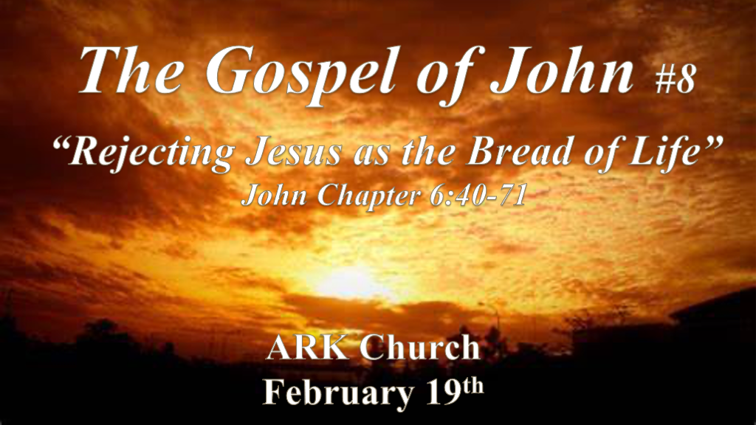

*Grumbling/Murmuring is the 1st Sign of Spiritual Hunger.
*John 6:40 And this is the will of Him who sent Me, that everyone who sees (looks to) the Son and believes in Him may have everlasting life; and I will raise him up at the last day.”
41 The Jews then complained about Him, because He said, “I am the bread which came down from heaven.” 42 And they said, “Is not this Jesus, the son of Joseph, whose father and mother we know? How is it then that He says, ‘I have come down from heaven’?”
43 Jesus therefore answered and said to them, “Do not murmur among yourselves. 44 No one can come to Me unless the Father who sent Me draws him; and I will raise him up at the last day. 45 It is written in the prophets, And they shall all be taught by God.’ Therefore everyone who has heard and learned from the Father comes to Me. 46 Not that anyone has seen the Father, except He who is from God; He has seen the Father. 47 Most assuredly, I say to you, he who believes in Me has everlasting life. 48 I am the bread of life. 49 Your fathers ate the manna in the wilderness, and are dead. 50 This is the bread which comes down from heaven, that one may eat of it and not die. 51 I am the living bread which came down from heaven. If anyone eats of this bread, he will live forever; and the bread that I shall give is My flesh, which I shall give for the life of the world.”

- V:40 God’s will is that you trust fully in His Son Jesus.
Believing in Jesus means more than you know about Him. It means you are in a relationship with Him.

- V:41-45 Taught by God & feed by God spiritual truths are a prophetic promise.
The initiative is always on God’s side. Your hunger is a sign that He is seeking you.

Are you becoming more aware of Biblical truth or do you find yourself doubting & questioning the Spirit of God?

*Is it possible you are hungry for a relationship with God and you have not recognized the signs?

- V:46-49 Supernatural physical bread or needs being met does not produce an eternal life.
Jesus’ life must be that which gives ours meaning. Jesus is the only path to eternal life.

- V:50-51 Seeing bread on a plate won’t satisfy the hunger.
*Seeing is not believing! Understanding who Jesus is isn’t believing.

Having heard the word you received a new noble and good heart, you keep the Word and bear fruit with it.

*Spiritually Hungry People Often Quarrel About What They Should Eat.

*John 6:52 The Jews therefore quarreled among themselves, saying, “How can this Man give us His flesh to eat?”
53 Then Jesus said to them, “Most assuredly, I say to you, unless you eat the flesh of the Son of Man and drink His blood, you have no life in you. 54 Whoever eats My flesh and drinks My blood has eternal life, and I will raise him up at the last day. 55 For My flesh is food indeed, and My blood is drink indeed. 56 He who eats My flesh and drinks My blood abides in Me, and I in him. 57 As the living Father sent Me, and I live because of the Father, so he who feeds on Me will live because of Me. 58 This is the bread which came down from heaven—not as your fathers ate the manna, and are dead. He who eats this bread will live forever.”
59 These things He said in the synagogue as He taught in Capernaum.

- V:52-56 Is Jesus talking about communion?
Yes and No communion is a reminder of the commitment and the price of our relationship with God.

And No, communion in itself will not get you into heaven. Getting to heaven through the sacraments is a Catholic false belief. The reason it is false is taking communion makes us a participant in our salvation. (Works) The work was done through Christ alone.

- V:57-59 A second time Jesus states living off of God’s bread doesn’t remove death. (Moses’ bread)
The Word of God is also consider bread. The fallen angels know the Word of God and the Word cannot save them.

Significantly Jesus taught these truths publicly in the synagogue. These weren’t truths just for His apostles to understand but for the world.

*Many may not profit by knowing they are spiritually hungry.

*John 6:60 Therefore many of His disciples, when they heard this, said, “This is a hard saying; who can understand it?”
61 When Jesus knew in Himself that His disciples complained about this, He said to them, “Does this offend you? 62 What then if you should see the Son of Man ascend where He was before? 63 It is the Spirit who gives life; the flesh profits nothing. The words that I speak to you are spirit, and they are life. 64 But there are some of you who do not believe.” For Jesus knew from the beginning who they were who did not believe, and who would betray Him. 65 And He said, “Therefore I have said to you that no one can come to Me unless it has been granted to him by My Father.”
66 From that time many of His disciples went back and walked with Him no more. 67 Then Jesus said to the twelve, “Do you also want to go away?”
68 But Simon Peter answered Him, “Lord, to whom shall we go? You have the words of eternal life. 69 Also we have come to believe and know that You are the Christ, the Son of the living God.”
70 Jesus answered them, “Did I not choose you, the twelve, and one of you is a devil?” 71 He spoke of Judas Iscariot, the son of Simon, for it was he who would betray Him, being one of the twelve.

- V:60-62 Having difficulty in understanding the hard sayings in the Bible? Offended by what Jesus requires?
*True salvation becomes possible when we are offended by our own sins and realize we are lost.

*1st Corinthians 1:18 For the message of the cross is foolishness to those who are perishing, but to us who are being saved it is the power of God. 19 For it is written: “I will destroy the wisdom of the wise, and bring to nothing the understanding of the prudent.”
20 Where is the wise? Where is the scribe? Where is the disputer of this age? Has not God made foolish the wisdom of this world? 21 For since, in the wisdom of God, the world through wisdom did not know God, it pleased God through the foolishness of the message preached to save those who believe. 22 For Jews request a sign, and Greeks seek after wisdom; 23 but we preach Christ crucified, to the Jews a stumbling block and to the Greeks foolishness, 24 but to those who are called, both Jews and Greeks, Christ the power of God and the wisdom of God. 25 Because the foolishness of God is wiser than men, and the weakness of God is stronger than men.

- V:63-66 It is the Spirit that gives life and any other source is a betrayal.

*The betrayal of God is in a desire to have a genie that serves you instead of a God that saves you.

*1st Corinthians 2:13 These things we also speak, not in words which man’s wisdom teaches but which the Holy Spirit teaches, comparing spiritual things with spiritual. 14 But the natural man does not receive the things of the Spirit of God, for they are foolishness to him; nor can he know them, because they are spiritually discerned.

Those that left Jesus at this time, were never really with Him.

- V:67-71 Jesus has the words of eternal life.

Words of life didn’t deliver Judas.

John 1 Jesus the Word became flesh. Let His Words sustain and keep you and though you may die, Jesus will raise you up on the last day.

