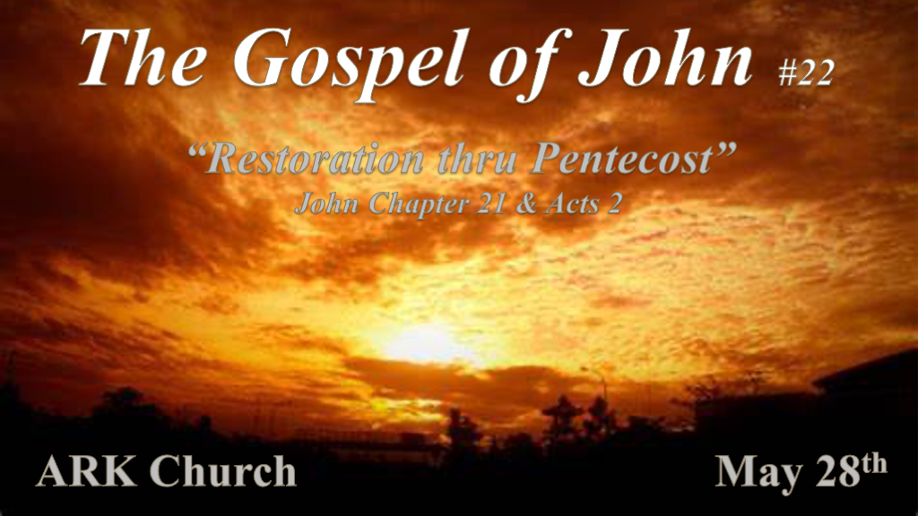

*Restoration and Divine Guidance.

*John 21:1: After these things Jesus showed Himself again to the disciples at the Sea of Tiberias, and in this way He showed Himself: 2 Simon Peter, Thomas called the Twin, Nathanael of Cana in Galilee, the sons of Zebedee, and two others of His disciples were together. 3 Simon Peter said to them, "I am going fishing."
They said to him, "We are going with you also." They went out and immediately got into the boat, and that night they caught nothing. 4 But when the morning had now come, Jesus stood on the shore; yet the disciples did not know that it was Jesus. 5 Then Jesus said to them, "Children, have you any food?" They answered Him, "No."
6 And He said to them, "Cast the net on the right side of the boat, and you will find some." So they cast, and now they were not able to draw it in because of the multitude of fish.
7 Therefore that disciple whom Jesus loved said to Peter, "It is the Lord!" Now when Simon Peter heard that it was the Lord, he put on his outer garment (for he had removed it), and plunged into the sea. 8 But the other disciples came in the little boat (for they were not far from land, but about two hundred cubits), dragging the net with fish. 9 Then, as soon as they had come to land, they saw a fire of coals there, and fish laid on it, and bread. 10 Jesus said to them, "Bring some of the fish which you have just caught."
11 Simon Peter went up and dragged the net to land, full of large fish, one hundred and fifty-three; and although there were so many, the net was not broken. 12 Jesus said to them, "Come and eat breakfast." Yet none of the disciples dared ask Him, "Who are You?"—knowing that it was the Lord. 13 Jesus then came and took the bread and gave it to them, and likewise the fish.
- This is now the third time Jesus showed Himself to His disciples after He was raised from the dead.

- V:1-6 Miracles/Blessings happen when we follow Jesus—parallels to the first miracle in Chapter 2.

They are both in Galilee; the wedding was on the 3rd day this was Jesus' 3rd appearance.
There was no wine in Cana, and there were no fish here.
Jesus instructed them in Cana to fill the water pots, here instructed to cast the nets on the right side of the boat.
The water pots, we are told, were filled to the brim John 2:7 and miraculously changed to wine. The empty nets are marvelously full to beyond capacity with fish.

- V:7-8 (Luke 5:5-10) This same miracle of catching fish happened on the day Peter received his call to follow Jesus.

Jesus uses the same miracle to awaken Peter's spirit. Interestingly, the net broke on the 1st miracle but not this last time.

- V:9-14 Some questions went unanswered within our text.

Was the last time Peter saw the fire of coals was it on the night of his betraying Jesus?
Why is the number of fish recorded 153 of them?
No one dared asked who are you?

*How does God reconcile us to Himself?

*John 21:15 So when they had eaten breakfast, Jesus said to Simon Peter, "Simon, son of Jonah, do you love Me more than these?" He said to Him, "Yes, Lord; You know that I love You." He said to him, "Feed My lambs." 16 He said to him again a second time, "Simon, son of Jonah, do you love Me?" He said to Him, "Yes, Lord; You know that I love You." He said to him, "Tend My sheep." 17 He said to him the third time, "Simon, son of Jonah, do you love Me?" Peter was grieved because He said to him the third time, "Do you love Me?" And he said to Him, "Lord, You know all things; You know that I love You."
Jesus said to him, "Feed My sheep. 18 Most assuredly, I say to you, when you were younger, you girded yourself and walked where you wished; but when you are old, you will stretch out your hands, and another will gird you and carry you where you do not wish." 19 This He spoke, signifying by what death he would glorify God. And when He had spoken this, He said to him, "Follow Me."

- V:15-17 Jesus addresses Peter as if it is the first-time meeting him, calling him Simon, son of Jonah.
*Jesus asks do you love (agapao) me? Peter answers you know I love (Phileo) you. One is God's commitment the other is a friendship commitment.

This happens a second time. On the third time, Jesus says do you love (Phileo) me? Peter is grieved because of the three times. Says, "You know all things you know I love you (Phileo). Jesus is now meeting Peter where he is in his commitment.

Three subtleties in the Greek language to Jesus replying feed my lambs and sheep. The 1st reply was to take care of young lambs, the second was to shepherd the sheep, and the last was to keep feeding or helping mature sheep.

- V:18-19 Jesus uses a future tense of the word to follow.

Keep on following me is what Jesus was saying.
Peter is placed in his own category with his relationship with Jesus. This is how much God loves to have a personal relationship with each person. Don't settle for someone else relationship with God.

*Unique relationships and prophecy fulfillment.

*John 21:20 Then Peter, turning around, saw the disciple whom Jesus loved following, who also had leaned on His breast at the supper, and said, "Lord, who is the one who betrays You?" 21 Peter, seeing him, said to Jesus, "But Lord, what about this man?"
22 Jesus said to him, "If I will that he remain till I come, what is that to you? You follow Me."
23 Then this saying went out among the brethren that this disciple would not die. Yet Jesus did not say to him that he would not die, but, "If I will that he remain till I come, what is that to you?"
24 This is the disciple who testifies of these things, and wrote these things; and we know that his testimony is true.
25 And there are also many other things that Jesus did, which if they were written one by one, I suppose that even the world itself could not contain the books that would be written. Amen.

*Acts 2:14 But Peter, standing up with the eleven, raised his voice and said to them, "Men of Judea and all who dwell in Jerusalem, let this be known to you, and heed my words. 15 For these are not drunk, as you suppose, since it is only the third hour of the day. 16 But this is what was spoken by the prophet Joel: 17 'And it shall come to pass in the last days, says God, that I will pour out of My Spirit on all flesh; Your sons and your daughters shall prophesy, your young men shall see visions, your old men shall dream dreams.

- V:20-23 Jesus reinstates Peter by saying; Follow me V:19.
The inner circle was Peter and John: their seating assignment and the last supper and Peter and John racing to the tomb together. Was there a competition? Maybe?

Peter knew that his assignment was to die for Jesus. However, he also wanted to know how John was going to die.

- V:24-25 How unique is John's Gospel?

John's entire Gospel only covers twenty-one different days of Jesus' life over a three and half period.
Truths are contained in each chapter that isn't in the other Gospels.
The restoration of the Jewish people is within this Gospel. (My personal favorite is the story of the woman at the well.)

- Acts 2:14-17 Prophecy fulfilled and the potential restoration of humanity.

Humanity was separated from God because of the sin in paradise, resulting in human beings being born without God's Spirit. Pentecost allows us to be restored.

Of course, the apostle Peter is the keynote speaker on this day, completing his restoration.

- *I Peter 5:2-4, 2 Shepherd the flock of God which is among you, serving as overseers, not by compulsion but willingly, not for dishonest gain but eagerly; 3 nor as being lords over those entrusted to you, but being examples to the flock; 4 and when the Chief Shepherd appears, you will receive the crown of glory that does not fade away.

