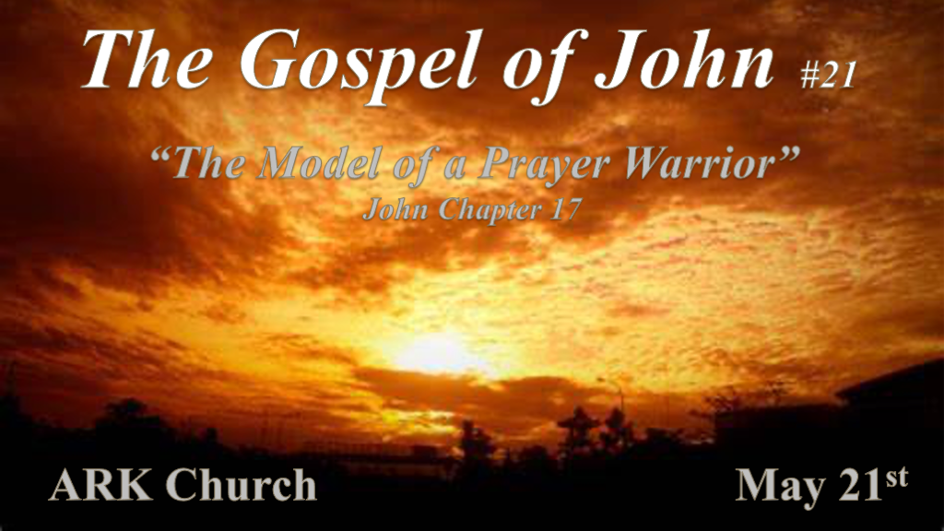
*A PRAYER WARRIOR: Knows who to pray to and why they are praying with a fervor that won't let go.

*Prayer with a Heavenly Purpose.

*John 17:1: Jesus spoke these words, lifted up His eyes to heaven, and said: "Father, the hour has come. Glorify Your Son, that Your Son also may glorify You, 2 as You have given Him authority over all flesh, that He should give eternal life to as many as You have given Him. 3 And this is eternal life, that they may know You, the only true God, and Jesus Christ whom You have sent. 4 I have glorified You on the earth. I have finished the work which You have given Me to do. 5 And now, O Father, glorify Me together with Yourself, with the glory which I had with You before the world was.

- V:1-3 Jesus connects the glory dots in the purpose of prayer.
- V:1 Jesus is not seeking glory for glory's sake but to elevate His Father.
Prayer Warriors see their prayers as a child that runs to their good, good Father.

- V:2 Jesus is praying so others may receive eternal life. (Role model)
The tandem relationship of Jesus and His Father working on our behalf.

- V:3 Jesus understood the cross was a form of humiliation to the world, but it would now be an instrument of purifying creation and glorifying the Father.
Knowing God is Eternal life. It's not knowledge about God but a relationship of knowing Him as God. (Obedience)
Here's a thought: What you think is humiliation now may actually be a jewel in your crown later.

- V:4-5 Jesus' deity is revealed. Isaiah 42:8 & 48:11 Father, glorify your Son is a crucial request.

Isaiah 42:8, 48:11 Says God won't share His glory with anyone.

*Isaiah 42:8 I am the LORD, that is My name; And My glory I will not give to another, nor My praise to carved images.

The Father and Son sharing glory mean they are both Yahweh/God!

The Purpose of the Gospel of John was to leave signs to future generations that Jesus is the Son of God.

*Prayer is to be taught, but when it is manifested, we experience its power.

*John 17:6 "I have manifested Your name to the men whom You have given Me out of the world. They were Yours, You gave them to Me, and they have kept Your word. 7 Now they have known that all things which You have given Me are from You. 8 For I have given to them the words which You have given Me; and they have received them, and have known surely that I came forth from You; and they have believed that You sent Me.
9 "I pray for them. I do not pray for the world but for those whom You have given Me, for they are Yours. 10 And all Mine are Yours, and Yours are Mine, and I am glorified in them. 11 Now I am no longer in the world, but these are in the world, and I come to You. Holy Father, keep through Your name those whom You have given Me, that they may be one as We are. 12 While I was with them in the world, I kept them in Your name. Those whom You gave Me I have kept; and none of them is lost except the Son of perdition, that the Scripture might be fulfilled. 13 But now I come to You, and these things I speak in the world, that they may have My joy fulfilled in themselves. 14 I have given them Your word; and the world has hated them because they are not of the world, just as I am not of the world.

15 I do not pray that You should take them out of the world, but that You should keep them from the evil one. 16 They are not of the world, just as I am not of the world. 17 Sanctify them by Your truth. Your word is truth. 18 As You sent Me into the world, I also have sent them into the world. 19 And for their sakes I sanctify Myself, that they also may be sanctified by the truth.

- V:6-8 Jesus spoke of the many names of God. His demonstration (manifestation) of God's names is better!

"I AM"
The Bread: The sustainer of human life. John 6:35
The Light: The guide and insight to life. John 8:12
The Door: The only access to life. John 10:7
The Good Shepherd: The protector of life. John 10:11, 14
The Resurrection & Life: The guarantee of eternal life without the consequence of sin. John 11:25
The Way, Truth, and Life: The Direction and the absolutes within life. John 14:6
The True Vine: The sustainer of eternal life John 15:1

- V:9-12, V:9, Why doesn't Jesus pray for the world?

1st, Jesus will not violate the will of those who are choosing to live under the world's influence.
2nd, Jesus is telling us that we don't have to be perfect to not be of this world.

Jesus prayed about His disciples being saved or kept. He was not asking them to be protected from physical harm or death but from spiritual death. Judas was the only apostle lost spiritually.

- V:13-19 Jesus' prayer is to allow the truth to sanctify them.

Jesus understands truth alone will not sanctify (set apart a person) unless the truth is received.

*Prayers for future Generations.

*John 17:20 "I do not pray for these alone, but also for those who will believe in Me through their word; 21 that they all may be one, as You, Father, are in Me, and I in You; that they also may be one in Us, that the world may believe that You sent Me. 22 And the glory which You gave Me I have given them, that they may be one just as We are one: 23 I in them, and You in Me; that they may be made perfect in one, and that the world may know that You have sent Me, and have loved them as You have loved Me.
24 "Father, I desire that they also whom You gave Me may be with Me where I am, that they may behold My glory which You have given Me; for You loved Me before the foundation of the world. 25 O righteous Father! The world has not known You, but I have known You; and these have known that You sent Me. 26 And I have declared to them Your name, and will declare it, that the love with which You loved Me may be in them, and I in them."

- V:20-23 Prayers for unity of Spirit.
Unity is not a prayer for uniformity that seeks to unite wheat and tares; They must not be connected. The same is true; the unity of institutions does not ensure the unity of the Spirit.

Our prayers must emphasize unity around the Word of Truth and Spirit.

- V:24-26 Pray that a world that rejected and hated Jesus will see His love that willing died for us.
Jesus is praying that the world would know God the Father.

John 3:16 For God the Father so loved the world that He gave His one and only Son.

