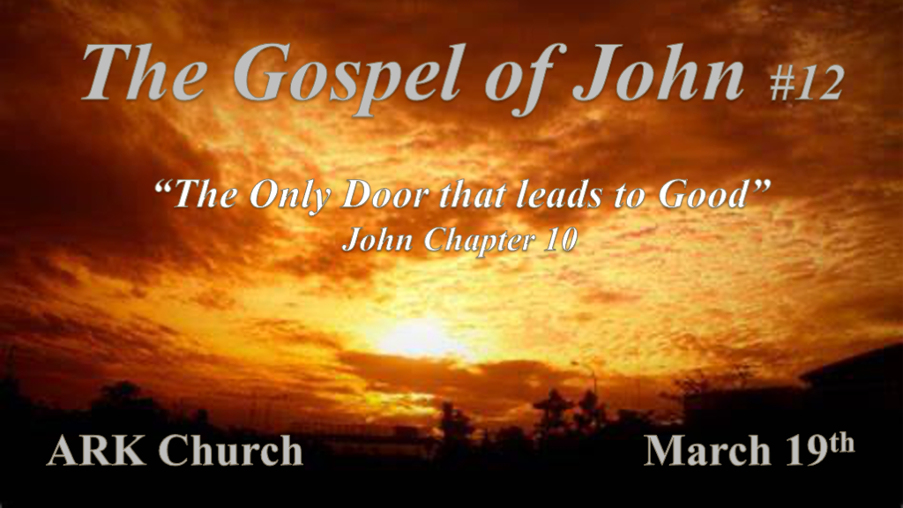

*The Doorkeeper and What He says about Strangers, Thieves, and Hirelings.

*John 10:1 “Most assuredly, I say to you, he who does not enter the sheepfold by the door, but climbs up some other way, the same is a thief and a robber. 2 But he who enters by the door is the shepherd of the sheep. 3 To him the doorkeeper opens, and the sheep hear his voice; and he calls his own sheep by name and leads them out. 4 And when he brings out his own sheep, he goes before them; and the sheep follow him, for they know his voice. 5 Yet they will by no means follow a stranger, but will flee from him, for they do not know the voice of strangers.” 6 Jesus used this illustration, but they did not understand the things which He spoke to them.

- V:1-2 Most confidently Jesus speaks about the door and The Shepherd.

- V:3-5 The Door is an idiom. The door & the doorkeeper are both Jesus in this narrative.

- V:6 Those in darkness could not understand Jesus' illustration, because they rejected the light the day before.

*Access to the Goodness of God is only through the Door.

*John 10:7 Then Jesus said to them again, “Most assuredly, I say to you, I am the door of the sheep. 8 All who ever came before Me are thieves and robbers, but the sheep did not hear them. 9 I am the door. If anyone enters by Me, he will be saved, and will go in and out and find pasture. 10 The thief does not come except to steal, and to kill, and to destroy. I have come that they may have life and that they may have it more abundantly.
11 “I am the good shepherd. The good shepherd gives His life for the sheep. 12 But a hireling, he who is not the shepherd, one who does not own the sheep, sees the wolf coming and leaves the sheep and flees; and the wolf catches the sheep and scatters them. 13 The hireling flees because he is a hireling and does not care about the sheep. 14 I am the good shepherd; and I know My sheep, and am known by My own. 15 As the Father knows Me, even so I know the Father; and I lay down My life for the sheep. 16 And other sheep I have which are not of this fold; them also I must bring, and they will hear My voice; and there will be one flock and one shepherd.
17 “Therefore My Father loves Me, because I lay down My life that I may take it again. 18 No one takes it from Me, but I lay it down of Myself. I have power to lay it down, and I have power to take it again. This command I have received from My Father.”

- V:7-9 Jesus is the only door for our salvation.

- V:10 The connection of false Teachers and Pastors with the Devil’s agenda, “The Thief.”

- V:11-16 I am the good shepherd who lays down his life & Jesus includes Gentiles.

- V:17-18 The gift of salvation came from a surrendered life to God the Father.

*I AM the Light of The World, Speaks about Darkness at the Feast of Dedication.

*John 10:19 Therefore there was a division again among the Jews because of these sayings. 20 And many of them said, “He has a demon and is mad. Why do you listen to Him?”
21 Others said, “These are not the words of one who has a demon. Can a demon open the eyes of the blind?”
22 Now it was the Feast of Dedication in Jerusalem, and it was winter. 23 And Jesus walked in the temple, in Solomon’s porch. 24 Then the Jews surrounded Him and said to Him, “How long do You keep us in doubt? If You are the Christ, tell us plainly.”
25 Jesus answered them, “I told you, and you do not believe. The works that I do in My Father’s name, they bear witness of Me. 26 But you do not believe, because you are not of My sheep, as I said to you. 27 My sheep hear My voice, and I know them, and they follow Me. 28 And I give them eternal life, and they shall never perish; neither shall anyone snatch them out of My hand. 29 My Father, who has given them to Me, is greater than all; and no one is able to snatch them out of My Father’s hand. 30 I and My Father are one.”
31 Then the Jews took up stones again to stone Him. 32 Jesus answered them, “Many good works I have shown you from My Father. For which of those works do you stone Me?”
33 The Jews answered Him, saying, “For a good work we do not stone You, but for blasphemy, and because You, being a Man, make Yourself God.”
34 Jesus answered them, “Is it not written in your law, I said, “You are gods” ’? 35 If He called them gods, to whom the word of God came (and the Scripture cannot be broken), 36 do you say of Him whom the Father sanctified and sent into the world, ‘You are blaspheming,’ because I said, ‘I am the Son of God’? 37 If I do not do the works of My Father, do not believe Me; 38 but if I do, though you do not believe Me, believe the works, that you may know and believe that the Father is in Me, and I in Him.” 39 Therefore they sought again to seize Him, but He escaped out of their hand.

*John 10:40 And He went away again beyond the Jordan to the place where John was baptizing at first, and there He stayed. 41 Then many came to Him and said, “John performed no sign, but all the things that John spoke about this Man were true.” 42 And many believed in Him there.

- V:19-21 A division about Jesus is still happening today.

- V:22-27 Many will never accept the hard sayings of Jesus.

- V:28-32 The great falling away that was prophesied is being fulfilled.

- V:33-39 They got it backward, Jesus is the God who became man.
(Psalm 82 & Exodus 22:8-9)

- V:40-42 Jesus leaves Jerusalem and goes across the Jordan where many believe in Him.

The uniqueness of John’s Gospel
The things that are not in the other Gospels. (No Parables)

Chapter 1 He is the Word that became flesh.
Chapter 2 Changes water into wine.
Chapter 3 Nicodemus comes to Jesus at night.
Chapter 4 The Woman at the Well.
Chapter 5 The man at the pool who was crippled for 38 years.
Chapter 6 The feeding of the 5000 at Passover and the insight that the lunch came from a little boy.
Chapter 7 Jesus goes secretly to the Feast of Tabernacles.
Chapter 8 The Woman Caught in Adultery.
Chapter 9 The man born blind is healed.
Chapter 10 I am the door and I am Good Shepherd.

