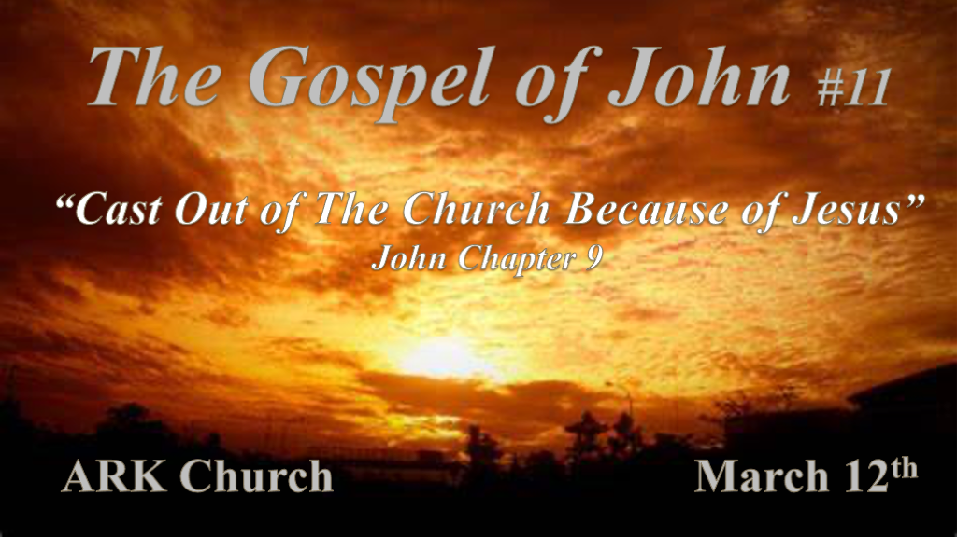

*Real-life narratives in scriptures often have a broader context than the stories.
*John 8:59 Then they took up stones to throw at Him; but Jesus hid Himself and went out of the temple, going through the midst of them, and so passed by.

*John 9:1 Now as Jesus passed by, He saw a man who was blind from birth. 2 And His disciples asked Him, saying, “Rabbi, who sinned, this man or his parents, that he was born blind?” 3 Jesus answered, “Neither this man nor his parents sinned, but that the works of God should be revealed in him. 4 I must work the works of Him who sent Me while it is day; the night is coming when no one can work. 5 As long as I am in the world, I am the light of the world.” 6 When He had said these things, He spat on the ground and made clay with the saliva; and He anointed the eyes of the blind man with the clay. 7 And He said to him, “Go, wash in the pool of Siloam” (which is translated, Sent). So he went and washed, and came back seeing.
8 Therefore the neighbors and those who previously had seen that he was blind said, “Is not this he who sat and begged?”
9 Some said, “This is he.” Others said, “He is like him.” He said, “I am he.” 10 Therefore they said to him, “How were your eyes opened?”
11 He answered and said, “A Man called Jesus made clay and anointed my eyes and said to me, ‘Go to the pool of Siloam and wash.’ So I went and washed, and I received sight.” 12 Then they said to him, “Where is He?” He said, “I do not know.”

- John 8:59 & 9:1 Jesus passed by: He didn’t fear or dwell on those who wanted to kill him. Jesus won’t over-stress now on a theological question.
Jesus’ lasered focus in the Gospel of John is that He is the Son of God and is about the work of the Father.

Jesus passed by those who wanted to kill him and left them in their darkness. Jesus passed by a man born in darkness and is going to change that man’s world.

- V:2-5 Can we get by the questions that haunt us? If you can the whole world will change for you.
You will have eyes to see what remained hidden from you for years.

I am the light of the World. Light is always going to disrupt the darkness. This should be very individualized.

*Chapter 8 they despised and rejected His claim of being the light of the world and they remained in their darkness.
*Chapter 9 Jesus shows the literal light to a man born blind in darkness and Jesus is accepted and worshipped for it.

- V:6-8 Unorthodox method of healing. Why?
In Chapter 8 the religious reached down for stones to kill and in Chapter 9 Jesus reaches down for clay to heal.

The contrast is they are blinded by their religion about God and the one born blind wanted light and was obedient.

- V:9-12 When you are touched by Jesus' healing power friends and family shouldn’t recognize you!
This is true once you’ve gone on to full surrender. Inviting Jesus to heal the way you do life.

Most Christians will give up because they see so much duplicity in their own life.

*Our Witness and why others may reject it.

*John 9:13 They brought him who formerly was blind to the Pharisees. 14 Now it was a Sabbath when Jesus made the clay and opened his eyes. 15 Then the Pharisees also asked him again how he had received his sight. He said to them, “He put clay on my eyes, and I washed, and I see.”
16 Therefore some of the Pharisees said, “This Man is not from God, because He does not keep the Sabbath.”
Others said, “How can a man who is a sinner do such signs?” And there was a division among them.
17 They said to the blind man again, “What do you say about Him because He opened your eyes?”
He said, “He is a prophet.”
18 But the Jews did not believe concerning him, that he had been blind and received his sight, until they called the parents of him who had received his sight. 19 And they asked them, saying, “Is this your son, who you say was born blind? How then does he now see?”
20 His parents answered them and said, “We know that this is our son, and that he was born blind; 21 but by what means he now sees we do not know, or who opened his eyes we do not know. He is of age; ask him. He will speak for himself.” 22 His parents said these things because they feared the Jews, for the Jews had agreed already that if anyone confessed that He was Christ, he would be put out of the synagogue. 23 Therefore his parents said, “He is of age; ask him.”

24 So they again called the man who was blind, and said to him, “Give God the glory! We know that this Man is a sinner.”
25 He answered and said, “Whether He is a sinner or not I do not know. One thing I know: that though I was blind, now I see.”
26 Then they said to him again, “What did He do to you? How did He open your eyes?”
27 He answered them, “I told you already, and you did not listen. Why do you want to hear it again? Do you also want to become His disciples?”
28 Then they reviled him and said, “You are His disciple, but we are Moses’ disciples. 29 We know that God spoke to Moses; as for this fellow, we do not know where He is from.”
30 The man answered and said to them, “Why, this is a marvelous thing, that you do not know where He is from; yet He has opened my eyes! 31 Now we know that God does not hear sinners; but if anyone is a worshiper of God and does His will, He hears him. 32 Since the world began it has been unheard of that anyone opened the eyes of one who was born blind. 33 If this Man were not from God, He could do nothing.”
34 They answered and said to him, “You were completely born in sins, and are you teaching us?” And they cast him out.

- V:13-17 Formerly a man was in darkness and his focus was on the miracle.
The focus of the religious men was on the commandment, not the God who wrote them.

- V:18-29 Do you want to be a disciple of Jesus? Accept this truth, “I am the light of the World.”
Investigations didn’t turn their darkness to light. (Investigated his parents, him, and probably others)

Believing in Jesus is the only path to light.

- V:30-34 The blind man knew where Jesus was from V:30
If this man wasn’t from God he could not open the eyes of the blind. This truth is rejected and they cast him out of the synagogue.

*The Difference between having spiritual sight and spiritual obedience.

*John 9:35 Jesus heard that they had cast him out; and when He had found him, He said to him, “Do you believe in the Son of God?”
36 He answered and said, “Who is He, Lord, that I may believe in Him?”
37 And Jesus said to him, “You have both seen Him and it is He who is talking with you.”
38 Then he said, “Lord, I believe!” And he worshiped Him.
39 And Jesus said, “For judgment I have come into this world, that those who do not see may see, and that those who see may be made blind.”
40 Then some of the Pharisees who were with Him heard these words, and said to Him, “Are we blind also?”
41 Jesus said to them, “If you were blind, you would have no sin; but now you say, ‘We see.’ Therefore your sin remains.

- V:35-38 The action of our belief.
When you worshiped Jesus. You will treat others the way Jesus did. This is best learned from the Word of God and His Spirit or else it will become a ritual or routine that becomes empty.

Be careful that the action of your belief. Doesn’t cast people out. (Jesus Revolution the story of Chuck Smith played by Kelsey Grammer) He let the hippies come and welcomed them to the Church.

- V:39-40 Why you must go beyond your religion.
Religion may vaccinate you against the real relationship with Jesus. Why? They make traditions that are required to be identified as a believer that Jesus didn’t require.

Belief leads to worship. What do you believe and who or what do worship?

- V:41 The sin of the Church/religious organization is they won’t let the results be evaluated. They often are guilty of adding or taking away from the Word of God.
Study to show yourself approved a person who correctly handles the Word of truth.

