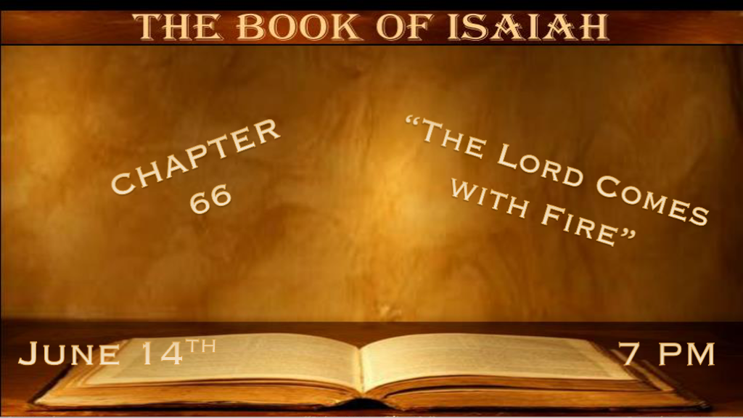

*God has a special connection with those who tremble at His Word.
*Isaiah 66:1 Thus says the LORD: “Heaven is My throne, and earth is My footstool. Where is the house that you will build Me?
And where is the place of My rest? 2 For all those things My hand has made, and all those things exist,” Says the LORD.
“But on this one will I look: On him who is poor and of a contrite spirit, and who trembles at My word. 3 “He who kills a bull is as if he slays a man; He who sacrifices a lamb, as if he breaks a dog’s neck; He who offers a grain offering, as if he offers swine’s blood; He who burns incense, as if he blesses an idol. Just as they have chosen their own ways, and their soul delights in their abominations, 4 so will I choose their delusions, and bring their fears on them; Because, when I called, no one answered,
when I spoke they did not hear; But they did evil before My eyes, and chose that in which I do not delight.”

V:1-2 Christians grow up and mature spiritually when they understand the authority of God.

- V:1-2 This is a proper perspective of God’s greatness as Creator.
Those that assign creation to anything other than God are in trouble.
V:2 God’s hand has made the heavens and earth. Everything else is speculation.
- V:2 How do we serve God?
He describes it happens through a repentant spirit and total respect for His Word.

V:3-4 Empty religious rituals and their delusions.
To all religions that practice ritualism, it only adds to your sin.

*Fire and judgment for some and comfort for the righteous.
*Isaiah 66:5 Hear the word of the LORD, you who tremble at His word: “Your brethren who hated you, who cast you out for My name’s sake, said, Let the LORD be glorified, that we may see your joy.’ But they shall be ashamed.” 6 The sound of noise from the city! A voice from the temple! The voice of the LORD, who fully repays His enemies! 7 “Before she was in labor, she gave birth; Before her pain came, She delivered a male child. 8 Who has heard such a thing? Who has seen such things? Shall the earth be made to give birth in one day? Or shall a nation be born at once? For as soon as Zion was in labor, she gave birth to her children. 9 Shall I bring to the time of birth, and not cause delivery?” says the LORD. “Shall I who cause delivery shut up the womb?” says your God. 10 “Rejoice with Jerusalem, and be glad with her, all you who love her; Rejoice for joy with her, all you who mourn for her; 11 That you may feed and be satisfied with the consolation of her bosom, that you may drink deeply and be delighted with the abundance of her glory.” 12 For thus says the LORD: “Behold, I will extend peace to her like a river, and the glory of the Gentiles like a flowing stream. Then you shall feed; On her sides shall you be carried, and be dandled on her knees.
13 As one whom his mother comforts, so I will comfort you; And you shall be comforted in Jerusalem.”

- V:5-6 The dividing force is the Word of God.
Those that love the Word of God will be hated by those who denounce the Word of God.
One will see joy, the other shame. The voice of the Lord will be the source of the shame for the unfaithful to the Word of God. The phrase His voice is a purposeful double play on words.

- V:7-11 The deliverance of Israel through fire and many symbolic signs.
V:7 Is a Double meaning that just as Israel is released from the Babylonian captivity without pain, it speaks to a future event of Israel’s birth.
V:8-10 So, the releasing of the land of Israel in the last times a birth of the nation in a single day.
Both apply to Jesus and the deliverance of the people and a nation. They won’t be able to fight and win; it will be done for them when Christ returns.

V:11-12 The subject switches to Gentiles. When the world sees the Christ/God followers as radical, the time is near for Christ's return.
God will send a river to comfort (to sweep the followers away?) Is this the ultimate comfort of the Rapture?
Yet, at the same time, He talks of comfort to Jerusalem. Is it a mystery, or is it comforted from their total destruction during the Gog and Magog War? An intertwining of Israel and the Church is in these scriptures.

*The Gathering, Restoration, and Certainty of God’s Judgment.
Isaiah 66:14 When you see this, your heart shall rejoice, and your bones shall flourish like grass; The hand of the LORD shall be known to His servants, and His indignation to His enemies. 15 For behold, the LORD will come with fire and with His chariots, like a whirlwind, to render His anger with fury, and His rebuke with flames of fire. 16 For by fire and by His sword
The LORD will judge all flesh; And the slain of the LORD shall be many. 17 “Those who sanctify themselves and purify themselves, to go to the gardens after an idol in the midst, eating swine’s flesh and the abomination and the mouse, shall be consumed together,” says the LORD. 18 “For I know their works and their thoughts. It shall be that I will gather all nations and tongues; and they shall come and see My glory. 19 I will set a sign among them; and those among them who escape I will send to the nations: to Tarshish and Pul and Lud, who draw the bow, and Tubal and Javan, to the coastlands afar off who have not heard My fame nor seen My glory. And they shall declare My glory among the Gentiles. 20 Then they shall bring all your brethren for an offering to the LORD out of all nations, on horses and in chariots and in litters, on mules and on camels, to My holy mountain Jerusalem,” says the LORD, “as the children of Israel bring an offering in a clean vessel into the house of the LORD. 21 And I will also take some of them for priests and Levites,” says the LORD.
22 “For as the new heavens and the new earth which I will make shall remain before Me,” says the LORD, “So shall your descendants and your name remain. 23 And it shall come to pass that from one New Moon to another, and from one Sabbath to another, all flesh shall come to worship before Me,” says the LORD. 24 “And they shall go forth and look upon the corpses of the men who have transgressed against Me. For their worm does not die, and their fire is not quenched. They shall be an abhorrence to all flesh.”

- V:14-21 The Lord’s indignation speaks of Jesus second coming.
Very descriptive judgment is taking place. Like in other passages about Jesus' 1st coming, many things are combined. We see this as a pattern of Prophecy with a purpose. We will know about the events but not the timing. (Isaiah 9:6-7)

*V:15-16 The Lord’s fire and sword, a picture of Revelation 19, is the wrath coming on all humanity.

V:17-18 Gross humanity and the revealing of The Lord’s Glory.

V:19-21 Focuses on Israel declaring God’s glory to the Gentiles, and restoration begins.

- V:22-24 New heaven and earth for a second time. Plus, a strange 30-day period that may be related to Daniel’s mystery. This is speculation on my part.

A literal meaning within an event is part of the prophetic pattern.

Read the last three chapters of Revelation and see how much it lines up with the previous two chapters of Isaiah.

V:24 is a familiar reference to the great white throne judgment and those thrown into the lake of fire that does not quench.

