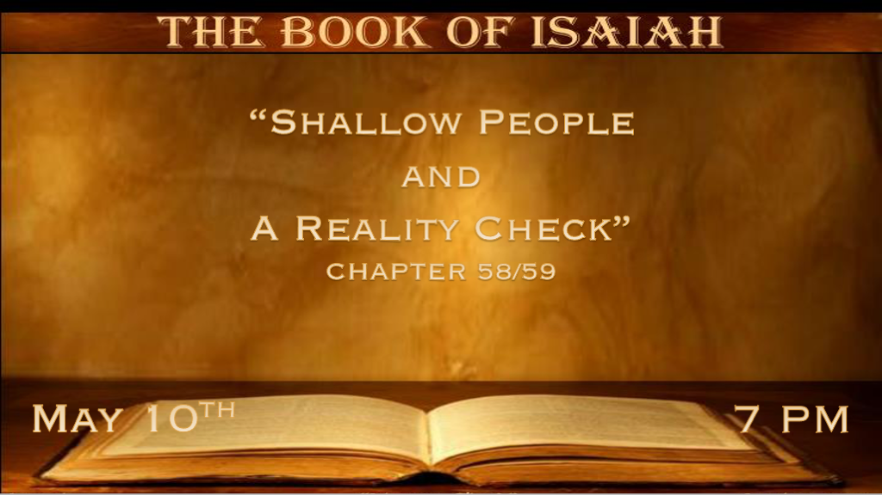

*All the motions of religion and no power.

*Isaiah 58:1 “Cry aloud, spare not; Lift up your voice like a trumpet; Tell My people their transgression, and the house of Jacob their sins. 2 Yet they seek Me daily, and delight to know My ways, as a nation that did righteousness, and did not forsake the ordinance of their God. They ask of Me the ordinances of justice; They take delight in approaching God. 3 ‘Why have we fasted,’ they say, ‘and You have not seen? Why have we afflicted our souls, and You take no notice?’ “In fact, in the day of your fast you find pleasure, and exploit all your laborers. 4 Indeed you fast for strife and debate, And to strike with the fist of wickedness. You will not fast as you do this day, to make your voice heard on high. 5 Is it a fast that I have chosen, a day for a man to afflict his soul? Is it to bow down his head like a bulrush, and to spread out sackcloth and ashes? Would you call this a fast, and an acceptable day to the LORD? 6 “Is this not the fast that I have chosen: To loose the bonds of wickedness, to undo the heavy burdens, to let the oppressed go free, and that you break every yoke? 7 Is it not to share your bread with the hungry, and that you bring to your house the poor who are cast out; When you see the naked, that you cover him, and not hide yourself from your own flesh? 8 Then your light shall break forth like the morning, your healing shall spring forth speedily, and your righteousness shall go before you; The glory of the LORD shall be your rear guard. 9 Then you shall call, and the LORD will answer; You shall cry, and He will say, ‘Here I am.’ “If you take away the yoke from your midst, The pointing of the finger, and speaking wickedness, 10 If you extend your soul to the hungry and satisfy the afflicted soul, then your light shall dawn in the darkness, and your darkness shall be as the noonday. 11 The LORD will guide you continually, And satisfy your soul in drought, And strengthen your bones; You shall be like a watered garden, and like a spring of water, whose waters do not fail. 12 Those from among you shall build the old waste places; You shall raise up the foundations of many generations; And you shall be called the Repairer of the Breach, The Restorer of Streets to Dwell In. 13 “If you turn away your foot from the Sabbath, from doing your pleasure on My holy day, and call the Sabbath a delight, the holy day of the LORD honorable, and shall honor Him, not doing your own ways, nor finding your own pleasure, nor speaking your own words, 14 Then you shall delight yourself in the LORD; And I will cause you to ride on the high hills of the earth, and feed you with the heritage of Jacob your father. The mouth of the LORD has spoken.”

V:1-7 Shallow people believe they seek God daily, yet their hard hearts rule them?

- The religious transgressors: They know about God, but He is not Lord in their lives.
Notice God calls Israel Jacob. We are included in the deception of Israel, and we can live in darkness when it comes to our relationship with God.

- The shallow worship of people: The tradition of praying, fasting, and going to church can be a starting place for a relationship with God.
Shallow worship also includes routines that you do without thinking about God entering into His presence.
The Catholic knows these very well—for example, the saying of the rosary.

- Stop protecting your heart: When you feel the bondage of others to wickedness and see their spiritual nakedness, you’ve begun partaking in the mercy of God.
Empathy is essential, but it should never lead us to excuses for those who choose a sinful lifestyle.

V:8-11 When we see people the way God does, our actions will show greater compassion and tenderness.

- The spiritual drought is not addressing the world of sinners: It’s in the soul of the shallow believer or follower of God.
Going deeper in prayer, Bible reading, and spending time in God’s presence will satisfy the soul.

- The light will come to us: It’s our healing from the darkness that has to happen for us to help others.
Our finger-pointing at others could be a sign of our darkness.

V:12-14 Spirit-filled people will guide, help, and become a sweet fragrant to God because of our love for others, even our enemies.

*The Reality Check-UP.
*Isaiah 59:1 Behold, the LORD’s hand is not shortened, that it cannot save; Nor His ear heavy, that it cannot hear. 2 But your iniquities have separated you from your God; And your sins have hidden His face from you, so that He will not hear. 3 For your hands are defiled with blood,
And your fingers with iniquity; Your lips have spoken lies, your tongue has muttered perversity. 4 No one calls for justice, nor does any plead for truth. They trust in empty words and speak lies; They conceive evil and bring forth iniquity. 5 They hatch vipers’ eggs and weave the spider’s web; He who eats of their eggs dies, and from that which is crushed a viper breaks out. 6 Their webs will not become garments, nor will they cover themselves with their works; Their works are works of iniquity, and the act of violence is in their hands. 7 Their feet run to evil,
and they make haste to shed innocent blood; Their thoughts are thoughts of iniquity; Wasting and destruction are in their paths. 8 The way of peace they have not known, and there is no justice in their ways; They have made themselves crooked paths; Whoever takes that way shall not know peace.

- V:1-3 God’s hearing and heart are good. Nevertheless, our iniquities have made us obstinate.
The declaration of some that “God Can’t” or is not omnipotent is one of the greatest deceptions of our times.
Sin separates us from God’s voice, blessings, and benefits of experiencing His hand.

- V:4-8 When justice and truth are abandoned, destruction is not far behind.
Notice the thought process and the action. The sinful feet run to evil. They are embracing the falsehood at such a fast pace that crooked paths seem correct. The key is they have NO peace.

*The Reality is death, and the darkness has overtaken them.

Isaiah 59:9 Therefore justice is far from us, nor does righteousness overtake us; We look for light, but there is darkness! For brightness, but we walk in blackness! 10 We grope for the wall like the blind, and we grope as if we had no eyes; We stumble at noonday as at twilight; We are as dead men in desolate places. 11 We all growl like bears, and moan sadly like doves; We look for justice, but there is none; For salvation, but it is far from us. 12 For our transgressions are multiplied before You, and our sins testify against us; For our transgressions are with us, and as for our iniquities, we know them: 13 In transgressing and lying against the LORD, and departing from our God, speaking oppression and revolt, conceiving and uttering from the heart words of falsehood. 14 Justice is turned back, and righteousness stands afar off; For truth is fallen in the street, and equity cannot enter. 15 So truth fails, and he who departs from evil makes himself a prey.
Then the LORD saw it, and it displeased Him that there was no justice. 16 He saw that there was no man, and wondered that there was no intercessor; Therefore His own arm brought salvation for Him; And His own righteousness, it sustained Him. 17 For He put on righteousness as a breastplate, and a helmet of salvation on His head; He put on the garments of vengeance for clothing, and was clad with zeal as a cloak. 18 According to their deeds, accordingly He will repay, fury to His adversaries, recompense to His enemies; The coastlands He will fully repay. 19 So shall they fear the name of the LORD from the west, and His glory from the rising of the sun; When the enemy comes in like a flood, the Spirit of the LORD will lift up a standard against him. 20 “The Redeemer will come to Zion, and to those who turn from transgression in Jacob,” Says the LORD.
21 “As for Me,” says the LORD, “this is My covenant with them: My Spirit who is upon you, and My words which I have put in your mouth, shall not depart from your mouth, nor from the mouth of your descendants, nor from the mouth of your descendants’ descendants,” says the LORD, “from this time and forevermore.”

- V:9-15 The darkness is because they have no spiritual eyes to see, and society has gone dark.
The multiplication of sin in every area has overwhelmed this generation.

- V:16-18 There wasn’t a mighty human prayer force. So, The Lord brings righteousness and salvation. The apostle Paul builds on this in Eph. 6:10-17
These scriptures are two-fold; they speak to what Jesus will do in His first coming.
They also describe a futuristic scenario for the people of the coastlands. Of course, this could be the apostasy of the U.S.A., but this is conjecture on my part but worth studying.

- V:19-21 The promise of the Kinsman Redeemer is coming to Zion, and this is the second coming of Jesus.
His Spirit and Word are upon them!

