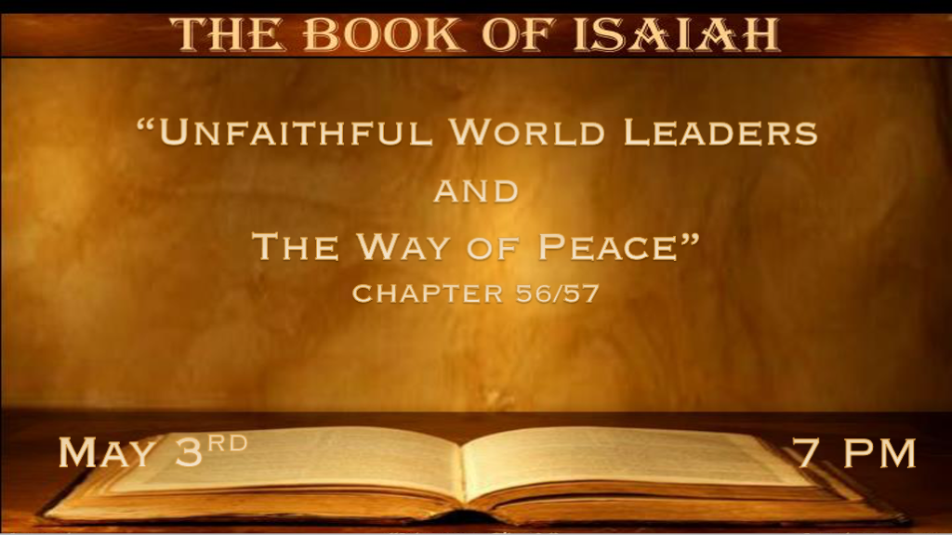

*What happens when leaders remove justice and righteousness and live for themselves?

*Isaiah 56:1 Thus says the LORD: “Keep justice, and do righteousness, for My salvation is about to come, and My righteousness to be revealed. 2 Blessed is the man who does this, and the son of man who lays hold on it; Who keeps from defiling the Sabbath, and keeps his hand from doing any evil.” 3 Do not let the son of the foreigner who has joined himself to the LORD speak, saying, “The LORD has utterly separated me from His people”; Nor let the eunuch say, “Here I am, a dry tree.” 4 For thus says the LORD: “To the eunuchs who keep My Sabbaths, and choose what pleases Me, and hold fast My covenant, 5 even to them I will give in My house and within My walls a place and a name better than that of sons and daughters; I will give them an everlasting name that shall not be cut off. 6 “Also the sons of the foreigner
who join themselves to the LORD, to serve Him, and to love the name of the LORD, to be His servants—Everyone who keeps from defiling the Sabbath, and holds fast My covenant—7 Even them I will bring to My holy mountain, and make them joyful in My house of prayer. Their burnt offerings and their sacrifices will be accepted on My altar; For My house shall be called a house of prayer for all nations.” 8 The Lord GOD, who gathers the outcasts of Israel, says, “Yet I will gather to him others besides those who are gathered to him.” 9 All you beasts of the field, come to devour, all you beasts in the forest. 10 His watchmen are blind, they are all ignorant; They are all dumb dogs, They cannot bark; Sleeping, lying down, loving to slumber. 11 Yes, they are greedy dogs which never have enough. And they are shepherds who cannot understand; They all look to their own way, every one for his own gain, from his own territory. 12 “Come,” one says, “I will bring wine, and we will fill ourselves with intoxicating drink; Tomorrow will be as today, and much more abundant.”

- V:1-2 The Lord combines keeping justice and doing righteousness with peace.

*Review Chapters 40-48, The Purpose of Peace.
Chapters 49-57, The Prince of Peace.

*Both Chapters 48:22 & 57:21 End with this saying, “There is no peace,” says the LORD, “for the wicked.”

- V:3-8 The transformation: A people who are restored far beyond the letter of the law. (Lev. 21)
My house is a house of prayer to all nations. The Lamb of God's sacrifice now overrides the law that limits what you can be.
V:8 Jesus gathers the outcasts of Israel. His blood sets them free from their bondage both physically and spiritually.

- V:9-11 The promise to judge blind leaders of the world.
DESCRIPTIVE WORDS FOR THE WICKED: Blind, ignorant, dumb dogs, sleeping, greedy dogs, and those who look for their own gain and get drunk on all the wrong things.
Sadly, they are the watchmen instead of knowing the times and understanding them. (V:11) They are Shepherds who cannot understand.

*The perversion of the last generation is prophesied.
*Isaiah 57:1 The righteous perishes, and no man takes it to heart; Merciful men are taken away, while no one considers that the righteous is taken away from evil. 2 He shall enter into peace; They shall rest in their beds, each one walking in his uprightness. 3 “But come here, you sons of the sorceress, you offspring of the adulterer and the harlot! 4 Whom do you ridicule? Against whom do you make a wide mouth and stick out the tongue? Are you not children of transgression, offspring of falsehood, 5 inflaming yourselves with gods under every green tree,
slaying the children in the valleys, under the clefts of the rocks? 6 Among the smooth stones of the stream is your portion; They, they, are your lot! Even to them you have poured a drink offering, you have offered a grain offering. Should I receive comfort in these? 7 “On a lofty and high mountain you have set your bed; Even there you went up to offer sacrifice. 8 Also behind the doors and their posts you have set up your remembrance; For you have uncovered yourself to those other than Me, and have gone up to them; You have enlarged your bed and made a covenant with them; You have loved their bed, where you saw their nudity. 9 You went to the king with ointment, and increased your perfumes;
You sent your messengers far off, and even descended to Sheol. 10 You are wearied in the length of your way; Yet you did not say, ‘There is no hope.’ you have found the life of your hand; Therefore you were not grieved. 11 “And of whom have you been afraid, or feared, that you have lied and not remembered Me, nor taken it to your heart? Is it not because I have held My peace from of old that you do not fear Me?
12 I will declare your righteousness and your works, for they will not profit you. 13 When you cry out, let your collection of idols deliver you.
But the wind will carry them all away, a breath will take them. But he who puts his trust in Me shall possess the land, and shall inherit My holy mountain.”

- V:1-2 The righteous of Israel and the Church are persecuted.
King Manasseh persecuted the priest during his reign and will have Isaiah the prophet sawed in two.
These scriptures have a prophetic message to the Church. Possible rapture of the righteous?

- V:3-13 Perversion, in great detail, is the description of spiritual adultery of the past and future.
- *They mock or make fun of the godly and eventually persecute.
- *They become consumed by other gods. They literally adopt their ways. Perverted in their sexuality and their understanding of it.
- *Marked by the slaying or destruction of their own children.
- *They become wearied by their own practices. They belittle those who don’t accept what is now the norm in society.
- *They do not repent.
- *The consequence is real. The breath of God/Jesus will destroy them.
- *2 Thess. 2:8 And then the lawless one will be revealed, whom the Lord will consume with the breath of His mouth and destroy with the brightness of His coming.

*The revived spirit and heart must happen, or you’ll live without peace.

Isaiah 57:14 And one shall say, “Heap it up! Heap it up! Prepare the way, take the stumbling block out of the way of My people.”15 For thus says the High and Lofty One Who inhabits eternity, whose name is Holy: “I dwell in the high and holy place, with him who has a contrite and humble spirit, to revive the spirit of the humble, and to revive the heart of the contrite ones. 16 For I will not contend forever, nor will I always be angry; For the spirit would fail before Me, And the souls which I have made. 17 For the iniquity of his covetousness, I was angry and struck him; I hid and was angry, and he went on backsliding in the way of his heart. 18 I have seen his ways, and will heal him; I will also lead him, and restore comforts to him and to his mourners. 19 “I create the fruit of the lips: Peace, peace to him who is far off and to him who is near,” says the LORD, “And I will heal him.” 20 But the wicked are like the troubled sea, when it cannot rest, Whose waters cast up mire and dirt. 21 “There is no peace,” Says my God, “for the wicked.”

- V:14-15 The raising of the standard of holiness.
Our calling is to remove the stumbling blocks from God’s people. How?
The most significant block to revival is pride. A sinner must have a humble and repentant spirit to be nurtured by God.

- V:16-18 God knows the way of the sinner and backslider.
God knows the way of our hearts.
He will heal our hearts if we cry out to God for grace and mercy. This step cannot be just a spoiled person manipulating God’s goodness.

- V:19-20 Peace to those who are far off and to those who are near. Get your eyes off the wicked who stir up the dirt.
The far-off person during Isaiah’s day was the Gentile. Today it is both the Jew and Gentile. Those close to God are His devoted followers living in peace.

*Isaiah 57:21 “There is no peace,” Says my God, “for the wicked.”

