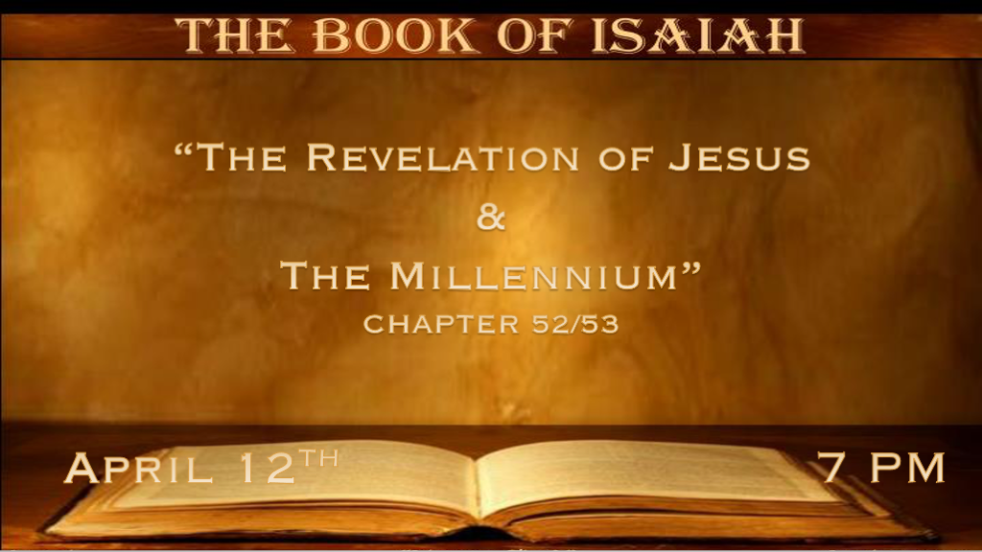

* Zion (Jerusalem) redemption and the Millennium

*Isaiah 52:1 Awake, awake! Put on your strength, O Zion; Put on your beautiful garments, O Jerusalem, the holy city! For the uncircumcised and the unclean shall no longer come to you. 2 Shake yourself from the dust, arise; Sit down, O Jerusalem!
Loose yourself from the bonds of your neck, O captive daughter of Zion! 3 For thus says the LORD: “You have sold yourselves for nothing, and you shall be redeemed without money.” 4 For thus says the Lord GOD: “My people went down at first into Egypt to dwell there; Then the Assyrian oppressed them without cause. 5 Now therefore, what have I here,” says the LORD, “That My people are taken away for nothing? Those who rule over them make them wail,” says the LORD, “And My name is blasphemed continually every day. 6 Therefore My people shall know My name; Therefore they shall know in that day that I am He who speaks: ‘Behold, it is I.’ ” 7 How beautiful upon the mountains are the feet of him who brings good news, Who proclaims peace, Who brings glad tidings of good things,
Who proclaims salvation, Who says to Zion, “Your God reigns!” 8 Your watchmen shall lift up their voices, with their voices they shall sing together; For they shall see eye to eye when the LORD brings back Zion. 9 Break forth into joy, sing together, You waste places of Jerusalem! For the LORD has comforted His people, He has redeemed Jerusalem. 10 The LORD has made bare His holy arm in the eyes of all the nations; And all the ends of the earth shall see the salvation of our God. 11 Depart! Depart! Go out from there, touch no unclean thing; Go out from the midst of her, be clean, you who bear the vessels of the LORD. 12 For you shall not go out with haste, Nor go by flight; For the LORD will go before you, and the God of Israel will be your rear guard.

- V:1-3 The third Warning to “Awake, Awake” The 1st was a plea to the Lord, 2nd was to remember judgments and promises.
This Awake is to put on strength from the Lord and the garments that speak of redemption.
Awake out of your captivity to sin and stop selling yourself to false gods.
Redeemed without money. The price will be the Messiah’s blood.

- V:4-7 The History of Israel and the nations who wail because of what they have done to Israel.
Egypt, Assyria, and Babylon have already wailed hopefully America won’t be a nation that will wail.
V:6-7 The nation will know the name of Jesus and they will stop their blaspheming.

- V:8-12 Who are the modern-day watchmen of Israel? The Warning to “Depart, Depart” from unclean things.
Amir Tsarfati, Jonathan Cahn, Aaron Budjen, Sid Roth, and T.W. Tramm are a good list of watchmen.
V:11 The Warning is speaking to the immediate future to come out of the demonic teachings of Babylon spirits. It is also a futuristic warning to stay holy.

*The Servant of God.
*Isaiah 52:13 Behold, My Servant shall deal prudently; He shall be exalted and extolled and be very high. 14 Just as many were astonished at you, so His visage was marred more than any man, and His form more than the sons of men; 15 So shall He sprinkle many nations. Kings shall shut their mouths at Him; For what had not been told them they shall see, and what they had not heard they shall consider.

- V:13-14 The word servant is rightly capitalized!
An exalted Messiah who will be viciously beaten for our sins.
Remember many did not recognize Jesus after His resurrection. This is why.

- V:15 The cleansing of many nations. The Great Commission is a prophecy and a reality.

Jesus the Savior and so much more.

Isaiah 53:1 Who has believed our report? And to whom has the arm of the LORD been revealed? 2 For He shall grow up before Him as a tender plant, and as a root out of dry ground. He has no form or comeliness; And when we see Him, there is no beauty that we should desire Him. 3 He is despised and rejected by men, a Man of sorrows and acquainted with grief. And we hid, as it were, our faces from Him; He was despised, and we did not esteem Him. 4 Surely He has borne our griefs and carried our sorrows; Yet we esteemed Him stricken, smitten by God, and afflicted. 5 But He was wounded for our transgressions, He was bruised for our iniquities; The chastisement for our peace was upon Him, and by His stripes we are healed. 6 All we like sheep have gone astray; We have turned, every one, to his own way; And the LORD has laid on Him the iniquity of us all. 7 He was oppressed and He was afflicted, Yet He opened not His mouth; He was led as a lamb to the slaughter, and as a sheep before its shearers is silent, so He opened not His mouth. 8 He was taken from prison and from judgment,
and who will declare His generation? For He was cut off from the land of the living; For the transgressions of My people He was stricken.
9 And they made His grave with the wicked—But with the rich at His death, because He had done no violence, Nor was any deceit in His mouth. 10 Yet it pleased the LORD to bruise Him; He has put Him to grief. When You make His soul an offering for sin, He shall see His seed, He shall prolong His days, and the pleasure of the LORD shall prosper in His hand. 11 He shall see the labor of His soul, and be satisfied. By His knowledge My righteous Servant shall justify many, for He shall bear their iniquities. 12 Therefore I will divide Him a portion with the great, and He shall divide the spoil with the strong, because He poured out His soul unto death, and He was numbered with the transgressors, and He bore the sin of many, and made intercession for the transgressors.

- V:1-3 The most accurate report even beyond the Gospels about Jesus.
God knows how to bring good out of the dry ground. This is a reference to the physical as well as the spiritual condition of Israel.
The descriptions of Jesus does not mean He was ugly. His appearance like most of our world was average or common.

- V:4-6 God’s Servant that bore our sins.

- Jesus made our sorrows and griefs His.
- Our transgression & iniquities were paid for by Jesus being smitten, beaten, and wounded.
- Our healing came at the expense of His back being whipped or by His stripes, we are healed.
- Every human being rejected or turned against God.
- V:7-9 Jesus was led like a lamb to the slaughter. He was killed among the wicked and buried among the rich.

- The analogy says: We like lambs don’t have to be led to slaughter.
- Despite the efforts to have Jesus associated with the wicked. God honored His Son’s obedience and had Jesus buried among the rich.
- V:10-12 Christians are Jesus' offspring and He shall see His seed.

Great promise that we shall see Jesus!

Jesus says it was worth it all and we will sing it with Him when we see Christ.

