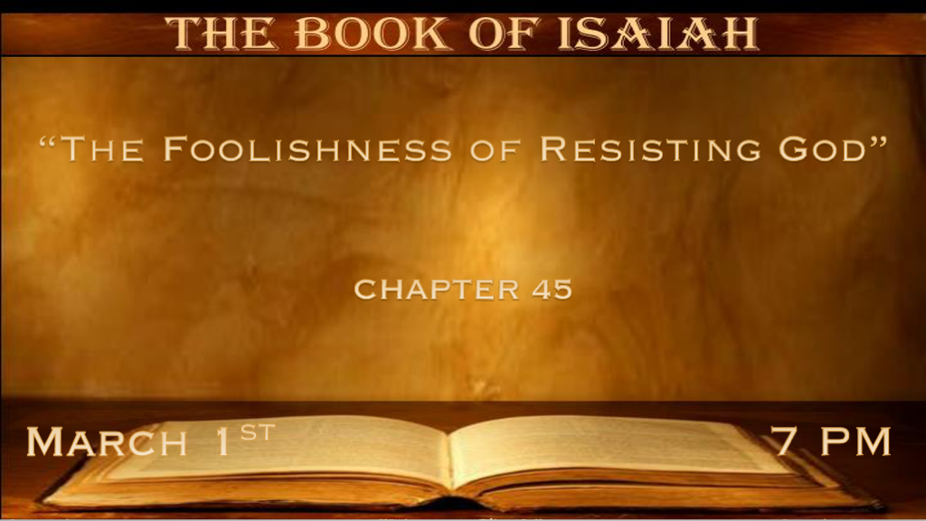

*Who can understand God?

*Isaiah 44:27 Who says to the deep, ‘Be dry! And I will dry up your rivers’; 28 Who says of Cyrus, ‘He is My shepherd, and he shall perform all My pleasure, saying to Jerusalem, “You shall be built,” and to the temple, “Your foundation shall be laid.”
(Jeremiah 50 & 51, Isaiah 13 & 14, Revelation 17 & 18) Isaiah wrote this about the temple over a hundred years before its destruction.

*Isaiah 45:1 “Thus says the LORD to His anointed, to Cyrus, whose right hand I have held—To subdue nations before him and loose the armor of kings, to open before him the double doors, so that the gates will not be shut: 2 ‘I will go before you and make the crooked places straight; I will break in pieces the gates of bronze and cut the bars of iron. 3 I will give you the treasures of darkness and hidden riches of secret places, that you may know that I, the LORD, Who call you by your name, Am the God of Israel. 4 For Jacob My servant’s sake, and Israel My elect, I have even called you by your name; I have named you, though you have not known Me. 5 I am the LORD, and there is no other; There is no God besides Me. I will gird you, though you have not known Me, 6 that they may know from the rising of the sun to its setting that there is none besides Me. I am the LORD, and there is no other; 7 I form the light and create darkness, I make peace and create calamity; I, the LORD, do all these things.’

- V:1-4 God has a plan for you do you believe it?
The letters that we have to read give this generation more knowledge than any other.

Will we be as obedient as Cyrus?

V:2 We live in a crooked path world and you know the one who makes them straight. (Pun intended)

- V:5-7 Are God’s promises just for Cyrus & how much did he believe they were for him?
I will gird (Anchor) you though you have not known Me.

Isaiah 66:8 Can a nation be born in one day?

*Ezra 1:1 Now in the first year of Cyrus king of Persia, that the word of the LORD by the mouth of Jeremiah might be fulfilled, the LORD stirred up the spirit of Cyrus king of Persia, so that he made a proclamation throughout all his kingdom, and also put it in writing, saying,
2 Thus says Cyrus king of Persia:
All the kingdoms of the earth the LORD God of heaven has given me. And He has commanded me to build Him a house at Jerusalem which is in Judah. 3 Who is among you of all His people? May his God be with him, and let him go up to Jerusalem which is in Judah, and build the house of the LORD God of Israel (He is God), which is in Jerusalem.

*V:7 God created darkness and separated it from the light. He created both peace and calamity which it and darkness are the consequences of living in sin.

*Fighting against the Creator is the ultimate sign of the lawless one.

*Isaiah 45:8 “Rain down, you heavens, from above, and let the skies pour down righteousness; Let the earth open, let them bring forth salvation, and let righteousness spring up together. I, the LORD, have created it. 9 “Woe to him who strives with his Maker! Let the potsherd strive with the potsherds of the earth! Shall the clay say to him who forms it, ‘What are you making?’ Or shall your handiwork say, ‘He has no hands’? 10 Woe to him who says to his father, ‘What are you begetting?’ Or to the woman, ‘What have you brought forth?’ ”
11 Thus says the LORD, The Holy One of Israel, and his Maker: “Ask Me of things to come concerning My sons; And concerning the work of My hands, you command Me. 12 I have made the earth, and created man on it. I—My hands—stretched out the heavens, and all their host I have commanded. 13 I have raised him up in righteousness, and I will direct all his ways; He shall build My city and let My exiles go free, not for price nor reward,” Says the LORD of hosts.

- V:8-9 Striving against our Maker is foolishness.
Yet, some think they have outgrown God.

Jeremiah 18:1-11 The Potter and the Clay is the witness that God is sovereign.

- V:10-13 God verifies/authenticates His work, His Word, and His record is 100%.
This is why prophecy is important to the believer. The Future is guaranteed!

God did not create something and put it on autopilot.

The world is living under a consequence of the fallen nature. This doesn’t mean believers will only live a life of peace and light though we will receive justifice.

*Only The Bible Transcends Time and Space as a Historical & Futuristic Book.

*Isaiah 45:14 Thus says the LORD: “The labor of Egypt and merchandise of Cush and of the Sabeans, men of stature, shall come over to you, and they shall be yours; They shall walk behind you, they shall come over in chains; And they shall bow down to you. They will make supplication to you, saying, surely God is in you, and there is no other; There is no other God.’ ” 15 Truly You are God, who hide Yourself,
O God of Israel, the Savior! 16 They shall be ashamed and also disgraced, all of them; They shall go in confusion together, Who are makers of idols. 17 But Israel shall be saved by the LORD with an everlasting salvation; You shall not be ashamed or disgraced forever and ever. 18 For thus says the LORD, Who created the heavens, Who is God, Who formed the earth and made it, Who has established it,
Who did not create it in vain, Who formed it to be inhabited: “I am the LORD, and there is no other. 19 I have not spoken in secret, in a dark place of the earth; I did not say to the seed of Jacob, ‘Seek Me in vain’; I, the LORD, speak righteousness, I declare things that are right. 20 “Assemble yourselves and come; Draw near together, You who have escaped from the nations. They have no knowledge, who carry the wood of their carved image, and pray to a god that cannot save. 21 Tell and bring forth your case; Yes, let them take counsel together. Who has declared this from ancient time? Who has told it from that time? Have not I, the LORD? And there is no other God besides Me, a just God and a Savior; There is none besides Me. 22 “Look to Me, and be saved, all you ends of the earth! For I am God, and there is no other. 23 I have sworn by Myself; The word has gone out of My mouth in righteousness, and shall not return, that to Me every knee shall bow, every tongue shall take an oath. 24 He shall say, ‘Surely in the LORD I have righteousness and strength. To Him men shall come, and all shall be ashamed who are incensed against Him. 25 In the LORD all the descendants of Israel shall be justified, and shall glory.’ ”

- V:14-17 Israel has experienced captivity but one day they will reign with God as their Savior.
An everlasting salvation. The shame is removed. This is true for all believers.

- V:18-21 The Greatness of God and the foolishness of idolatry.
Israel will need this truth you will escape the nations!

God rewards those who seek Him, this is a promise to everyone.

V:20 Those who look to false gods have no knowledge or insight about the spiritual world.

- V:22-25 Finding salvation to all who bend their knee and every tongue that confesses He is Lord.
This final act is the description of a surrendered life.

