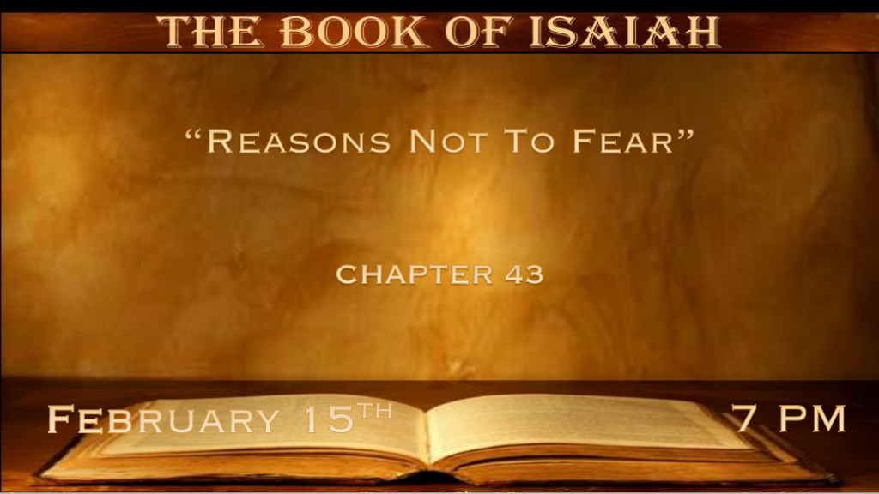

*Fear Not, You’ve been Redeemed by God.
*Isaiah 43:1 But now, thus says the LORD, who created you, O Jacob, and He who formed you, O Israel: “Fear not, for I have redeemed you; I have called you by your name; You are Mine. 2 When you pass through the waters, I will be with you; and through the rivers, they shall not overflow you. When you walk through the fire, you shall not be burned, nor shall the flame scorch you. 3 For I am the LORD your God, The Holy One of Israel, your Savior; I gave Egypt for your ransom, Ethiopia and Seba in your place. 4 Since you were precious in My sight, you have been honored, and I have loved you; Therefore I will give men for you, and people for your life. 5 Fear not, for I am with you; I will bring your descendants from the east, and gather you from the west; 6 I will say to the north, ‘Give them up!’ And to the south, ‘Do not keep them back!’ Bring My sons from afar, and My daughters from the ends of the earth—7 Everyone who is called by My name, Whom I have created for My glory; I have formed him, yes, I have made him.”

- V:1-4 Fear not is a command that comes with great promises.
- Deep Waters: What’s the promise?
1st We will have deep water experiences at times. The trails will vary in life. But the promise is God is stable in His love and care for us.
2nd The Holy One of Israel, your Savior. The Word Savior appears 8 times in Isaiah and 8 is the number of new beginnings.

- Walking through fire: The promise says?
Walking is a pace that says you are promised peace when you go through the fierce trials of life.
Interestingly the three Hebrew servants, Shadrack, Meshach, and Abednego walked into the fiery furnace.
- V:5-7 Fear not, God is over all the different directions, spirits, and kingdoms of the world.
- V:5 Over the East represents those that will come back from being conquered by Babylon
- V:5 Over the West could represent gathering Israel from the USA/Europe

- V:6 Over the North could it represent those who are being gathered from Ukraine/Russia?

- V:6 Over the South all the regions of Africa know the best place for a Jew to live is in Israel.

*Fear not, there is no other God or Savior.
*Isaiah 43:8 Bring out the blind people who have eyes, and the deaf who have ears. 9 Let all the nations be gathered together, and let the people be assembled. Who among them can declare this, and show us former things? Let them bring out their witnesses, that they may be justified; Or let them hear and say, “It is truth.” 10 “You are My witnesses,” says the LORD, “and My servant whom I have chosen,
that you may know and believe Me, and understand that I am He. Before Me there was no God formed, nor shall there be after Me. 11 I, even I, am the LORD, and besides Me there is no savior. 12 I have declared and saved, I have proclaimed, and there was no foreign god among you; Therefore you are My witnesses,” says the LORD, “that I am God. 13 Indeed before the day was, I am He; And there is no one who can deliver out of My hand; I work, and who will reverse it?” 14 Thus says the LORD, your Redeemer, The Holy One of Israel:
“For your sake I will send to Babylon, and bring them all down as fugitives—The Chaldeans, who rejoice in their ships. 15 I am the LORD, your Holy One, The Creator of Israel, your King.” 16 Thus says the LORD, who makes a way in the sea and a path through the mighty waters, 17 Who brings forth the chariot and horse, the army and the power (They shall lie down together, they shall not rise; They are extinguished, they are quenched like a wick): 18 “Do not remember the former things, nor consider the things of old. 19 Behold, I will do a new thing, Now it shall spring forth; Shall you not know it? I will even make a road in the wilderness and rivers in the desert. 20 The beast of the field will honor Me, the jackals and the ostriches, because I give waters in the wilderness and rivers in the desert, to give drink to My people, My chosen. 21 This people I have formed for Myself; They shall declare My praise.

- V:8-9 The Blind and deaf spiritually will never declare the glory of God.

The Jewish people were to be a witness of the one and only God. The believer is now that witness.

- V:10-15 There are no junior gods. The commandment is no other gods before Him.
Only the deceive trust in other gods. When God has shown who He is to the world.

- Jonathan Cahn's book “The return of the gods.” They are gods of the wicked who are evil and may have demonic spirits in themselves.
- Demonic spirits are real but have no power over the believer/follower of Jesus.

- V:16-21 God makes a way even when there seems to be no path.
The Red Sea is just one Biblical reminder.

*The hard heart is dangerous, but fear not, God can change your heart.

*Isaiah 43:22 “But you have not called upon Me, O Jacob; And you have been weary of Me, O Israel. 23 You have not brought Me the sheep for your burnt offerings, nor have you honored Me with your sacrifices. I have not caused you to serve with grain offerings, nor wearied you with incense. 24 You have bought Me no sweet cane with money, nor have you satisfied Me with the fat of your sacrifices;
But you have burdened Me with your sins, you have wearied Me with your iniquities. 25 “I, even I, am He who blots out your transgressions for My own sake; and I will not remember your sins. 26 Put Me in remembrance; Let us contend together; State your case, that you may be acquitted. 27 Your first father sinned, and your mediators have transgressed against Me. 28 Therefore I will profane the princes of the sanctuary; I will give Jacob to the curse, and Israel to reproaches.

- V:22-24 Don’t be afraid to call on God. God becomes weary when we know better and do not turn to Him.
The weariness comes from generational sins or iniquities.
The inability to see freedom from our sins makes us weary.

- V:25-26 The God who forgives all our sins.
He does not remember our sins.
Let’s contend together! It’s a fellowship of walking through something together.

- V:27-28 The first father who sins is Adam. The challenge is don’t live under deceit and reproach.
Remember that God refers to the nation of Israel as Jacob when they are living under deception.

