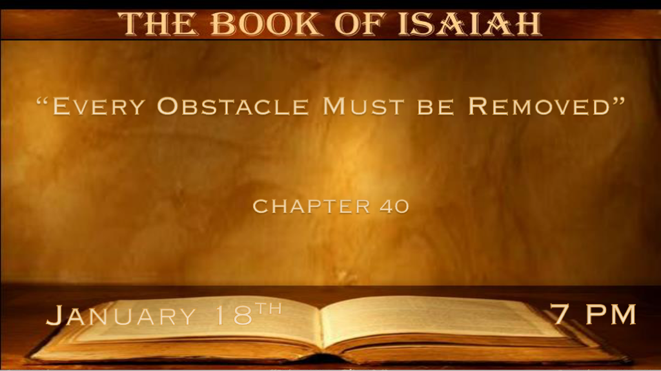

*The Holy Spirit removes every obstacle within the Scriptures.

*Isaiah 40:1 “Comfort, yes, comfort My people!” Says your God. 2 “Speak comfort to Jerusalem, and cry out to her, that her warfare is ended, that her iniquity is pardoned; For she has received from the LORD’s hand double for all her sins.” 3 The voice of one crying in the wilderness: “Prepare the way of the LORD; Make straight in the desert a highway for our God. 4 Every valley shall be exalted and every mountain and hill brought low; The crooked places shall be made straight and the rough places smooth; 5 The glory of the LORD shall be revealed, and all flesh shall see it together; For the mouth of the LORD has spoken.” 6 The voice said, “Cry out!” And he said, “What shall I cry?” “All flesh is grass, and all its loveliness is like the flower of the field. 7 The grass withers, the flower fades, because the breath of the LORD blows upon it; Surely the people are grass. 8 The grass withers, the flower fades, but the word of our God stands forever.”
9 O Zion, You who bring good tidings, get up into the high mountain; O Jerusalem, You who bring good tidings, lift up your voice with strength, lift it up, be not afraid; Say to the cities of Judah, “Behold your God!”

- V:1-2 An amazing jump to the future. The Holy Spirit anticipated every apostasy concerning the Word of God. These things are spoken so we might be comforted. (2 Cor. 1, John 14:16 & 26)
*John 12:38 that the word of Isaiah the prophet might be fulfilled, which he spoke: “Lord, who has believed our report?
And to whom has the arm of the LORD been revealed?” (Isaiah 53:1)
39 Therefore they could not believe, because Isaiah said again:
40 “He has blinded their eyes and hardened their hearts, Lest they should see with their eyes, Lest they should understand with their hearts and turn, So that I should heal them.” (Isaiah 6:10)

Double for all her sins. The 1st born inheritance is double. They received a double opportunity too.

- V:3-5 The assignment of John the Baptist 700 years before he’s born.
*Matthew 3:1 In those days John the Baptist came preaching in the wilderness of Judea, 2 and saying, “Repent, for the kingdom of heaven is at hand!” 3 For this is he who was spoken of by the prophet Isaiah, saying:
“The voice of one crying in the wilderness: Prepare the way of the LORD; Make His paths straight.’ ”

- V:6-8 People’s lives are like grass. The Word of God stands forever.
God’s Word isn’t just forever it will stand forever. The power of The Word of God’s authority is never subject to humanity's interpretation of that authority.

- V:9 Say to the cities of Judah behold your God.
Good tidings are the Gospel of Salvation.

*God has no obstacles but humanity does.

*Isaiah 40:10 Behold, the Lord GOD shall come with a strong hand, and His arm shall rule for Him; Behold, His reward is with Him,
and His work before Him. 11 He will feed His flock like a shepherd; He will gather the lambs with His arm, and carry them in His bosom,
and gently lead those who are with young. 12 Who has measured the waters in the hollow of His hand, measured heaven with a span
and calculated the dust of the earth in a measure? Weighed the mountains in scales and the hills in a balance? 13 Who has directed the Spirit of the LORD, or as His counselor has taught Him? 14 With whom did He take counsel, and who instructed Him, and taught Him in the path of justice? Who taught Him knowledge, and showed Him the way of understanding?
15 Behold, the nations are as a drop in a bucket, and are counted as the small dust on the scales; Look, He lifts up the isles as a very little thing. 16 And Lebanon is not sufficient to burn, Nor its beasts sufficient for a burnt offering. 17 All nations before Him are as nothing, and they are counted by Him less than nothing and worthless. 18 To whom then will you liken God? Or what likeness will you compare to Him? 19 The workman molds an image, the goldsmith overspreads it with gold, and the silversmith casts silver chains. 20 Whoever is too impoverished for such a contribution chooses a tree that will not rot; He seeks for himself a skillful workman to prepare a carved image that will not totter.
21 Have you not known? Have you not heard? Has it not been told you from the beginning? Have you not understood from the foundations of the earth?

- V:10-12 All four Gospel declares Jesus is the Shepherd.
- The care of His flock and His protection started before the flock was formed.

- The connection of this Shepherd with Creation is the same as the Gospel of John.

- V:13-14 Humanities' greatest error is in trying to give God our counsel.
Many professors and pastors wrongly claim God didn’t know how advanced this world would become and that His ways and thoughts were from a more primitive time.

- V:15-17 All Nations are as dust from God’s perspective, the nation’s policy-making is nothing more than vanity. The subject God is referring to is their wisdom and understanding of how life and this world work.

- V:18-21 All Nations have gone astray. They haven’t understood the greatness of God.

*The World needs God who is described as having no obstacles.

*Isaiah 40:22 It is He who sits above the circle of the earth, and its inhabitants are like grasshoppers, who stretches out the heavens like a curtain, and spreads them out like a tent to dwell in. 23 He brings the princes to nothing; He makes the judges of the earth useless.
24 Scarcely shall they be planted, scarcely shall they be sown, scarcely shall their stock take root in the earth, when He will also blow on them, and they will wither, and the whirlwind will take them away like stubble. 25 “To whom then will you liken Me, or to whom shall I be equal?” says the Holy One. 26 Lift up your eyes on high, and see who has created these things, who brings out their host by number;
He calls them all by name, by the greatness of His might and the strength of His power; not one is missing. 27 Why do you say, O Jacob,
and speak, O Israel: “My way is hidden from the LORD, and my just claim is passed over by my God”? 28 Have you not known? Have you not heard? The everlasting God, the LORD, The Creator of the ends of the earth, neither faints nor is weary. His understanding is unsearchable. 29 He gives power to the weak, and to those who have no might He increases strength. 30 Even the youths shall faint and be weary, and the young men shall utterly fall, 31 But those who wait on the LORD shall renew their strength; They shall mount up with wings like eagles, they shall run and not be weary, they shall walk and not faint.

- V:22-23 His throne is above the earth and no authority on the earth surpasses His.
Our founding fathers had this knowledge and understood the only place safe for a Nation was to be under God.

- V:24-28 Once again, humanity has forgotten God's might and greatness.
Question? Who is like our God, He does faint nor is weary. His understanding is unsearchable.
God calls the stars by name. In just the Milky Way if you called out the name of each star at the rate of one per second it would take you 2,500 years to say each star's name.

- V:29-31 God gives power to the weak. Verse 31 is in reverse order, why?
*All who enjoy soaring with God and running in His power, must learn to walk the faithful walk and not faint.

Waiting on God is one of the more difficult aspects of being a follower of Christ. His timing is not ours.

The N.T. reinforces this truth. In our weakness, He is made strong.

