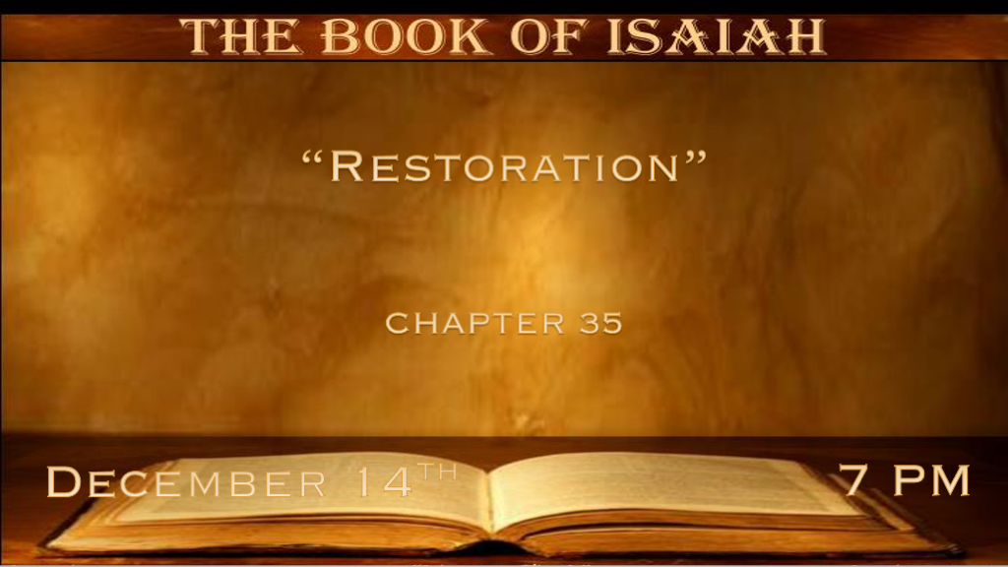

*The restoration of the land and a lot more.
*Isaiah 35:1 The wilderness and the wasteland shall be glad for them, and the desert shall rejoice and blossom as the rose;
2 It shall blossom abundantly and rejoice, even with joy and singing. The glory of Lebanon shall be given to it, the excellence of Carmel and Sharon. They shall see the glory of the LORD, the excellency of our God.

- V:1 A three-part truth After the Assyrians Israel blossomed, it’s happening again in Israel right now. It is also futuristic speaking about the millennial reign.

*Ezekiel 36:35 So they will say, ‘This land that was desolate has become like the garden of Eden; and the wasted, desolate, and ruined cities are now fortified and inhabited.’ 36 Then the nations which are left all around you shall know that I, the LORD, have rebuilt the ruined places and planted what was desolate. I, the LORD, have spoken it, and I will do it.”

- V:2 What will be the distinguishing marks in the third time period?
- The glory of the Lord is a figurative term referring to the very presence of God.

This in itself is amazing. Remember Moses was protected when looking upon God. (Exodus 24:15-17)

Jesus was raised from the dead by the Glory of the Father.

*Romans 6:4 Therefore we were buried with Him through baptism into death, that just as Christ was raised from the dead by the glory of the Father, even so, we also should walk in newness of life.

- The excellency of our God is another level of His glory and his power working in and through us.
*2 Corinthians 3:18 But we all, with unveiled face, beholding as in a mirror the glory of the Lord, are being transformed into the same image from glory to glory, just as by the Spirit of the Lord.

*Now is the time to renew our spiritual strength.

*Isaiah 35:3 Strengthen the weak hands, and make firm the feeble knees. 4 Say to those who are fearful-hearted,
“Be strong, do not fear! Behold, your God will come with vengeance, with the recompense of God; He will come and save you.” 5 Then the eyes of the blind shall be opened, and the ears of the deaf shall be unstopped. 6 Then the lame shall leap like a deer and the tongue of the dumb sing. For waters shall burst forth in the wilderness, and streams in the desert.
7 The parched ground shall become a pool, and the thirsty land springs of water; In the habitation of jackals, where each lay, there shall be grass with reeds and rushes.

- V:3-4 God’s promises are a source of our strength.

God never breaks a promise.
We are to encourage one another with the admonishment to be strong, don’t fear, because God is coming.

- V:5-6a Futuristic with double time-period meaning with insights for the discouraged.

Jesus literally fulfilled this in His first coming. This tells us His power to restore in his second coming is a guarantee. He also quotes these verses when it came to John the Baptist dying.

- *Matthew 11:4 Jesus answered and said to them, “Go and tell John the things which you hear and see: 5 The blind see and the lame walk; the lepers are cleansed and the deaf hear; the dead are raised up and the poor have the gospel preached to them. 6 And blessed is he who is not offended because of Me.”

- V:6b-7 Transformation of the land declaring an abundance will where there once was a shortage.
- *Romans 8:22 For we know that the whole creation groans and labors with birth pangs together until now.

*Transformation in how we live by the High Way of Holiness.

*Isaiah 35:8 A highway shall be there, and a road, and it shall be called the Highway of Holiness. The unclean shall not pass over it, but it shall be for others. Whoever walks the road, although a fool, shall not go astray. 9 No lion shall be there, Nor shall any ravenous beast go up on it; It shall not be found there. But the redeemed shall walk there, 10 And the ransomed of the LORD shall return, and come to Zion with singing, with everlasting joy on their heads. They shall obtain joy and gladness, and sorrow and sighing shall flee away.

- V:8 We will not only get to see our King but we will travel on a raised road.
It is according to Jesus in the Bible it’s a narrow road. Those who found it even if they were not wise in other things they are commended that they found the narrow way & they shall not go astray.

- V:9 The redeemed will walk there. The only highway or road that is identified with no danger on it.
I love the sound of this it’s the highway to heaven.

- V:10 The return of the ransomed. The saints return with a celebration and a song.

