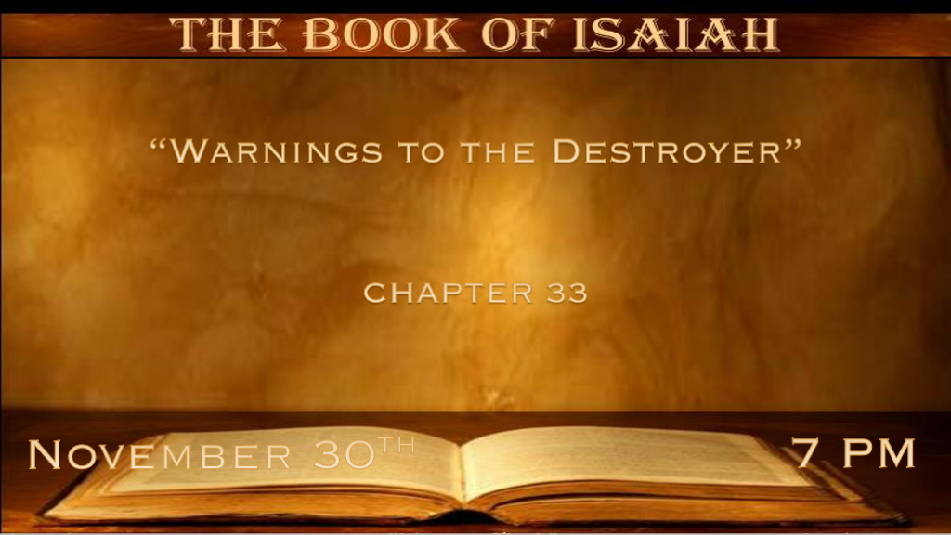

*The reaping and sowing principle.
*Isaiah 33:1 Woe to you who plunder (O destroyer), though you have not been plundered; And you who deal treacherously (O traitor), though they have not dealt treacherously with you! When you cease plundering, you will be plundered; When you make an end of dealing treacherously, they will deal treacherously with you. 2 O LORD, be gracious to us; We have waited for You. Be their arm every morning, our salvation also in the time of trouble.
3 At the noise of the tumult the people shall flee; When You lift Yourself up, the nations shall be scattered; 4 And Your plunder shall be gathered like the gathering of the caterpillar; As the running to and fro of locusts, He shall run upon them.
5 The LORD is exalted, for He dwells on high; He has filled Zion with justice and righteousness. 6 Wisdom and knowledge will be the stability of your times, and the strength of salvation; The fear of the LORD is His treasure. 7 Surely their valiant ones shall cry outside, the ambassadors of peace shall weep bitterly. 8 The highways lie waste, the traveling man ceases.
He has broken the covenant, he has despised the cities, he regards no man. 9 The earth mourns and languishes, Lebanon is shamed and shriveled; Sharon is like a wilderness, and Bashan and Carmel shake off their fruits.

- V:1 The Assyrians were the treacherous destroyers. What they sowed they will soon reap. The timing of this is probably right after the angel kills 185,000 Assyrians in a single night.
Who are the destroyers in our day?
A traitor to the faith will reap what they’d sowed.
Woe to Russia, or any country that wants to plunder other nations.

- V:2-4 The prayers of God’s people.
- Those who look to the Lord every morning shall renew their strength.
- The prayer for grace is a powerful prayer when it’s with a sincere heart.
What is exciting about this verse? Israel is no longer looking to the Egyptians for their help they are looking to the Lord.

- V:5-9 The fear of The Lord is His treasure. Plus: The duplicity of the world becomes greater.
Honor, respect, and reverence towards the LORD are His treasure. It is a gift God gives us, not so we will cower in fear, but so we will rightly honor Him.

Wisdom and knowledge of God will be the stability for the future.
Mourning and languishing for those who don’t accept God and they shall weep bitterly.

*Now is the time for God or it’s a time for His fire.

*Isaiah 33:10 “Now I will rise,” says the LORD; “Now I will be exalted, now I will lift Myself up. 11 You shall conceive chaff, you shall bring forth stubble; Your breath, as fire, shall devour you. 12 And the people shall be like the burnings of lime;
Like thorns cut up they shall be burned in the fire. 13 Hear, you who are afar off, what I have done; And you who are near, acknowledge My might.” 14 The sinners in Zion are afraid; Fearfulness has seized the hypocrites: “Who among us shall dwell with the devouring fire? Who among us shall dwell with everlasting burnings?” 15 He who walks righteously and speaks uprightly, he who despises the gain of oppressions, who gestures with his hands, refusing bribes, who stops his ears from hearing of bloodshed, and shuts his eyes from seeing evil: 16 He will dwell on high; his place of defense will be the fortress of rocks; Bread will be given him, his water will be sure.

- V:10-13 A call to acknowledge God’s Might.
As the world is judged and brought to its knees. God will be lifting Himself up.

- V:14-19 Fearful sinners or blessed saints. Which group will you belong to?

Fear is the greatest tool of the enemy.
Grace is God’s greatest weapon for all who believe.

*Your eyes will see the king that your heart has believed.

*Isaiah 33:17 Your eyes will see the King in His beauty; They will see the land that is very far off. 18 Your heart will meditate on terror: “Where is the scribe? Where is he who weighs? Where is he who counts the towers?” 19 You will not see a fierce people, A people of obscure speech, beyond perception, of a stammering tongue that you cannot understand. 20 Look upon Zion, the city of our appointed feasts; Your eyes will see Jerusalem, a quiet home, a tabernacle that will not be taken down; Not one of its stakes will ever be removed, nor will any of its cords be broken.
21 But there the majestic LORD will be for us a place of broad rivers and streams, in which no galley with oars will sail,
Nor majestic ships pass by 22 (For the LORD is our Judge, The LORD is our Lawgiver, The LORD is our King; He will save us); 23 Your tackle is loosed, They could not strengthen their mast, they could not spread the sail. Then the prey of great plunder is divided; The lame take the prey. 24 And the inhabitant will not say, “I am sick”; The people who dwell in it will be forgiven their iniquity.

- V:17-19 It’s not only seeing our King but seeing him in His beauty.
The ones whose heart is set against Jesus will not find comfort in all the other places that they look.

Isaiah mixes the judgment of the Northern Kingdom and the ultimate judgment of the world.
He also ties in the deliverance of people in the same scenario.

- V:20-21 You will see Jerusalem and this is a brand new one!
A tabernacle that will not be taken down or destroyed. This is an amazing announcement.

- V:22 The Lord is our Judge, Lawgiver, and our King. He will save us.

America’s founding fathers saw that God divided his government over the people. James Madison 4th President and a key contributor to the Constitutional Convention of 1787 suggested this for the United States based on Isaiah 33:22 He will save us.

We have the Judicial system, the Legislators, and the Executive branch of our government. In the USA.
Those leaders knew their Bibles trusting its wisdom.

- V:23-24 God’s provision is realized on earth. This is most likely the millennial age.

Protection the mighty rivers are a symbol of protection in that age.

The inhabitants are not sick.

Generational forgiveness. The breaking of the curse of sin that goes from one generation to another.

