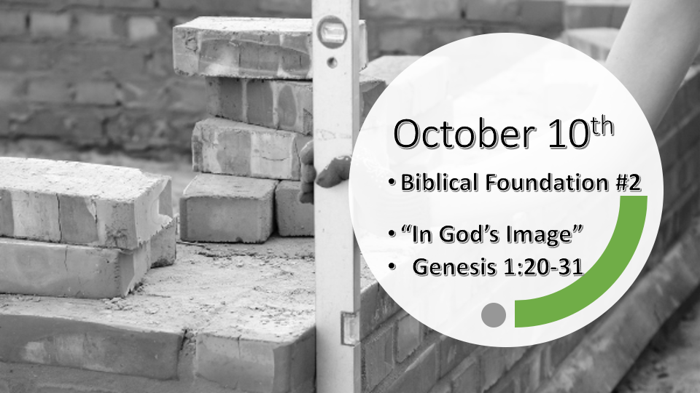

*Psalm 11: 3 When the foundations are being destroyed, what can the righteous do?"

Things we must know about God’s foundations.

- He has set the foundations and He won’t leave them to chance or change. (Job 38:4)

- He has set the universe with the sky, the stars, sun, and moon to mark what is sacred. (Genesis 1:14)

- He has set the appointed times of the end and His coming Kingdom. (Acts 1:6-7)

*Acts 1:7 He said to them: "It is not for you to know the times or dates the Father has set by his own authority.

*Genesis 1:20 And God said, "Let the water teem with living creatures, and let birds fly above the earth across the vault of the sky." 21 So God created the great creatures (Whales in KJV) of the sea and every living thing with which the water teems and that moves about in it, according to their kinds, and every winged bird according to its kind. And God saw that it was good. 22 God blessed them and said, "Be fruitful and increase in number and fill the water in the seas, and let the birds increase on the earth." 23 And there was evening, and there was morning—the fifth day.

*Created plants, trees, fish, birds, and animals have foundational boundaries.

- V:11-12 Vegetation and trees were created according to their kind.

- V:21 Whales, fish were created according to their kind and birds too.

- V:21-22 God not only saw the fish and birds and declared this was good, but He blessed them too.

*Genesis 1:24 And God said, "Let the land produce living creatures according to their kinds: the livestock, the creatures that move along the ground, and the wild animals, each according to its kind." And it was so. 25 God made the wild animals according to their kinds, the livestock according to their kinds, and all the creatures that move along the ground according to their kinds. And God saw that it was good.

*The Devil’s main agenda is to steal glory from God by challenging God’s boundaries.

- Genesis 1:11-25 The total count is eight times God places creation into their categories. The phrase according to their kind is now completed.

- V:24-25 Three times on the 6th day God declares He created according to their kind on the land and God announces it was good. (Colossians 1:16-17 KJV) All things are made by Jesus and by him, all things consist/held together.

*Genesis 1: 26 Then God said, "Let us make mankind in our image, in our likeness, so that they may rule over the fish in the sea and the birds in the sky, over the livestock and all the wild animals, and over all the creatures that move along the ground."
27 So God created mankind in his own image, in the image of God he created them; male and female he created them.
28 God blessed them and said to them, "Be fruitful and increase in number; fill the earth and subdue it. Rule over the fish in the sea and the birds in the sky and over every living creature that moves on the ground."
29 Then God said, "I give you every seed-bearing plant on the face of the whole earth and every tree that has fruit with seed in it. They will be yours for food. 30 And to all the beasts of the earth and all the birds in the sky and all the creatures that move along the ground—everything that has the breath of life in it—I give every green plant for food. " And it was so.
31 God saw all that he had made, and it was very good. And there was evening, and there was morning—the sixth day.

*God’s image is above all other forms of creations with foundational differences.

- *V:26-28 We are made in his image, likeness, and to rule over all other parts of creation. (The blessing is fruitfulness and dominion.)

- *V:29-30 All other subordinate categories are ours to eat, to enjoy, and to be in charge of them. (AMEN – and it was so.)

- *V:24-30 Some important stats. God spoke 4 times on the sixth day. He declares two things as good. (Humanity created in His image is the ONLY thing God declares as VERY good.)

*Genesis 2:1 Thus the heavens and the earth were completed in all their vast array.
2 By the seventh day God had finished the work he had been doing; so on the seventh day, he rested from all his work. 3 Then God blessed the seventh day and made it holy because on it he rested from all the work of creating that he had done.

*God’s great gift to all creation was rest, and to humanity, He uses it too introduces us to the holy.

- What does it mean to be set apart? (Removed from the unholy to the holy)
- God sets the foundation of rest. (He did this on day 4 when he created sacred, times, days & years)

