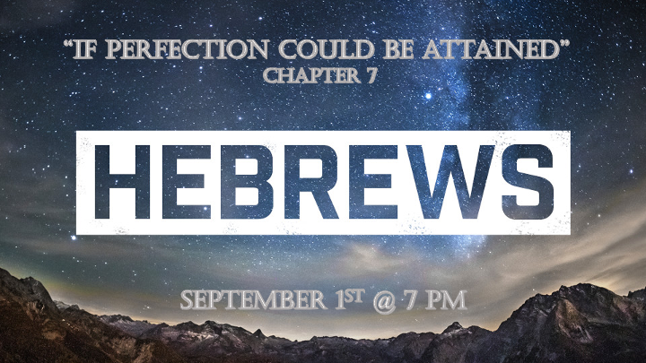

*Overview of Hebrews

*Let us not drift away from our faith in God. (Chapter 2:1-4)
*Let us not disobey the teaching of God. (Chapters 3:7 - 4:13)
*Let us not be deformed in our faith, the call to maturity in the Spirit. (Chapters 5:11- 6:20)

*Hebrews7:1 This Melchizedek was king of Salem and priest of God Most High. He met Abraham returning from the defeat of the kings and blessed him, 2 and Abraham gave him a tenth of everything. First, the name Melchizedek means "king of righteousness"; then also, "king of Salem" means "king of peace." 3 Without father or mother, without genealogy, without beginning of days or end of life, resembling the Son of God, he remains a priest forever.

4 Just think how great he was: Even the patriarch Abraham gave him a tenth of the plunder! 5 Now the law requires the descendants of Levi who become priests to collect a tenth from the people—that is, from their fellow Israelites—even though they also are descended from Abraham. 6 This man, however, did not trace his descent from Levi, yet he collected a tenth from Abraham and blessed him who had the promises. 7 And without doubt the lesser is blessed by the greater. 8 In the one case, the tenth is collected by people who die; but in the other case, by him who is declared to be living. 9 One might even say that Levi, who collects the tenth, paid the tenth through Abraham, 10 because when Melchizedek met Abraham, Levi was still in the body of his ancestor.

*A Shadow of what’s to come and parallels.

- V:1-2 Melchizedek was both priest (righteous) and king (peace) the same as Jesus.

- V:3 He had no beginning or end in the same manner resembling Jesus. John 1:1, Psalm 110:4

- V:4-6 Abraham reveals Melchizedek superiority by tithing to him a tenth of all he had.

- V:7 Melchizedek blesses Abraham. The greater blesses the lesser.

- V:8 Melchizedek was an independent High Priest as was Jesus both serving (V:1) the most- high God.

- V:9 Melchizedek priesthood was universal. Jesus universal priesthood was also confirmed. Our God so loved the world that he sent His son. (John 3:16)

*Hebrews7:11 If perfection could have been attained through the Levitical priesthood—and indeed the law given to the people established that priesthood—why was there still need for another priest to come, one in the order of Melchizedek, not in the order of Aaron? 12 For when the priesthood is changed, the law must be changed also. 13 He of whom these things are said belonged to a different tribe, and no one from that tribe has ever served at the altar. 14 For it is clear that our Lord descended from Judah, and in regard to that tribe Moses said nothing about priests. 15 And what we have said is even more clear if another priest like Melchizedek appears, 16 one who has become a priest not on the basis of a regulation as to his ancestry but on the basis of the power of an indestructible life. 17 For it is declared: "You are a priest forever, in the order of Melchizedek."

*Perfection can NOT be obtained through the priesthood.

- V:11 The Levitical priesthood could never bring perfection (absolution) to the people. It would only serve as a reminder of our need for a savior.

- V:12-15 The purpose of the priesthood was removed. Jesus fulfilled and superseded the purpose of the priest.

- V:16-17 The power Jesus has over sin is based on his indestructible life.

*Hebrews7:18 The former regulation is set aside because it was weak and useless 19 (for the law made nothing perfect), and a better hope is introduced, by which we draw near to God.

20 And it was not without an oath! Others became priests without any oath, 21 but he became a priest with an oath when God said to him: "The Lord has sworn and will not change his mind: 'You are a priest forever.' "

22 Because of this oath, Jesus has become the guarantor of a better covenant.

23 Now there have been many of those priests, since death prevented them from continuing in office; 24 but because Jesus lives forever, he has a permanent priesthood. 25 Therefore he is able to save completely those who come to God through him, because he always lives to intercede for them.

*Releasing the law & surrender are the steps to draw near to God.

- V:18-19 Our world needs a better hope not a weak and useless system. It’s Jesus who saves and sustains us. No substitutes are allowed.

- V:20-22 The guarantee of a better covenant. The O.T. Covenant was to give us insight into the future but it had no power to set us free.

- V:23-25 Jesus is the only priest you will ever need and He intercedes for us before God. (Please don’t let a man take the place of Jesus in your life.

