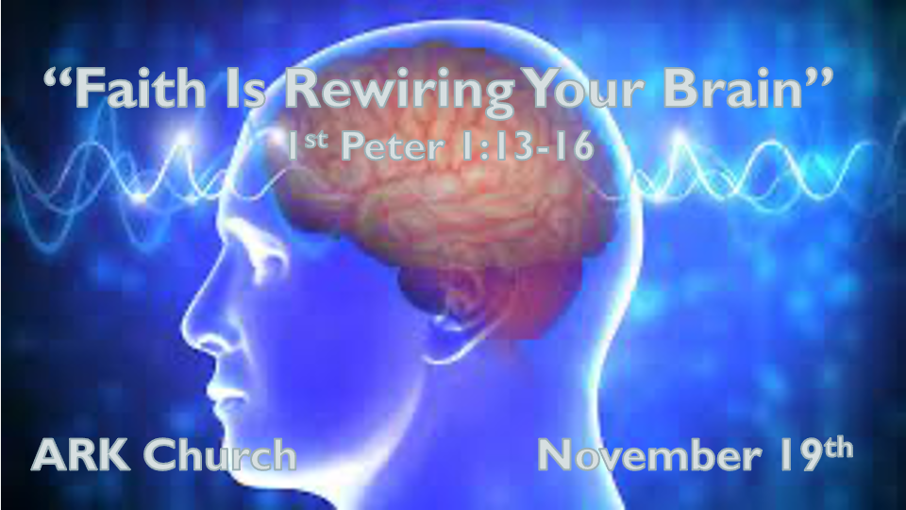
*A Biblical Eternal Perspective will enable the Rewiring of your Mind.

*I Peter 1:13 Therefore gird up the loins of your mind, be sober, and rest your hope fully upon the grace that is to be brought to you at the revelation of Jesus Christ; 14 as obedient children, not conforming yourselves to the former lusts, as in your ignorance; 15 but as He who called you is holy, you also be holy in all your conduct, 16 because it is written, "Be holy, for I am holy."

*The Power of Biblical Thinking

Insights I Peter 1:13 *Girding up the loins of your mind

Guarding your thoughts 2 Cor. 10:5 We take captive our thoughts to make them obedient.

- *V:13 The call to sober thinking
- *V:13 The need to rest or take mental breaks. An overactive mind is less hopeful.
- *V:13 Not Focusing on Jesus and His grace. We allow distractions to be the norm.

Faith is both an unlearning and learning process, adding the new truths of God as a manner of retraining our minds.

Be Sober Titus 2:6 Teach the young to be sober-minded.

In a recent survey, 64 percent of Americans believe that social media negatively impacts our country. A negative story has a higher click rate of 60% than a positive story.

*1 Peter 5:8 Be sober, be vigilant; because your adversary the devil walks about like a roaring lion, seeking whom he may devour. 9 Resist him, steadfast in the faith, knowing that the same sufferings are experienced by your brotherhood in the world.

- Clarity in thought only comes from a clear mind anointed by The Holy Spirit and the Word.
- Vigilant is being attentive and understanding what's trying to control our attention and why.
- Resisting the distractions of the mind through a routine of faith wiring.
- A devoured mind. (The lion has destroyed many minds) It works in two directions: it can think more highly of itself or lower than it should.

Insights about the wiring of our brain to the portion of faith given to us.

*Romans 12:2 And do not be conformed to this world, but be transformed by the renewing of your mind, that you may prove what is that good and acceptable and perfect will of God.
3 For I say, through the grace given to me, to everyone who is among you, not to think of himself more highly than he ought to think, but to think soberly, as God has dealt to each one a measure of faith. 4 For as we have many members in one body, but all the members do not have the same function, 5 so we, being many, are one body in Christ, and individually members of one another. 6 Having then gifts differing according to the grace that is given to us, let us use them: if prophecy, let us prophesy in proportion to our faith; 7 or ministry, let us use it in our ministering; he who teaches, in teaching; 8 he who exhorts, in exhortation; he who gives, with liberality; he who leads, with diligence; he who shows mercy, with cheerfulness.
- V:2 A pattern of thinking about God's will.
- V:3 Think soberly about your measure of faith.
- V:4-8 Allow for individuality to think according to their brain and gifted function.
- Prayer: Lord, increase our faith and heal our minds.

Insights for I Peter 1:14-16 Obedient children of God must not be ignorant but move to holiness.

Obedience is submission to a greater authority.

Ignorance is a default mode of mind when there are subjects that we don't believe have definitive answers.

*Christians' greatest ignorance is still around who Jesus is and The Word of God. (The only two sources of holiness)

*John 1:29 & 36 The next day John saw Jesus coming toward him, and said, "Behold! The Lamb of God who takes away the sin of the world!

How many accept Jesus as the Lamb of God who took away the sin of the world?

*Revelation 13:8 All who dwell on the earth will worship him, whose names have not been written in the Book of Life of the Lamb slain from the foundation of the world.

How many will stand on the truth that Jesus chose to die before the foundation of the world was laid?

*Revelation 12:11 They overcame him by the blood of the Lamb.
*Revelation 6:15 And said to the mountains and rocks, "Fall on us and hide us from the face of Him who sits on the throne and from the wrath of the Lamb! 17 For the great day of His wrath has come, and who is able to stand?"

How many believe in the blood of the lamb that enables us to be overcomers?
Will you accept that same lamb the Savior is also the one people want to hide from because of His wrath?

*Revelation 14:10 (those who worship the beast) he himself shall also drink of the wine of the wrath of God, which is poured out full strength into the cup of His indignation. He shall be tormented with fire and brimstone in the presence of the holy angels and in the presence of the Lamb.

Is this the same Lamb of God who is now watching the full strength of wrath poured out on those who take the mark of the beast?
Revelation 14:9 Then a third angel followed them, saying with a loud voice, "If anyone worships the beast and his image, and receives his mark on his forehead or on his hand, 10 he himself shall also drink of the wine of the wrath of God, which is poured out full strength into the cup of His indignation. He shall be tormented with fire and brimstone in the presence of the holy angels and in the presence of the Lamb. 11 And the smoke of their torment ascends forever and ever; and they have no rest day or night, who worship the beast and his image, and whoever receives the mark of his name."

Revelation 21:22 But I saw no temple in it (The New Jerusalem), for the Lord God Almighty and the Lamb are its temple. 23 The city had no need of the sun or of the moon to shine in it, for the glory of God illuminated it. The Lamb is its light. 24 And the nations of those who are saved shall walk in its light, and the kings of the earth bring their glory and honor into it. 25 Its gates shall not be shut at all by day (there shall be no night there). 26 And they shall bring the glory and the honor of the nations into it. 27 But there shall by no means enter it anything that defiles, or causes an abomination or a lie, but only those who are written in the Lamb's Book of Life.

Only Twos verse about Jesus being the lamb of God outside of Revelation 1 Peter 1:19 A lamb without blemish.
Seven verses in total declare Jesus as the Lamb of God, but five of those verses came from Revelation.

The Lamb's book of life. That's the title of the Book of Life. It's not a hotel registry. It is a journal about people who became citizens of heaven and took God's incorruptible and undefiled nature. Who by faith allowed His Holy Word to transform and rewire their minds so that they could live to the level of obedience pleasing to God.

