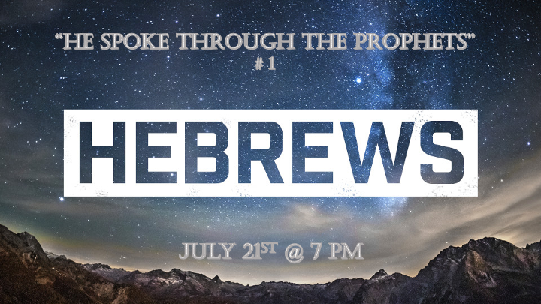

The Overview of Hebrews

- Hebrews will establish you in sound teaching/doctrine and prophetic patterns.
- *Christology – the study of The Messiah
- *Soteriology – the study of Salvation
- *Eschatology – the study of end times focused on the millennial period.

- The superiority of Jesus to the three pillars of Judaism. Those pillars are angels, Moses (The law), and the (Aaron) Levitical priesthood. Sobering truth: *The Exodus saw a generation freed from captivity but only two went on to the inheritance of the “Promise land”.

- 5 Major warnings as prophetic warnings. *The drifting from the truth, disobedience to the truth by believers (ignorance), the lack of maturity of the believer, the willful sinning of believers, and the indifference of believers will mark the future with the fulfillment of these prophecies.

*Hebrews 1:1 In the past God spoke to our ancestors through the prophets at many times and in various ways, 2 but in these last days he has spoken to us by his Son, whom he appointed heir of all things, and through whom also he made the universe. 3 The Son is the radiance of God's glory and the exact representation of his being, sustaining all things by his powerful word. After he had provided purification for sins, he sat down at the right hand of the Majesty in heaven.

*When God speaks His communication is flawless.

- V:1 The main point of the Bible, it’s God speaking to humanity. His vessels in the O. T. was the Prophets and in the N. T., the vessel is Jesus. *If you have a problem with prophecy, you may have a problem hearing God’s voice.

- V:1-3 Our Messiah is the Creator, and the sustainer of life. The purification of our sins is the greatest gift to humanity but don’t miss all that He is and does. *Jesus is revealed as Prophet, Priest and King all within the first three verses.

- Jesus is the Revealer of all things concerning humanity’s need and the Kingdom’s provision.
*The sustainer of all things!

*Hebrews 1:4 So he became as much superior to the angels as the name he has inherited is superior to theirs. 5 For to which of the angels did God ever say, "You are my Son; today I have become your Father"? Or again, "I will be his Father, and he will be my Son"?

6 And again, when God brings his firstborn into the world, he says, "Let all God's angels worship him."

7 In speaking of the angels he says, "He makes his angels spirits, and his servants flames of fire."

*Jesus and His angels are on a mission for the Kingdom of God.

- 1st Pillar of Judaism. Angels hold a special place in Jewish hearts, some even wrongly worshipped them. Yet they rejected the Son of God (Yeshua) as the Messiah.

- Angels are messengers and servants of God. According to Hebrews 2:2, Acts 7:53, Galatians 3:19 The Law was given to Moses by angels.

Hebrews 1:8 But about the Son he says, "Your throne, O God, will last for ever and ever; a scepter of justice will be the scepter of your kingdom.
9 You have loved righteousness and hated wickedness; therefore God, your God, has set you above your companions by anointing you with the oil of joy."
10 He also says, "In the beginning, Lord, you laid the foundations of the earth, and the heavens are the work of your hands.
11 They will perish, but you remain; they will all wear out like a garment.
12 You will roll them up like a robe; like a garment they will be changed. But you remain the same, and your years will never end."
13 To which of the angels did God ever say, "Sit at my right hand until I make your enemies a footstool for your feet"?
14 Are not all angels ministering spirits sent to serve those who will inherit salvation?

*The Throne of Justice is Being Established and So Much More!

- V:8-9 Prophetic time. This is the Millennial reign of Christ.

- V:10-13 The Foundations of the earth.

- V:14 The inheritance is a major theme to the believers and there are angels assigned to us so that we have the best opportunity to receive full salvation.

