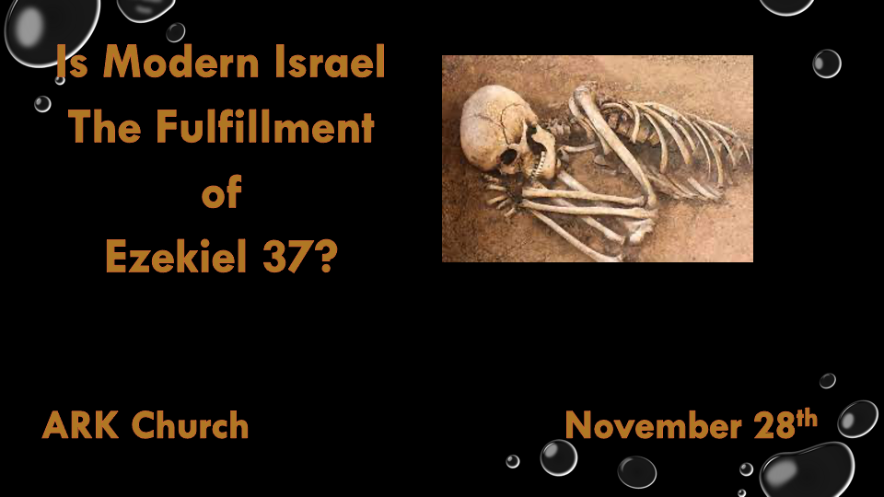
Review Chapter 36
Israel is a great comeback story, and they will no longer deal with the shame of other nations.
Their economy and the Land will be replenished when God breathes life into a nation or people. You will have life, indeed.

The prophecy is still in our future that Israel will become followers of Yeshua, The Christ.

Chapter 37
Two major prophecies are spoken. One has happened, and the other is about to happen in 2024

*The Dry Bones and the House of Israel are one.

Insights for Ezekiel 37:1-10
- There is a three-part process for dry bones to live again.
*Israel's return as a nation was attached to the Jews hearing/believing the Word of the Lord.
Ezekiel commanded to prophesy to the breath that those who were slain might live again.

- The 1st part was that life would come back to Israel. The 2nd part was they would be a great army.
Israel’s existence (Life) became a reality on May 14, 1948. Their nation’s spiritual life is still dead.

- Part 3: The rattling of the bones, the assembly of the body, and the breath of God
Modern-day Israel is still in the process of the assembly.

*Ezekiel 37:1:11 Then He said to me, “Son of man, these bones are the whole house of Israel. They indeed say, Our bones are dry, our hope is lost, and we ourselves are cut off!’ 12 Therefore prophesy and say to them, ‘Thus says the Lord GOD: “Behold, O My people, I will open your graves and cause you to come up from your graves, and bring you into the land of Israel. 13 Then you shall know that I am the LORD, when I have opened your graves, O My people, and brought you up from your graves. 14 I will put My Spirit in you, and you shall live, and I will place you in your own land. Then you shall know that I, the LORD, have spoken it and performed it,” says the LORD.’ ”

Insights V:11 The People, the Land, and the Nation are Israel, and they are the dry bones of Ezekiel 37
What are dry bones? They are the bones of someone who died a long time ago.

Israel died as a Nation in 70 A.D. and came back to life in 1948 A.D. 1,878 years; the nation couldn’t exist until they accepted the Word of God.

V:12-13 God will bring them back from the grave (After much death). Then, we will know that God and His Word are the source of truth.

V:14 The Promise: The Holy Spirit will be in the Jewish people, and they will be in the land. A millennial reign of Christ is the only path.

*The Prophecies of Unification
*Ezekiel 37:15 Again the word of the LORD came to me, saying, 16 “As for you, son of man, take a stick for yourself and write on it: ‘For Judah and for the children of Israel, his companions.’ Then take another stick and write on it, ‘For Joseph, the stick of Ephraim, and for all the house of Israel, his companions.’ 17 Then join them one to another for yourself into one stick, and they will become one in your hand.
18 “And when the children of your people speak to you, saying, Will you not show us what you mean by these?’— 19 say to them, ‘Thus says the Lord GOD: “Surely I will take the stick of Joseph, which is in the hand of Ephraim, and the tribes of Israel, his companions; and I will join them with it, with the stick of Judah, and make them one stick, and they will be one in My hand.” ’ 20 And the sticks on which you write will be in your hand before their eyes.
21 “Then say to them, ‘Thus says the Lord GOD: “Surely I will take the children of Israel from among the nations, wherever they have gone, and will gather them from every side and bring them into their own land; 22 and I will make them one nation in the land, on the mountains of Israel; and one king shall be king over them all; they shall no longer be two nations, nor shall they ever be divided into two kingdoms again. 23 They shall not defile themselves anymore with their idols, nor with their detestable things, nor with any of their transgressions; but I will deliver them from all their dwelling places in which they have sinned, and will cleanse them. Then they shall be My people, and I will be their God.

Insights V:15-20 The separation of Judah and the House of Israel will one day unite.

V:15 & 16 Judah's name represents the region of Jerusalem and the southern kingdom. His companions comprise four tribes associated with the south: Judah, Benjamin, Simeon, and Levi. The northern kingdom did away with the use of priests, and they migrated south.

Joseph/Ephraim are the names representing the Northern Kingdom. Their companions include the other eight tribes of Israel. The North was known as the House of Israel.

Ephraim was born out of Israel when Joseph was in Egypt. The majority of those born out of Israel today live in one nation (U.S.A.) that God raised up to represent His final Jubilee and Liberty.

Is the Jew heading home? Yes! See the two sticks God drew on the United States over seven years: the 2017-2024 eclipses.

V:18-20 God will make them one stick. The Christians don’t bring this about, and neither do governments.

V:21-23 After making them one, God will make them holy.

*David shall be king over Israel, but David is Dead.

*Ezekiel 37:24: “David My servant shall be king over them, and they shall all have one shepherd; they shall also walk in My judgments and observe My statutes, and do them. 25 Then they shall dwell in the land that I have given to Jacob My servant, where your fathers dwelt; and they shall dwell there, they, their children, and their children’s children, forever; and My servant David shall be their prince forever. 26 Moreover I will make a covenant of peace with them, and it shall be an everlasting covenant with them; I will establish them and multiply them, and I will set My sanctuary in their midst forevermore. 27 My tabernacle also shall be with them; indeed I will be their God, and they shall be My people. 28 The nations also will know that I, the LORD, sanctify Israel, when My sanctuary is in their midst forevermore.” ’ ”

Insights for V:24 David can only become king again when heaven comes to earth in the new millennium.

V:24-25 David being prince forever is because Jesus the King will be the only king on the planet.
The concept teaches that David and us will reign with Jesus.

V:26-28 What does it mean to you that God sanctifies Israel?

The setting a part is at the core of the concept of sanctification. The spirit-filled Jews finally, during the thousand-year reign, became all that God chose His nation to be.

