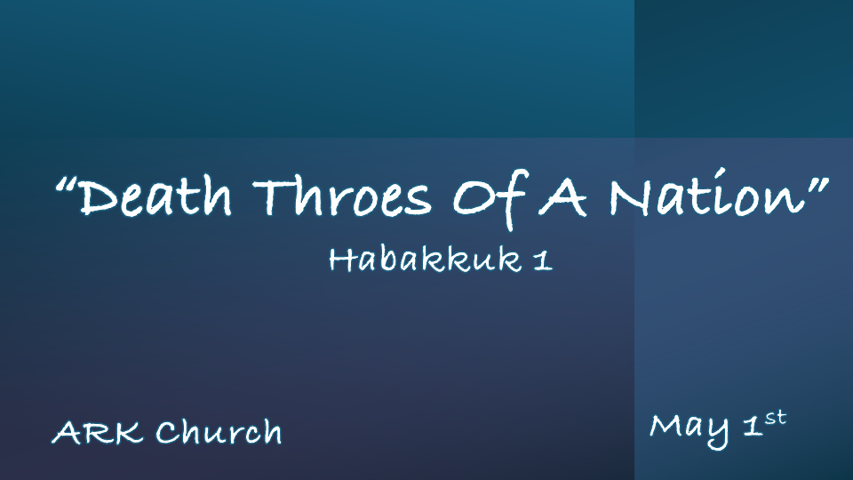
Habakkuk 612 BC to 586 BC
Habakkuk means One who embraces or One who clings.

*The Question Of The Day?

*Habakkuk 1:1 The burden which the prophet Habakkuk saw.
2 O LORD, how long shall I cry, and You will not hear? Even cry out to You, “Violence!” And You will not save.
3 Why do You show me iniquity, and cause me to see trouble? For plundering and violence are before me; There is strife, and contention arises. 4 Therefore the law is powerless, and justice never goes forth. For the wicked surround the righteous; Therefore perverse judgment proceeds.

- V:1 What burdens are you facing?

There’s a moral/physical burden
There’s a spiritual/eternal burden
There’s a National/government burden

Burdens are a part of our prayer list.

- V:2-4 Is it trouble or a privilege to discern the signs of the time?

Habakkuk cries out violence in verse 2 and says it’s ever before him in verse 3.
Violence is the Hebrew word H2555, translated in Hebrew as Hamas

We must see iniquity to be set free from it.

It is both a privilege and distressful to discern sin. Seeing the iniquity of others and in our own lives is a weight to bear.
Perverse judgment is a sign of a falling society.
The invasion of the wicked is not an exception but the norm that the wicked surround the righteous.

*What is God Doing When a Nation is Dying?

*Habakkuk 1:5 “Look among the nations and watch—Be utterly astounded! For I will work a work in your days which you would not believe, though it were told you. 6 For indeed I am raising up the Chaldeans, a bitter and hasty nation which marches through the breadth of the earth, to possess dwelling places that are not theirs.
7 They are terrible and dreadful; Their judgment and their dignity proceed from themselves. 8 Their horses also are swifter than leopards, and more fierce than evening wolves. Their chargers charge ahead; Their cavalry comes from afar; They fly as the eagle that hastens to eat. 9 “They all come for violence; Their faces are set like the east wind. They gather captives like sand. 10 They scoff at kings, and princes are scorned by them. They deride every stronghold, for they heap up earthen mounds and seize it.
11 Then his mind changes, and he transgresses; He commits offense, ascribing this power to his god.”

- V:5-6 Get ready to see all that God is about to do!
Get ready! Be utterly amazed, for God is working in our days.

The pattern is God uses a bitter and hasty nation to chastise the wayward nation of Israel.

Another pattern was they possessed dwelling places that were not theirs.

- V:7-11 Their transgressions and offenses ascribed the power to their god.
Weird similarities and outcomes in Israel’s war today.
- The Hamas and Hezbollah resources come from afar (Iran) V:8

- They don’t come for true victory. They came for violence. V:9

- They gather captives. Babylon did this, and so did Hamas. V:9

- They scoff at other world leaders. V:10

- They ridicule every stronghold. V:10

- Their crimes and transgressions boast that they are from their god. V:11

*Why Does God Bring Wrath In This Way?

*Habakkuk 1:12 Are You not from everlasting, O LORD my God, my Holy One? We shall not die. O LORD, You have appointed them for judgment; O Rock, You have marked them for correction. 13 You are of purer eyes than to behold evil, and cannot look on wickedness. Why do You look on those who deal treacherously, and hold Your tongue when the wicked devours a person G
14 Why do You make men like fish of the sea, like creeping things that have no ruler over them? 15 They take up all of them with a hook, they catch them in their net, and gather them in their dragnet. Therefore they rejoice and are glad. 16 Therefore they sacrifice to their net, and burn incense to their dragnet; Because by them their share is sumptuous and their food plentiful.
17 Shall they therefore empty their net, and continue to slay nations without pity?

- V:12-13 A particular generation is being marked for correction.
You have appointed them for judgment and marked them for correction.

Like Habakkuk, we are more concerned with God’s methods than the sin.

- V:14-16 Difficult questions: Why does God use treachery and wicked people? How do we address the permissive will of God?
What we become, we attract. The more sinful we are, the more we attract evil people.

God’s permissive will is only for a season. His perfect will is always the final result.

- V:17 Who is in control of sinful nations?
Though God allows wicked nations to be what a sinful nations reap, God is sovereign.

