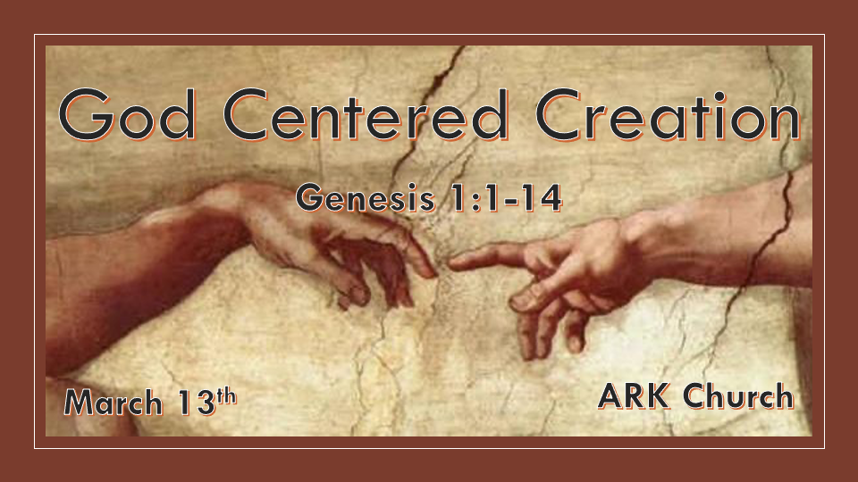

*God Speaks the Origin/Source of Life in Existence, and The Heavens declare His Glory.

*Genesis 1:1 In the beginning God created the heavens and the earth. 2 The earth was without form, and void; and darkness was on the face of the deep. And the Spirit of God was hovering over the face of the waters.
3 Then God said, “Let there be light” and there was light. 4 And God saw the light, that it was good; and God divided the light from the darkness. 5 God called the light Day, and the darkness He called Night. So the evening and the morning were the first day.
6 Then God said, “Let there be a firmament in the midst of the waters, and let it divide the waters from the waters.” 7 Thus God made the firmament, and divided the waters which were under the firmament from the waters which were above the firmament; and it was so. 8 And God called the firmament Heaven. So the evening and the morning were the second day.

- V:1-2 Chaos means to be without form, void, and darkness.
As God creates, He removes Chaos. God brings order as He establishes the day started in darkness.

Interestingly, most people start their day at midnight, while the Jewish people start at sunset. Both have the day beginning without the sun. (There is no sun on the 1st day of creation)

Earth is the name God gave our planet. It was without form. As Adam was created in a mature form, Is it possible God created the earth with maturity already built in?

- V:3-5 God sets the order of the day and its vocabulary.
When you purchase a car, the owner’s manual has named the different parts of the vehicle. We would never think of changing the names in the directory; only the inventor and designer of the car have that right.

Light is called Day and starts with the morning light
Darkness God calls Night and is associated with the lack of light.

There was darkness and light because God said so. Yet, there was no sun or moon.

- V:6-8 Every day has a different purpose within it.
The Second day has its unique characteristics. Waters being divided from the waters was a given God’s declares, and it was so.
In life, we deal with many situations that are not good. Believers can say, “And it was so,” or Amen to whatever took place.
It’s a season of holding on as God is working.

*A Double Good Day.

*Genesis 1:9 Then God said, “Let the waters under the heavens be gathered together into one place, and let the dry land appear”; and it was so. 10 And God called the dry land Earth, and the gathering together of the waters He called Seas. And God saw that it was good.
11 Then God said, “Let the earth bring forth grass, the herb that yields seed, and the fruit tree that yields fruit according to its kind, whose seed is in itself, on the earth” and it was so. 12 And the earth brought forth grass, the herb that yields seed according to its kind, and the tree that yields fruit, whose seed is in itself according to its kind. And God saw that it was good. 13 So the evening and the morning were the third day.

V:9-10 Let the dry land appear again. God calls it earth. Declares Earth and the Seas as good.

V:11-13 Grass, the herb that yields seed and fruit trees, is created. All were designed according to their kind, and God declared this good. The Second good spoken in one day gets the attention of the Hebrew people. John Chapter 2 (The creation miracle)

Two books
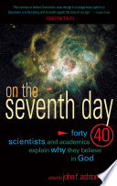
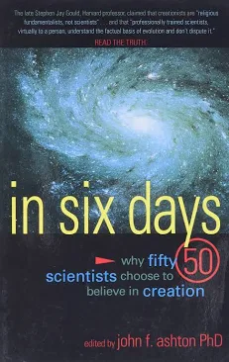

*The Sacred and Signs are Part of the Plan of Creation

*Genesis 1:14 Then God said, “Let there be lights in the firmament of the heavens to divide the day from the night; and let them be for signs and seasons, and for days and years; 15 and let them be for lights in the firmament of the heavens to give light on the earth”; and it was so. 16 Then God made two great lights: the greater light to rule the day, and the lesser light to rule the night. He made the stars also. 17 God set them in the firmament of the heavens to give light on the earth, 18 and to rule over the day and over the night, and to divide the light from the darkness. And God saw that it was good. 19 So the evening and the morning were the fourth day.

V:14-16 The creation of the sun, moon, stars, and time itself raises more questions than it answers.

V:14-15 The lights were created to mark signs and seasons.
- Every season has a sign attached to it.
- Every sign has God’s plan ready to be revealed.
- Both are created before there is a human being to share in them.

V:16 The sun, the greater light the moon, the lesser light to rule the night.

Inside verse 16 is a job description.
The moon gets its light by being a reflector of the greater light. So must we reflect God’s light.
The moon is assigned to rule the night.

V:17-19 The greater and lesser light rule over the day and the night. No darkness was ever created to have dominion but to be diminished by the light.

