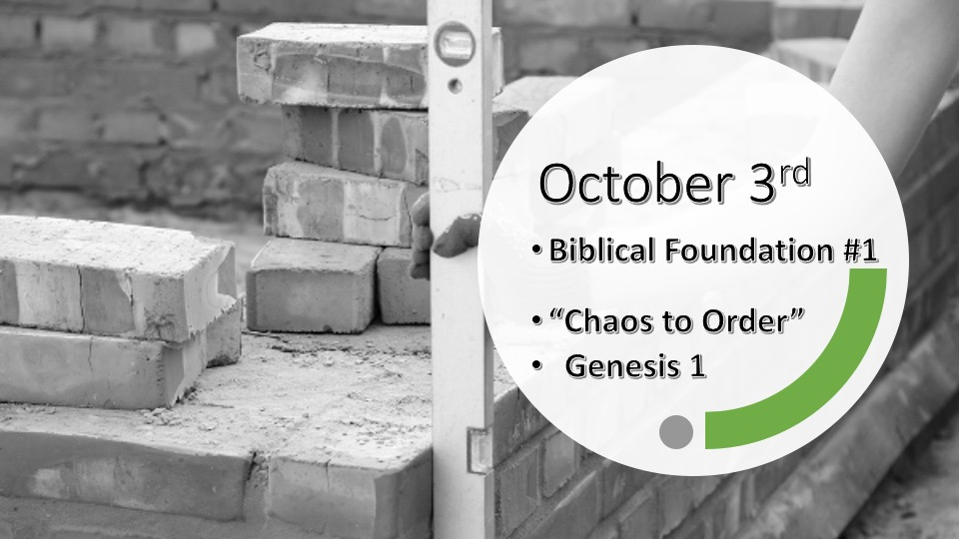

*Building our families on the foundation of God’s Word. (How do we know it’s from God and not a counterfeit?)

*Isaiah 46:10 (KJV) Declaring the end from the beginning and from ancient times the things that are not yet done, saying, My counsel shall stand, and I will do all my pleasure: (God writes history before it happens. We call it prophecy)

Chaos to Order pictures

*Genesis 1:1 In the beginning God created the heavens and the earth. 2 Now the earth was formless and empty, darkness was over the surface of the deep, and the Spirit of God was hovering over the waters.

3 And God said, "Let there be light," and there was light. 4 God saw that the light was good, and he separated the light from the darkness. 5 God called the light "day," and the darkness he called "night." And there was evening, and there was morning—the first day.

*Within the creation story there are different layers of revelation knowledge.

- V:1-2 The Creator is never afraid of emptiness nor darkness. When God’s presence moves over something a change is about to happen. He creates order out of Chaos. (He sees our chaos as an opportunity to reveal himself to us.)

- V:3-5 God’s words are powerful! God declares light as good and it will always be separated from the darkness. Darkness will be associated with night and light with the day. This is before a 24-hour period is created but God calls it the 1st day. (God worked evening till morning) Darkness is linked with chaos and light will be attached to order.

*Genesis 1:6 And God said, "Let there be a vault between the waters to separate water from water." 7 So God made the vault and separated the water under the vault from the water above it. And it was so. 8 God called the vault "sky." And there was evening, and there was morning—the second day.

*Within “Creation” and life there are identifying times as “And it was so.”

- V:6-7 God is still speaking and things are coming to order but, it may seem like not much is happening.

- V:8 It is the one day nothing is declared good. But it is a significant spiritual day as the sky is created. (It is the most orderly part of creation you can navigate and tell time from it.)

*Genesis 1:9 And God said, "Let the water under the sky be gathered to one place, and let dry ground appear." And it was so. 10 God called the dry ground "land," and the gathered waters he called "seas." And God saw that it was good.

11 Then God said, "Let the land produce vegetation: seed-bearing plants and trees on the land that bear fruit with seed in it, according to their various kinds. " And it was so. 12 The land produced vegetation: plants bearing seed according to their kinds and trees bearing fruit with seed in it according to their kinds. And God saw that it was good. 13 And there was evening, and there was morning—the third day.

*How do we live a double-good and double blessed day? What made it a double good day?

- *V:9-13 On the third day God declares something is good twice. What is created? (The land and the seas are created. The seeds of fruit and vegetation are created. God will use all of these to teach lessons on boundaries Psalm 74:17 and the power of a single seed. 2Cor. 9:10 and Matthew Chapter 13)

- *John 2:1 On the third day a wedding took place at Cana in Galilee. Jesus' mother was there, 2 and Jesus and his disciples had also been invited to the wedding. 3 When the wine was gone, Jesus' mother said to him, "They have no more wine."

- V:9 &11 What made it a double good day?

*Genesis 1:14 And God said, "Let there be lights in the vault of the sky to separate the day from the night, and let them serve as signs to mark sacred times, and days and years, 15 and let them be lights in the vault of the sky to give light on the earth." And it was so. 16 God made two great lights—the greater light to govern the day and the lesser light to govern the night. He also made the stars. 17 God set them in the vault of the sky to give light on the earth, 18 to govern the day and the night, and to separate light from darkness. And God saw that it was good. 19 And there was evening, and there was morning—the fourth day.

*Chaos moves to order as we let God mark what is sacred.

- V:14 The ability to keep track of time was created on the 4th day. (Note: God is not limited to the time he is the creator of it.)

- V: 14-17 Before there was humanity. There were sacred times set for them. Some will be marked as sacred times, days, and others as sacred years. (Sacred times could be the two-advent season around his first and second coming. Sacred days are the 7 feasts of Israel. Sacred years are the Shemitah and the Jubilee.)

