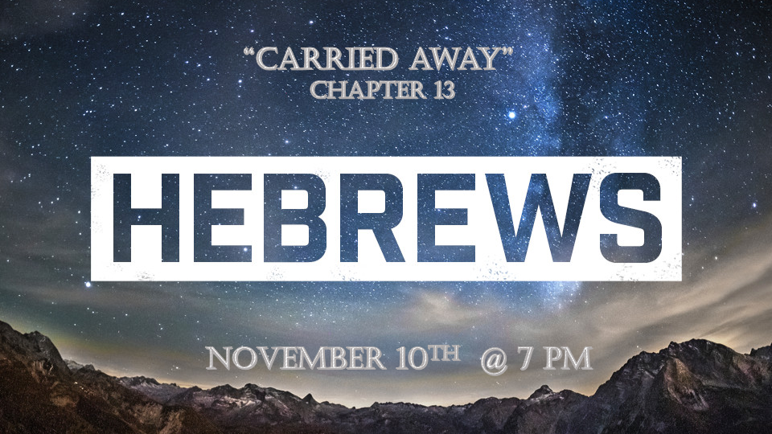

*The 5 Prophetic Warnings in Hebrews are preparing us for what’s coming.

*Hebrews 13:1 Keep on loving one another as brothers and sisters. 2 Do not forget to show hospitality to strangers, for by so doing some people have shown hospitality to angels without knowing it. 3 Continue to remember those in prison as if you were together with them in prison, and those who are mistreated as if you yourselves were suffering.

4 Marriage should be honored by all, and the marriage bed kept pure, for God will judge the adulterer and all the sexually immoral. 5 Keep your lives free from the love of money and be content with what you have, because God has said, "Never will I leave you; never will I forsake you."

6 So we say with confidence, "The Lord is my helper; I will not be afraid. What can mere mortals do to me?"

*Don’t be carried away by fear.

- *V:1-3 Fear keeps us from helping, I don’t want to get involved, is what is often said. (Matt. 25:31-45)

- *V:4 A healthy fear of sexual immorality, (Hebrews 12:16) See to it that no one is sexually immoral.

- V:5 A healthy fear of greed. (1st Timothy 6:17) To those that are rich command them to do good, and to be rich in good deeds, and to be generous.

- V:6 A healthy confidence in God gives a stark contrast and understanding between our mortality and immortality.

*Hebrews 13:7 Remember your leaders, who spoke the word of God to you. Consider the outcome of their way of life and imitate their faith. 8 Jesus Christ is the same yesterday and today and forever.

9 Do not be carried away by all kinds of strange teachings. It is good for our hearts to be strengthened by grace, not by eating ceremonial foods, which is of no benefit to those who do so. 10 We have an altar from which those who minister at the tabernacle have no right to eat. 11 The high priest carries the blood of animals into the Most Holy Place as a sin offering, but the bodies are burned outside the camp. 12 And so Jesus also suffered outside the city gate to make the people holy through his own blood. 13 Let us, then, go to him outside the camp, bearing the disgrace he bore. 14 For here we do not have an enduring city, but we are looking for the city that is to come.
15 Through Jesus, therefore, let us continually offer to God a sacrifice of praise—the fruit of lips that openly profess his name.

*We will remember what to hold on to and what to let go of.
- *V:7 We must remember the truth and dismiss falsehood. (2 Timothy 2:15 KJV) Study to show yourself approved unto God a workman that need not be ashamed who correctly divides the Word of truth.

- V:8 Jesus Christ is the same in what context? Answer: Savior. Before the foundations of the world, he choose to die (Savior) for humanity before we are created. Born to die, present tense Jesus is our Savior. Future tense forevermore Jesus is our Savior. Revelation 13:8 (Jesus did change in physical senses, He wasn’t human, Jesus became fully human and yet fully God. Jesus is resurrected as the fully human God/Man for all eternity.)

- V:9 Don’t be carried away by strange teachings.
  - Don’t Worship angels, Popes, saints, or anything except the triune God.
  - V:10-12 Only the blood of Jesus and His sacrifice are the essential ingredients to save humanity.

  - V:13 Stop trying to embrace the world. We are in the world but not of it. Our faith separates us from the world.
  - V:14-15 The city of God is accessible only through Jesus Christ.
*Hebrews 13:16 And do not forget to do good and to share with others, for with such sacrifices God is pleased.17 Have confidence in your leaders and submit to their authority, because they keep watch over you as those who must give an account. Do this so that their work will be a joy, not a burden, for that would be of no benefit to you.
18 Pray for us. We are sure that we have a clear conscience and desire to live honorably in every way. 19 I particularly urge you to pray so that I may be restored to you soon.
20 Now may the God of peace, who through the blood of the eternal covenant brought back from the dead our Lord Jesus, that great Shepherd of the sheep, 21 equip you with everything good for doing his will, and may he work in us what is pleasing to him, through Jesus Christ, to whom be glory for ever and ever. Amen.

*How to have a faith that will carry you through as Jesus returns.

- Hebrews 10:25-26 Continue to meet together and all the more as you see the day approaching.
- V:15-16 Praise is the path to victory even if it feels like a (spiritual & emotional) sacrifice. We are to (physically) be sacrificial to others.

- V:17 Our privileges as believers do not release us from our obligation to those placed in authority over us. We will be held accountable. (Verses 15-17.)
- V:18-21 Be a holy people of prayer, a covenant people, and an equipping people who strive to live in peace.

