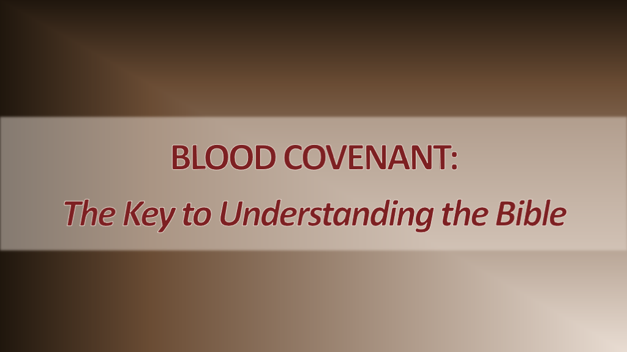
Dr. Jim Garlow
www.wellversedworld.org

Genesis 15:7 He also said to him, “I am the Lord, who brought you out of Ur of the Chaldeans to give you this land to take possession of it.” 8 But Abram said, “Sovereign Lord, how can I know that I will gain possession of it?” 9 So the Lord said to him, “Bring me a heifer, a goat and a ram, each three years old, along with a dove and a young pigeon.” 10 Abram brought all these to him, cut them in two and arranged the halves opposite each other; the birds, however, he did not cut in half. 11 Then birds of prey came down on the carcasses, but Abram drove them away. 12 As the sun was setting, Abram fell into a deep sleep, and a thick and dreadful darkness came over him.
Genesis 15:17 When the sun had set and darkness had fallen, a smoking firepot with a blazing torch appeared and passed between the pieces. 18 On that day the Lord made a covenant with Abram and said, “To your descendants I give this land, from the Wadi of Egypt to the great river, the Euphrates—

A Blood Covenant Old Testament

- Exchange Robes. 2. Exchange Belts. 3. Exchange Weapons. 4. Sacrificial Animal Slain
- Walk of Death. 6. Striking of the Hands. (Wrists) 7. Pronouncement of Blessings and Curses.
- Covenant Meal. 9. Exchange of Names.

Examples:

Genesis 15 – animal cut in two; walk between halves.
Genesis 17 – mark on the body (circumcision)
Deuteronomy 28 – pronouncement of blessings and curses
Jeremiah 34 – animal cut; walk of death (Jeremiah 7:33)
1 Samuel 17 – uncircumcised
1 Samuel 18 – exchange of robe, belt, weapons

*2 Samuel 4:4 Jonathan son of Saul had a son who was lame in both feet. He was five years old when the news about Saul and Jonathan came from Jezreel. His nurse picked him up and fled, but as she hurried to leave, he fell and became disabled. His name was Mephibosheth.)

2 Samuel 9:1-13 – covenant – multi-generational.

Spiritual Application
- David
- Lodebar
- Mephibosheth

The New Covenant

Hebrews 7:22a, Because of this oath, Jesus has become the guarantor of a better covenant.
8:6a But in fact the ministry Jesus has received is as superior to theirs as the covenant of which he is mediator is superior to the old one, since the new covenant is established on better promises.

Hebrews 10:1 The law is only a shadow of the good things that are coming—not the realities themselves. For this reason it can never, by the same sacrifices repeated endlessly year after year, make perfect those who draw near to worship.

- Exchange Robes, 2 Corinthians 5:21
- Exchange Belts, 2 Corinthians 12:7-10

Zechariah 4:6-9 So he said to me, “This is the word of the Lord to Zerubbabel: ‘Not by might nor by power, but by my Spirit,’ says the Lord Almighty. “What are you, mighty mountain? Before Zerubbabel you will become level ground. Then he will bring out the capstone to shouts of ‘God bless it! God bless it!’” Then the word of the Lord came to me: “The hands of Zerubbabel have laid the foundation of this temple; his hands will also complete it. Then you will know that the Lord Almighty has sent me to you.

- Exchange Weapons, Ephesians 6:10-17
- Sacrificial animal, Hebrews 10:19-20, Matthew 27:50-51
- Walk of Death, Luke 17:33
- A Mark on the Body, Romans 2:28-29
- Pronouncements of Blessings and Curses, Philippians 4:19, Galatians 3:13
- Covenant Meal, John 6:48-58, I Corinthians 11:24-30
- Exchange Names (Christian; Son of Man) Acts 11:26; John 5:27
- Exchange of Oldest Male Child. Genesis 22: 1-2, 16-18; Matthew 16:16; 18:18

Parity vs. Suzerain

Genesis 22:1-2 Some time later God tested Abraham. He said to him, “Abraham!” “Here I am,” he replied. Then God said, “Take your son, your only son, whom you love—Isaac—and go to the region of Moriah. Sacrifice him there as a burnt offering on a mountain I will show you.”
Hebrews 11:17-19 By faith Abraham, when God tested him, offered Isaac as a sacrifice. He who had embraced the promises was about to sacrifice his one and only son, even though God had said to him, “It is through Isaac that your offspring will be reckoned.” Abraham reasoned that God could even raise the dead, and so in a manner of speaking he did receive Isaac back from death.

Genesis 22:16-18 and said, “I swear by myself, declares the Lord, that because you have done this and have not withheld your son, your only son, I will surely bless you and make your descendants as numerous as the stars in the sky and as the sand on the seashore. Your descendants will take possession of the cities of their enemies, and through your offspring all nations on earth will be blessed, because you have obeyed me.”
Matthew 16:13-19 When Jesus came to the region of Caesarea Philippi, he asked his disciples, “Who do people say the Son of Man is?” They replied, “Some say John the Baptist; others say Elijah; and still others, Jeremiah or one of the prophets.” “But what about you?” He asked. “Who do you say I am?” Simon Peter answered, “You are the Messiah, the Son of the living God.” Jesus replied, “Blessed are you, Simon son of Jonah, for this was not revealed to you by flesh and blood, but by my Father in heaven. And I tell you that you are Peter, and on this rock I will build my church, and the gates of Hades will not overcome it. I will give you the keys of the kingdom of heaven; whatever you bind on earth will be bound in heaven, and whatever you loose on earth will be loosed in heaven.”
Matthew 18:18 “Truly I tell you, whatever you bind on earth will be bound in heaven, and whatever you loose on earth will be loosed in heaven.”

