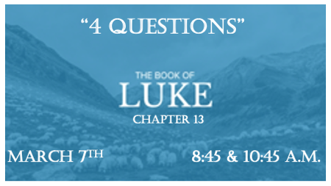

When you have questions who do you turn to?

*Luke 13:1 Now there were some present at that time who told Jesus about the Galileans whose blood Pilate had mixed with their sacrifices. 2 Jesus answered, "Do you think that these Galileans were worse sinners than all the other Galileans because they suffered this way? 3 I tell you, no! But unless you repent, you too will all perish. 4 Or those eighteen who died when the tower in Siloam fell on them—do you think they were more guilty than all the others living in Jerusalem? 5 I tell you, no! But unless you repent, you too will all perish."

Entrapment is the goal of many Questions

- V:1 If Jesus answers against Pilate he is in trouble, if he doesn’t defend the Galileans he is in trouble. What must Jesus do?

- V:2-4 Do you know how to think outside the box? Jesus challenges all Christians not to be imprisoned by their past, letting the latter dictate your focus will keep you trapped.

- V:5 The best way to answer an entrapment question is to ask a question.

- V:6-9 Parable of the fig tree: A parable about fruitfulness and the reality about the time it takes.

Why do Christians have trials?

- To glorify God. Daniel 3:24-29
- To build our faith and cause us to grow. Romans 5:3-6, I Peter 1:5-7
- To discipline us or keep us from pride. Hebrews 12:5-11, I Peter 4:1-3
- To Equip us for the comfort of others. 2 Corinthians 1:3-4
- To show testimony to the angels. Job 1:8, Eph. 3:8-11 ~(Hal Lindsey’s Combat Faith)

*Luke 13:18 Then Jesus asked, "What is the kingdom of God like? What shall I compare it to? 19 It is like a mustard seed, which a man took and planted in his garden. It grew and became a tree, and the birds perched in its branches."
20 Again he asked, "What shall I compare the kingdom of God to? 21 It is like yeast that a woman took and mixed into about sixty pounds of flour until it worked all through the dough."

2 Questions about the Kingdom of God

- V:10-18 The question in v:18 shows their religious ignorance about God. The tension wasn’t about a crippled woman suffering for 18 years. It was about healing on the sabbath.

- V:19 The tree is an idiom for both the Church & the Kingdom of God on earth . The demonic teaching in it is revealed by the birds will nestle in its branches. Daniel 4:19-27, Ezekiel 17:22-24, Matthew 13

- V:20 Jesus asked; “What can we compare the Kingdom of God to?” He raises a paradox in doing so by using yeast.

*Luke 13:22 Then Jesus went through the towns and villages, teaching as he made his way to Jerusalem. 23 Someone asked him, "Lord, are only a few people going to be saved?" He said to them, 24 "Make every effort to enter through the narrow door, because many, I tell you, will try to enter and will not be able to. 25 Once the owner of the house gets up and closes the door, you will stand outside knocking and pleading, 'Sir, open the door for us. '"But he will answer, 'I don't know you or where you come from.'
26 "Then you will say, 'We ate and drank with you, and you taught in our streets.'
27 "But he will reply, 'I don't know you or where you come from. Away from me, all you evildoers!'

Are only a few going to be saved?

- V:22-23 The truth around this Biblical question is staggering!

- V:24-25 The door is Jesus, He’s speaking of an event that many churches won’t teach on and the consequences must be heard.

- V:26 A perceived fellowship with Jesus and His Kingdom won’t save you!

- V:27 The (KJ) says; “you workers of iniquities depart from me. I don’t know you.”

