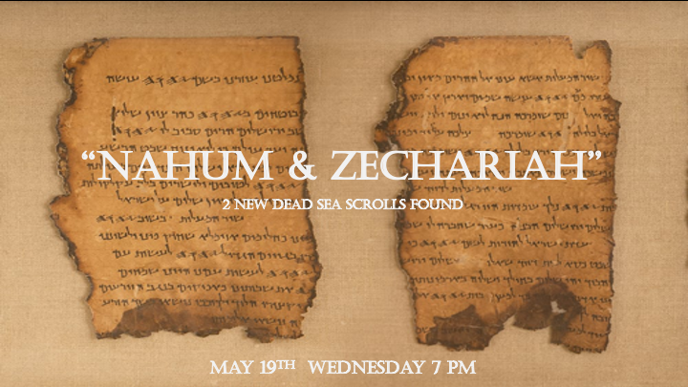

Dead Sea Scrolls and God’s Timing

- In 1947 the major find of the dead sea scrolls scriptures happened one year before Israel returns as a nation on May 14, 1948.

- The 11 lines found from Nahum and Zechariah gives us insights into profound consequences.

- March 16, 2021! One year from when our world went into lockdown from covid-19. Found in this cave.

*Nahum 1:2 The LORD is a jealous and avenging God; the LORD takes vengeance and is filled with wrath. The LORD takes vengeance on his foes and vents his wrath against his enemies.
3 The LORD is slow to anger but great in power; the LORD will not leave the guilty unpunished. His way is in the whirlwind and the storm, and clouds are the dust of his feet.

*Nahum 1:5-6 The mountains quake before him and the hills melt away. The earth trembles at his presence, the world and all who live in it. Who can withstand his indignation? Who can endure his fierce anger? His wrath is poured out like fire; the rocks are shattered before him.

7 The LORD is good, a refuge in times of trouble. He cares for those who trust in him,
8 but with an overwhelming flood he will make an end of Nineveh; he will pursue his foes into the realm of darkness.
*Nahum 2:6 The river gates are thrown open and the palace collapses.
*Nahum 3:1 Woe to the city of blood, full of lies, full of plunder, never without victims!

The Justice of God

- Nineveh the capital of the Assyrian empire is destroyed for its treatment of Israel. This destruction will bring short-term comfort to Israel. The city destruction is the introduction of the fall of this Nation.

- V:6-8 Who can withstand God’s indignation? God still uses water as a weapon the symbolic picture is powerful. This is historically accurate in Nineveh’s fall.

- Nahum 3:1 What major city and nation could this be describing?

*Zechariah 8:3 This is what the LORD says: "I will return to Zion and dwell in Jerusalem. Then Jerusalem will be called the Faithful City, and the mountain of the LORD Almighty will be called the Holy Mountain."
4 This is what the LORD Almighty says: "Once again men and women of ripe old age will sit in the streets of Jerusalem, each of them with cane in hand because of their age. 5 The city streets will be filled with boys and girls playing there."
6 This is what the LORD Almighty says: "It may seem marvelous to the remnant of this people at that time, but will it seem marvelous to me? " declares the LORD Almighty. 7 This is what the LORD Almighty says: "I will save my people from the countries of the east and the west. 8 I will bring them back to live in Jerusalem; they will be my people, and I will be faithful and righteous to them as their God."
9 This is what the LORD Almighty says: "Now hear these words, 'Let your hands be strong so that the temple may be built.' This is also what the prophets said who were present when the foundation was laid for the house of the LORD Almighty.

God Affirms the Future of these Prophecies.

- V:3-8 The Millennial reign: If he is returning to Jerusalem, he was already there once.

- V:9 The temple was built a second time. This is a historical truth. It is also pointing to the prophecy that a third temple will be built.

Zechariah 8:14 This is what the LORD Almighty says: "Just as I had determined to bring disaster on you and showed no pity when your ancestors angered me," says the LORD Almighty, 15 "so now I have determined to do good again to Jerusalem and Judah. Do not be afraid. 16 These are the things you are to do: Speak the truth to each other, and render true and sound judgment in your courts; 17 do not plot evil against each other, and do not love to swear falsely. I hate all this," declares the LORD.

Understanding the times

- V:14. The time of wrath is coming. Zechariah 13:8-9 is where we learned the truth that the remnant of Israel will only be 1 out of 3 Jewish people will survive the tribulation.

- V:15-16 The Instructions are clear, do not be afraid. Speak the truth to each other. Render true and sound judgment. Do not plot evil against each other. Do not love to swear falsely.

