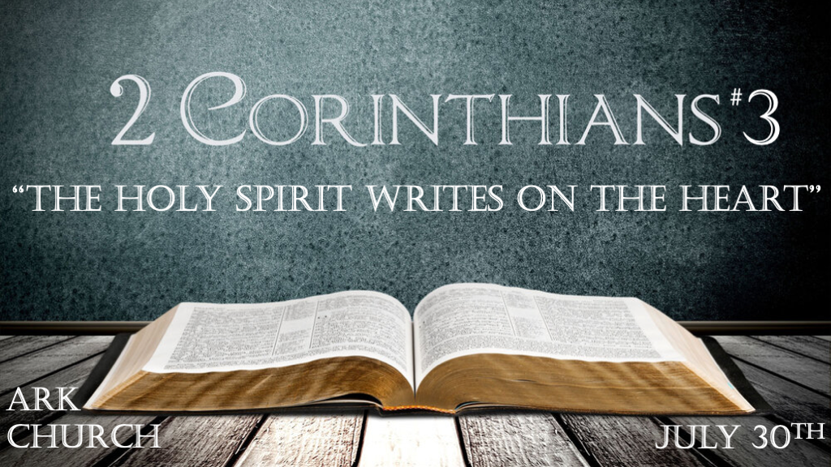
Chapter One
The God of all comfort. Who comforts us in our times of tribulation.

Chapter Two
Satan's strategies and Christ's Comfort through forgiveness.

*What's the Holy Spirit Writing on Your Heart?
*2 Corinthians 3:1 Do we begin again to commend ourselves? Or do we need, as some others, epistles of commendation to you or letters of commendation from you? 2 You are our epistle written in our hearts, known and read by all men; 3 clearly you are an epistle of Christ, ministered by us, written not with ink but by the Spirit of the living God, not on tablets of stone but on tablets of flesh, that is, of the heart.
4 And we have such trust through Christ toward God. 5 Not that we are sufficient of ourselves to think of anything as being from ourselves, but our sufficiency is from God, 6 who also made us sufficient as ministers of the new covenant, not of the letter but of the Spirit; for the letter kills, but the Spirit gives life.

V:1-3 Living letters are to be read by all. Jeremiah 17:9-10 The heart is deceitful above all things and beyond cure.
Our lives: say more than our words. Actions speak louder than words. (We need a new heart. You cannot cure the old one)

Our lives: These should be readable, demonstrates clarity, and is authentic. This life points to the one who makes this possible: God.

Our hearts need more than knowledge before the mind can be renewed. It must have The Spirit of God.
Romans 12:2
We are more than adequate we are abundantly able (sufficient) because our God is able.

V:4-6 The prophecy of the New Covenant. Jeremiah 31:31-33 Prophecy
Laws are written on the heart and mind according to Jeremiah 31:31-33. Part of The New Covenant is the promise of writing on our hearts. Our hearts are God's journal.

The letter of the law kills what? The chance to live right before God and others. But the Spirit gives life.

We are not meant to be self-sufficient. V:5 People enjoy reading about grace. Understanding the law in how we need to change is required.

*Ministry contrast and their extremes but with glory.

*2 Corinthians 3:7 But if the ministry of death, written and engraved on stones, was glorious, so that the children of Israel could not look steadily at the face of Moses because of the glory of his countenance, which glory was passing away, 8 how will the ministry of the Spirit not be more glorious? 9 For if the ministry of condemnation had glory, the ministry of righteousness exceeds much more in glory. 10 For even what was made glorious had no glory in this respect, because of the glory that excels. 11 For if what is passing away was glorious, what remains is much more glorious.

V:7-10 Is there a role for the glory of the O. T. ? Absolutely.
It is in understanding Glory and how it shows God's past, present, and future faithfulness.

The Glory of the O. T. still points to what is coming. It could never accomplish what Jesus would do through the incarnation and resurrection.

Never underestimate the role of understanding our complete hopelessness without Jesus' incarnation.

The N. T. completes what the O. T. could not accomplish but never competes with the O. T.

The severe mistake: Christians rejecting the law and ultimately making "Grace" something it's not.

*The Mirror that Reflects Jesus.

*2 Corinthians 3:12 Therefore, since we have such hope, we use great boldness of speech—13 unlike Moses, who put a veil over his face so that the children of Israel could not look steadily at the end of what was passing away. 14 But their minds were blinded. For until this day the same veil remains unlifted in the reading of the Old Testament, because the veil is taken away in Christ. 15 But even to this day, when Moses is read, a veil lies on their heart. 16 Nevertheless when one turns to the Lord, the veil is taken away. 17 Now the Lord is the Spirit; and where the Spirit of the Lord is, there is liberty. 18 But we all, with unveiled face, beholding as in a mirror the glory of the Lord, are being transformed into the same image from glory to glory, just as by the Spirit of the Lord.

V:12-14 Hope and transparency bring boldness of speech.
Moses put a veil over his face to hide the fading glory of God.

Christians must not put a veil over their speech. We must speak to the glory of God.

*V:15 The veil: Just as it was over Moses' eyes, it now is over the hearts of Israel.
Israel and non-believers have the same issue a rejection of the Messiah.

V:16 There is only one way to remove heart issues: Jesus.
The Gospel: Solves the problem of a wicked heart with a new one. Being born again guarantees a new heart.

V:17 Liberty is a crucial word for all of Christianity.
*Liberty is essential to spiritual freedom and physical freedom.

Liberty is why Jesus died to set us free from the captivity of our sins.

V:18 The reflection of our lives must not be going from failure to failure, but from glory to glory.
Our image is not one of perfection; it's about maturation. Every failure, misstep, etc., is an opportunity to grow in the knowledge of the Holy Spirit. The work of transformation is a continuation of living from glory to glory.

